Critical Operations Test Scenario Document DMS

Contents

**Testing environment** 2

**Features** 2

1. FOLDERS 2

1.1. Create main library (delete after creation) 2

1.2. Create new folder. 3

1.3. Upload a file 3

1.4. Upload and edit file and Check in 7

1.5. Granting rights to the file 9

1.6. Click on all the buttons in the Side Panel 10

1.7. Workflow creation/edit, process rights and workflow design 13

1.8. Workflow initiation 17

1.9. New from template 20

1.10. Advanced search 24

1.11. File – properties – click on all the tabs from Consola, Inbox, Dashboard, Advanced Search like in the screenshot bellow: 25

1.12. Side panel - click on all tabs in Console, Inbox, Dashboard, Advanced Search, Reports 26

2. Administration 27

2.1 Users creation / Edit 27

3.2 Users / Organization Chart / Create / Edit / save user & department 28

3.3 Documents > Attributes - Create / Edit / Save 32

3.4 Admin > Unit > Partners Add/ Edit / Save 34

4. Reports 35

4.1 Define a Report and Edit / Save columns 35

4.2. Run reports 38

5. Activities 38

5.1 Activities - Projects - Tickets – Add/Edit ticket 38

6.1. Register . Create / Edit 41

7. REGISTRATION LIGHT 44

7.1 Document registration and reference to a person, with PDF upload 44

8.3 Preview 47

8.4. Send on workflow from Register 47

# **Testing environment**

|  |  |
| --- | --- |
| User: [cristina.meirosu@electrica.ro](mailto:cristina.meirosu@electrica.ro)  password: imw1 | Link access:  <https://gts.documenta-dms.com/> |
| Testing environment: GTS | Result: FAILED OR PASS |
| Language: ROMANA |  |
| Browser: Google Chrome |  |

# **Features**

## FOLDERS

### Create main library (delete after creation)

It is created and deleted

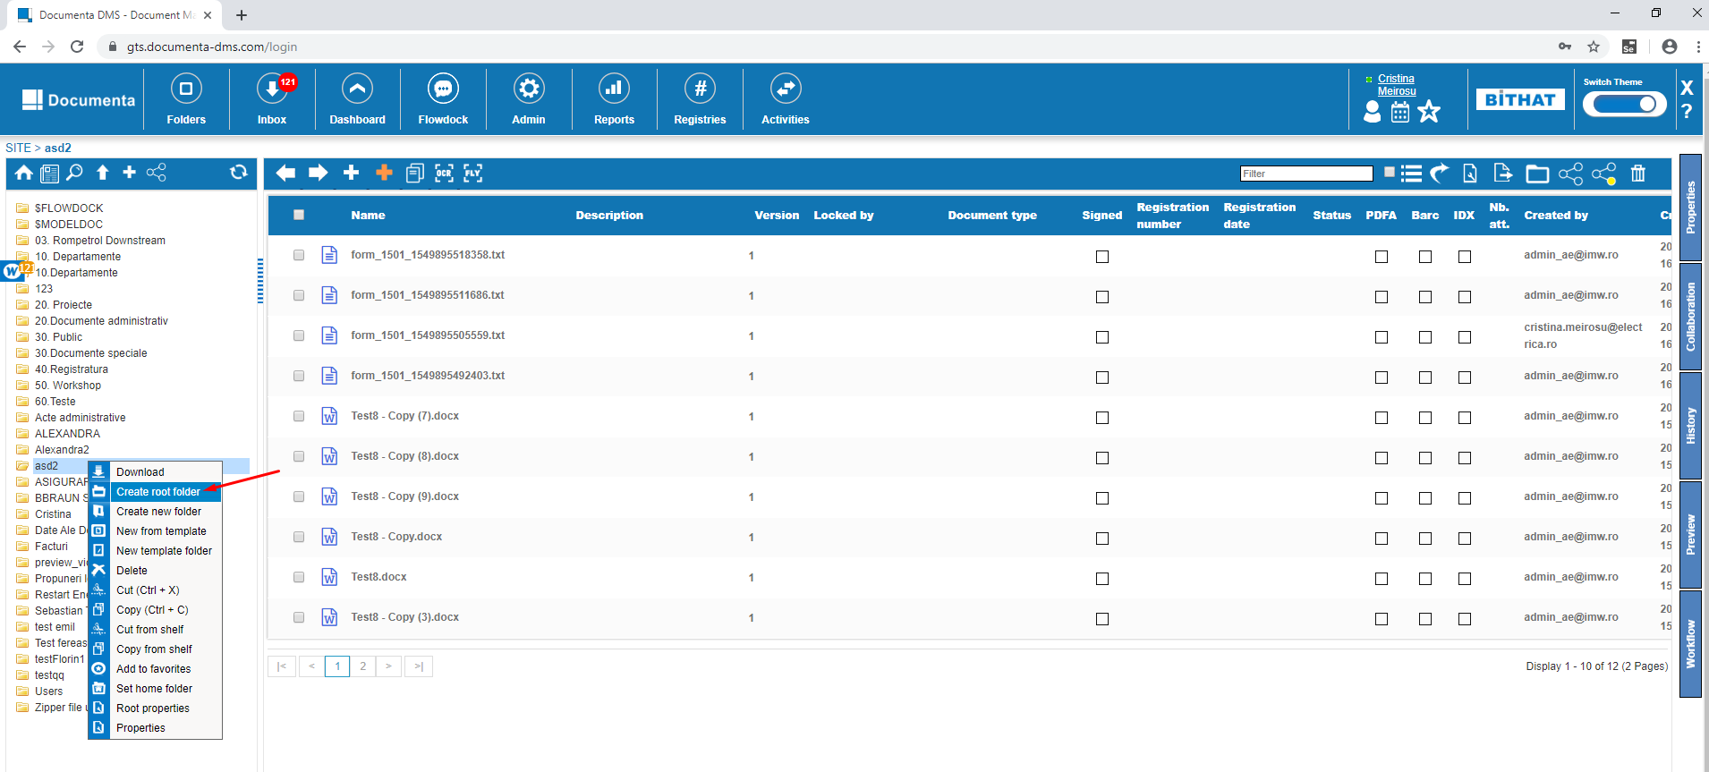

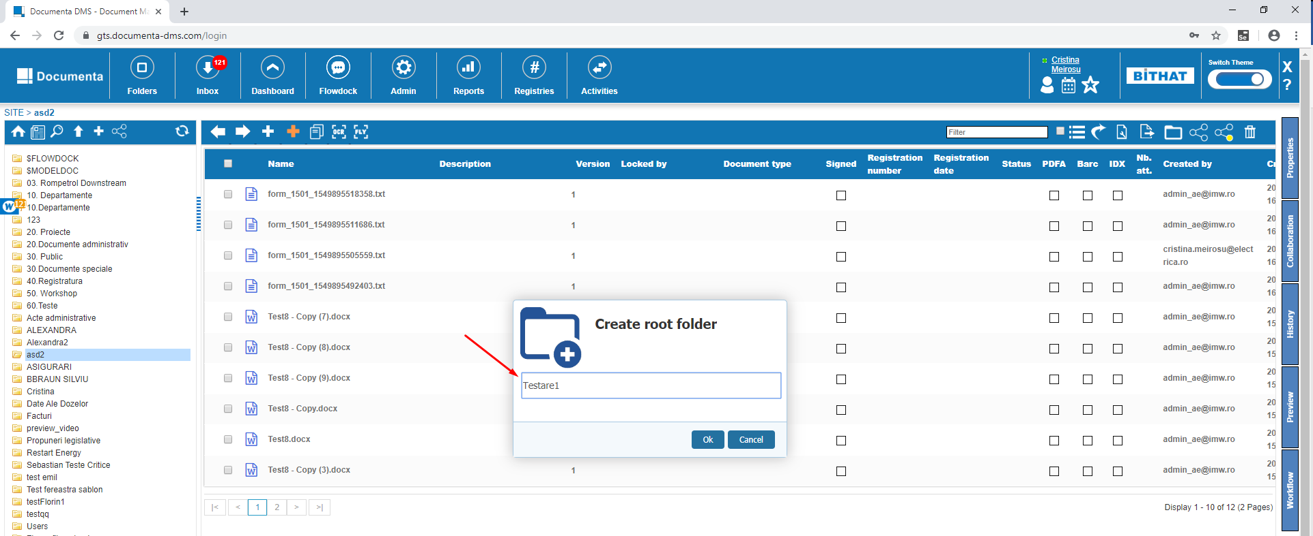

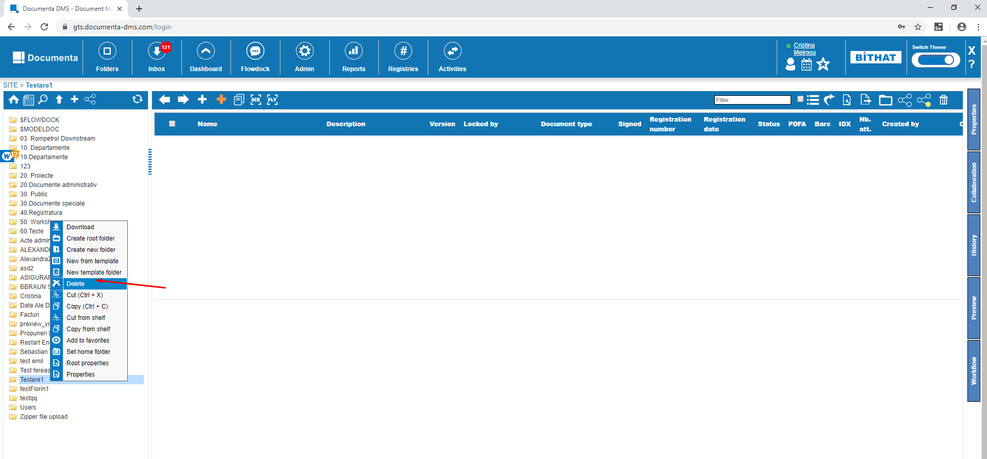

### Create new folder.

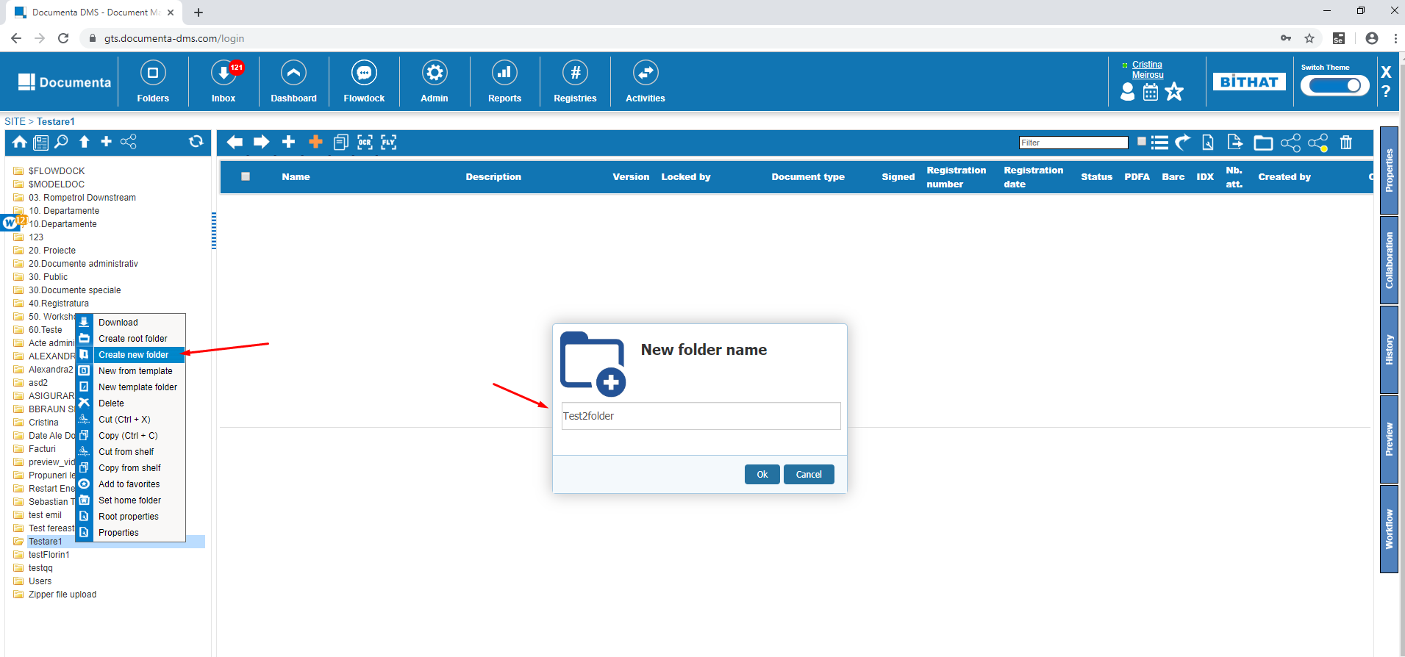

### Upload a file

Create a folder for testing:

Upload File PDF, XLSX, XLS. This can be done by:

- right click in the midle of the screen and click upload

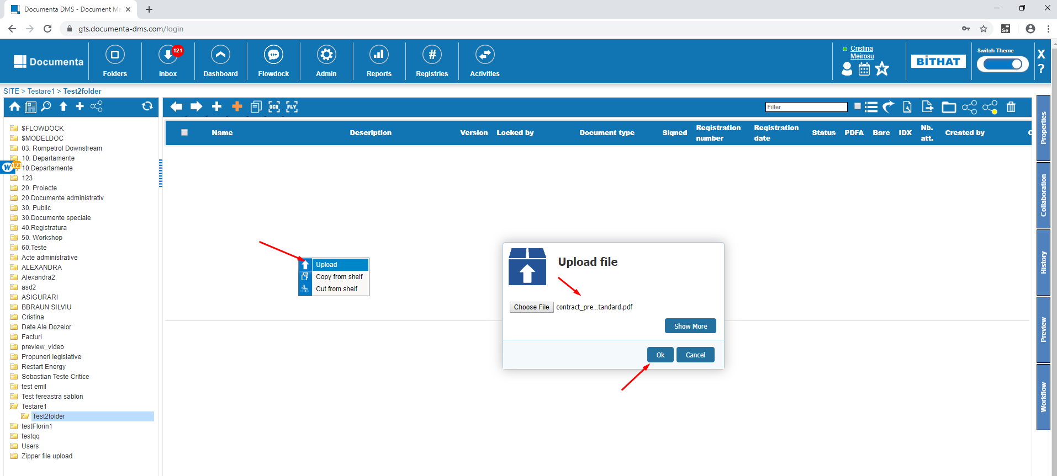

Select Document type ‘Factura’ as example and complete the fields that are mandatory (bolded out) from the Attributes tab

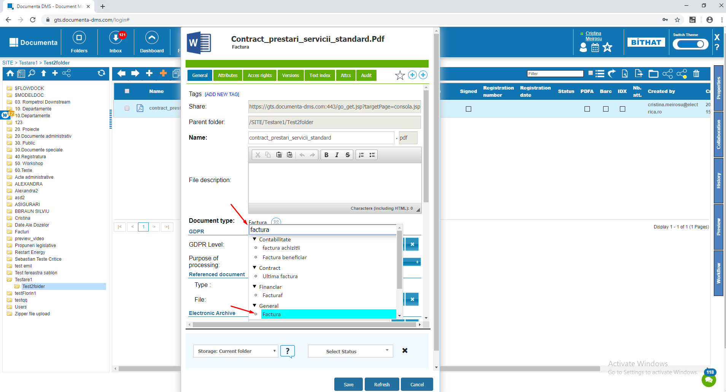

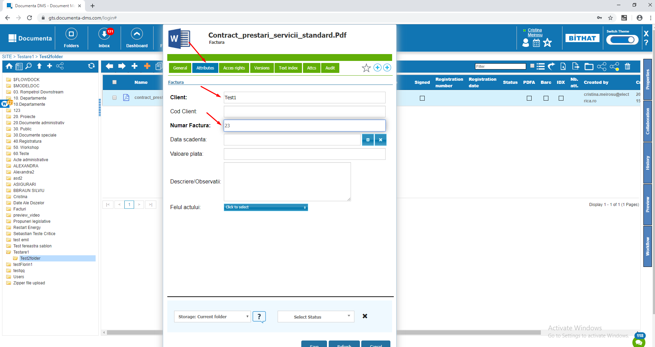

Preview on the file that is uploaded:

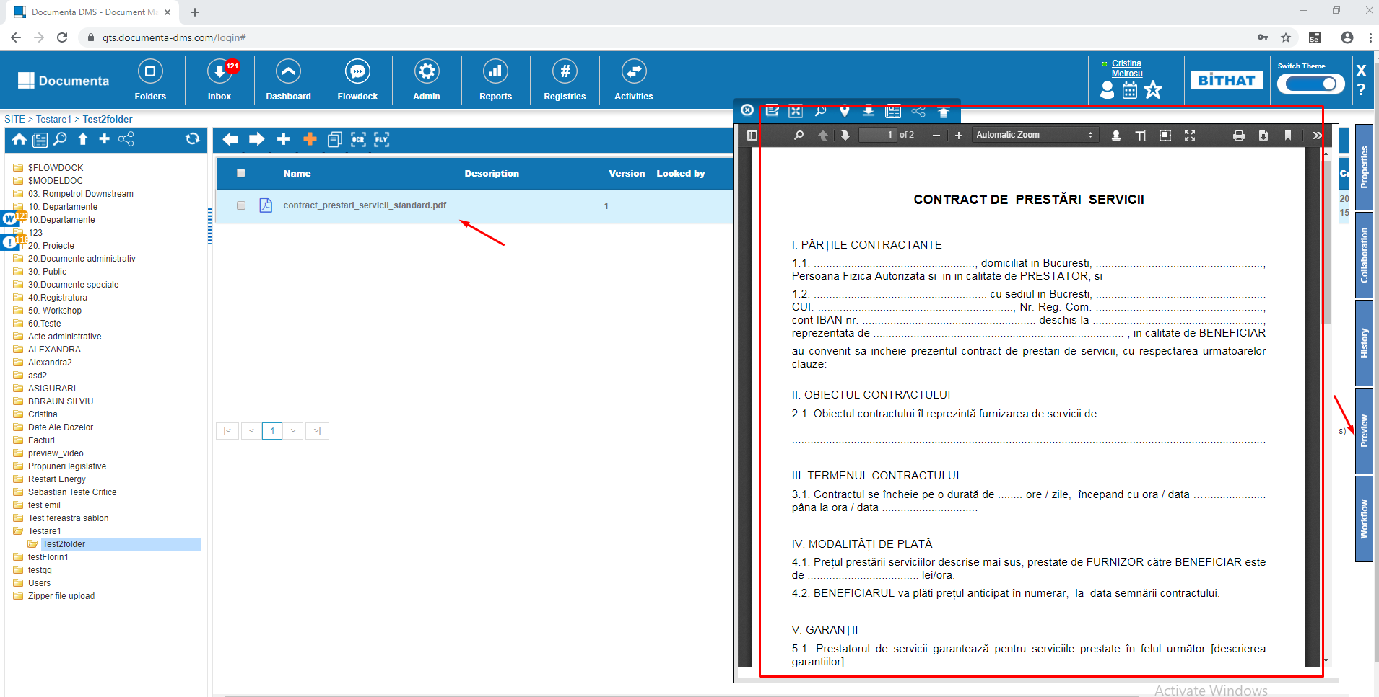

* Click on the upload button from the toolbar and repeat the steps above

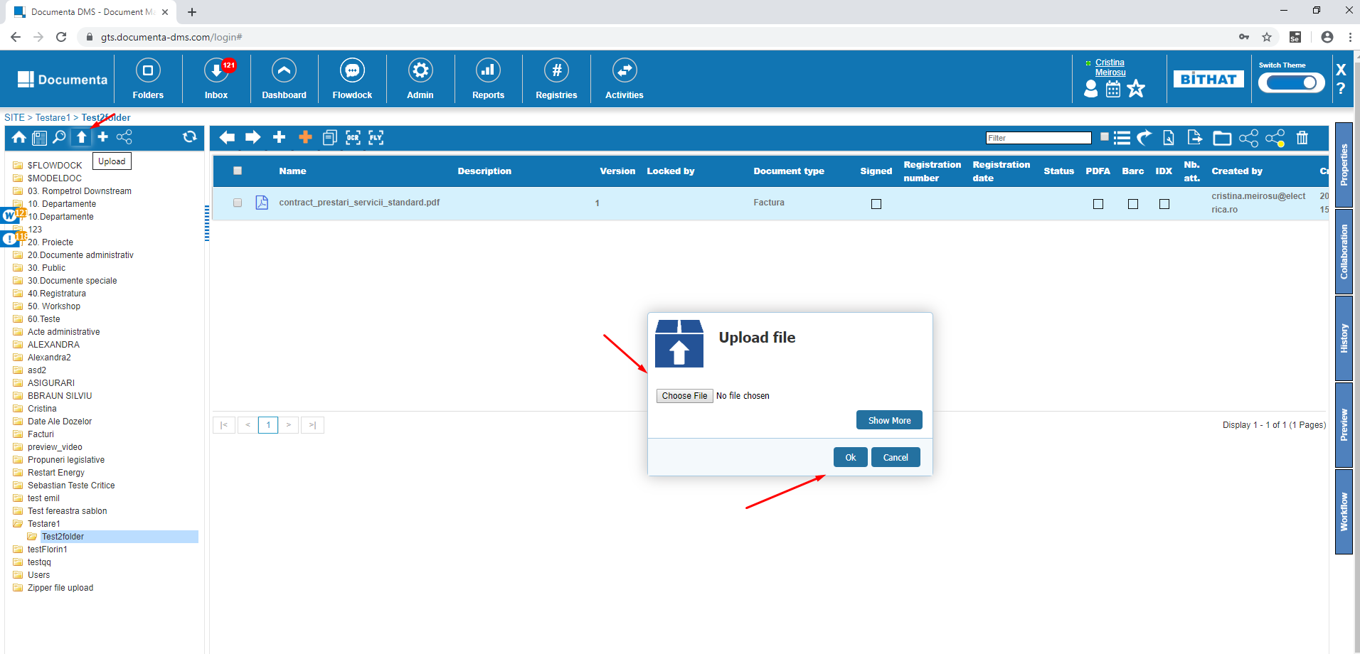

* Drag and drop a file directly in Documenta to upload a file and repeat the steps above

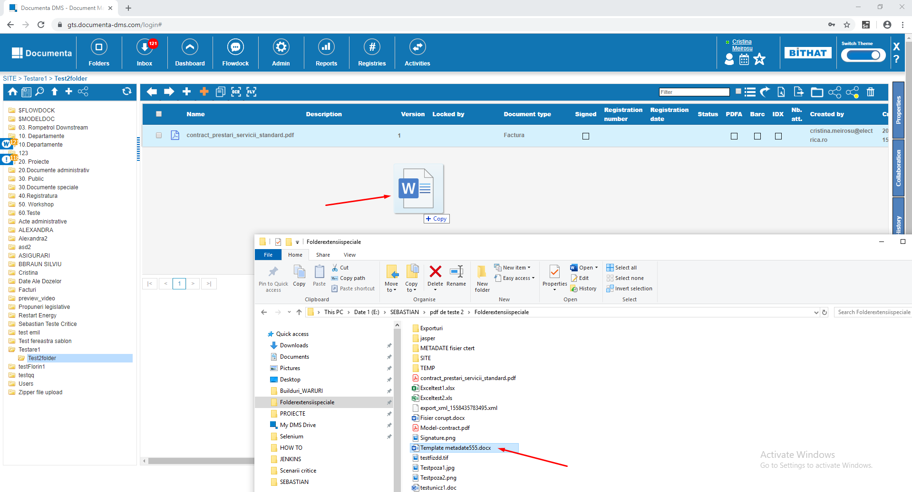

### Upload and edit file and Check in

We double click on an existing Microsoft word file with extension .docx or .doc and click Edit file

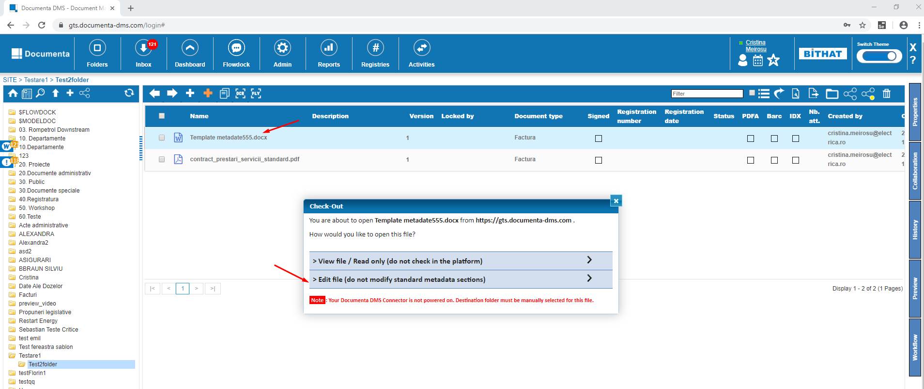

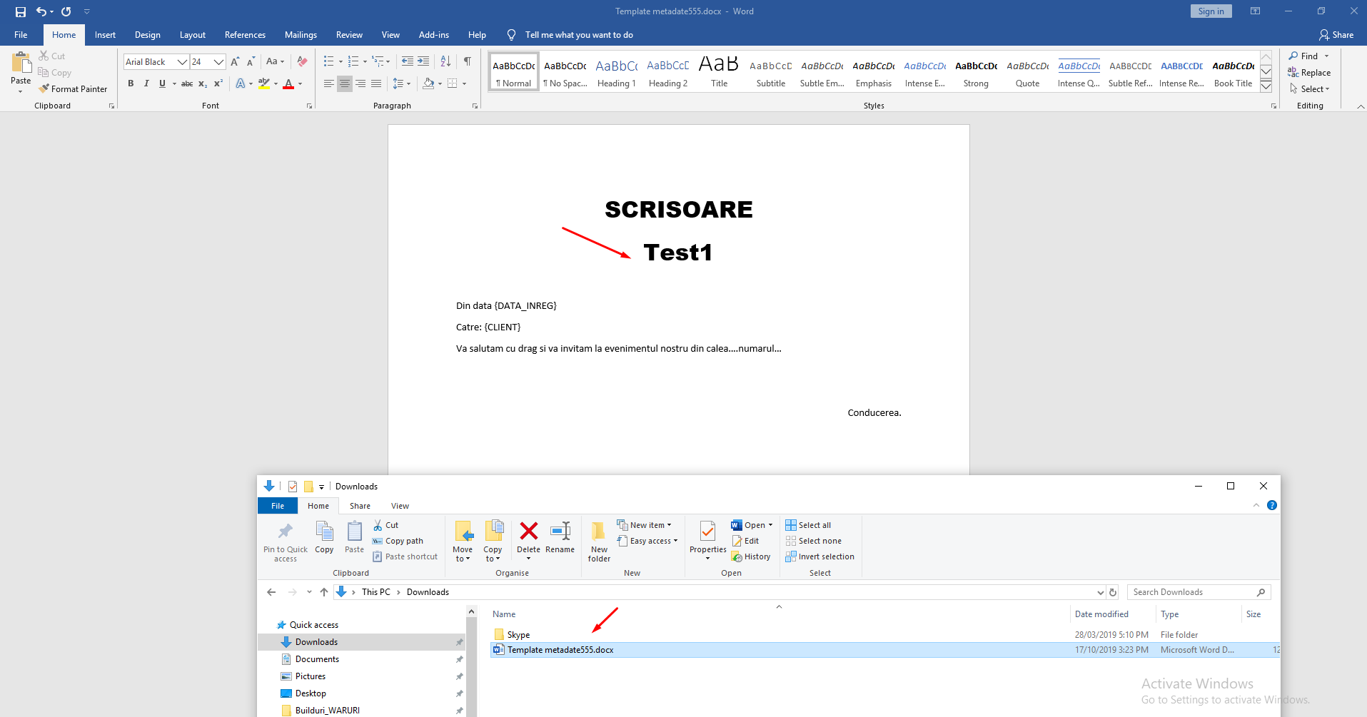

Modify something in the file and then in Documenta and click on Check in . In Version comments type anything you want and then click Ok and upload the file that you modified in Windows Explorer.

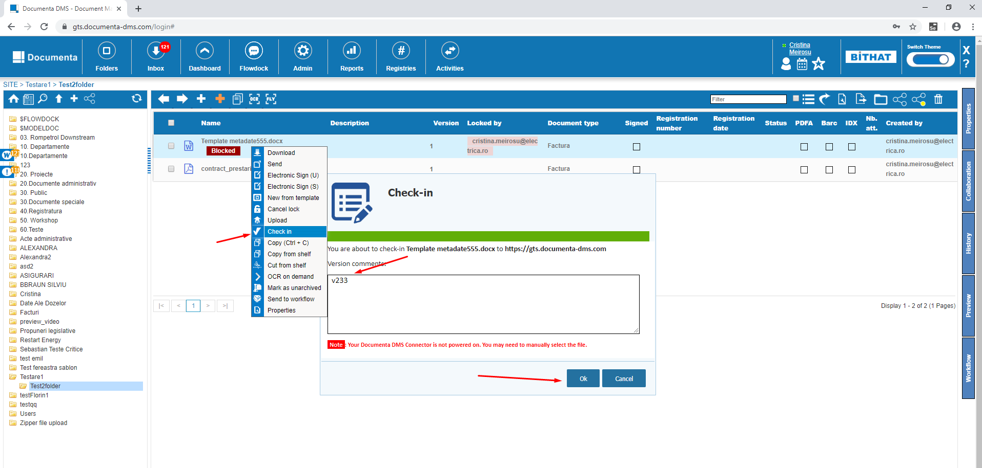

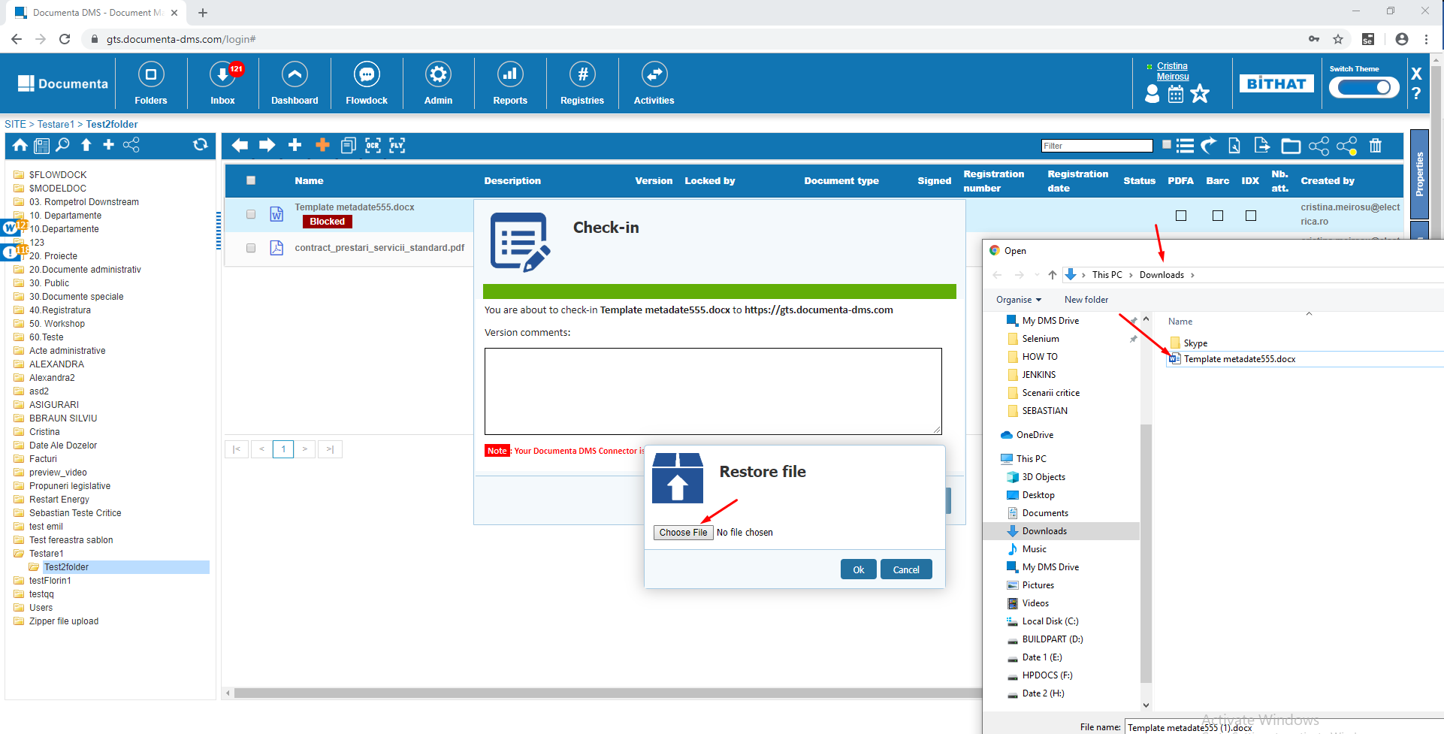

Click on Preview to see the new changes and also Version number that’s is 2.

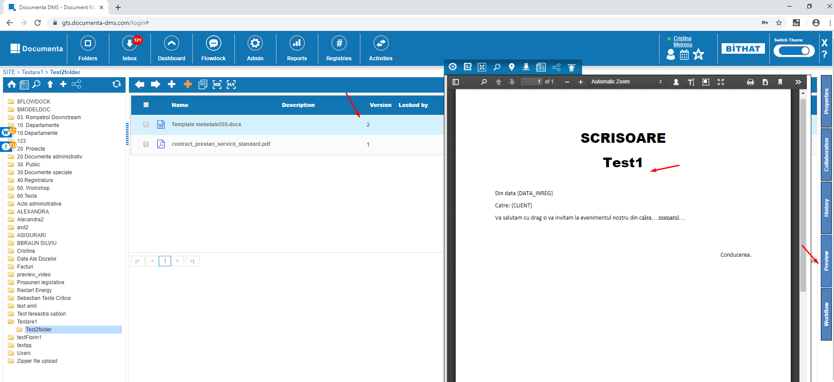

### Granting rights to the file

Right click on a file – Properties - Acces Rights Tab – Add – Select any user from the User field – Check all the 3 options Read, Write, Full. - Save

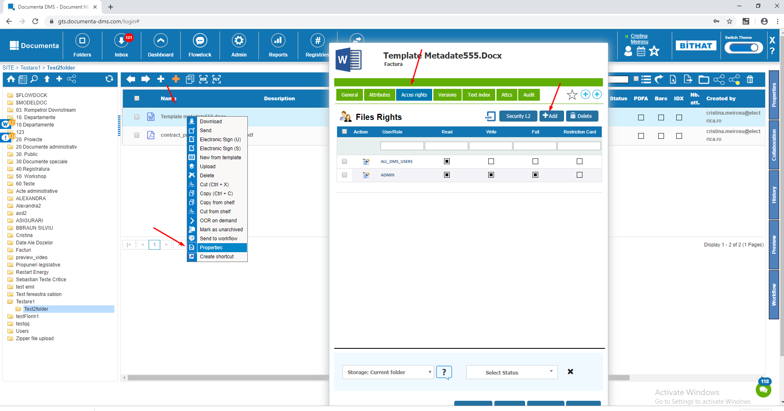

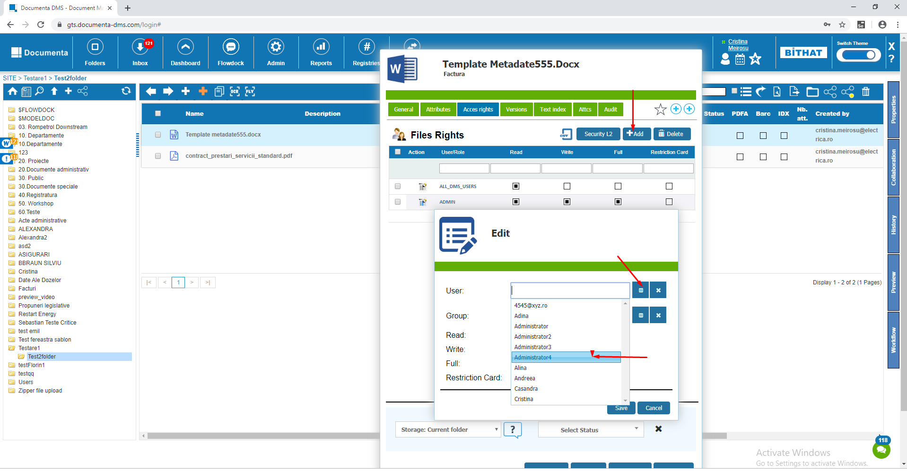

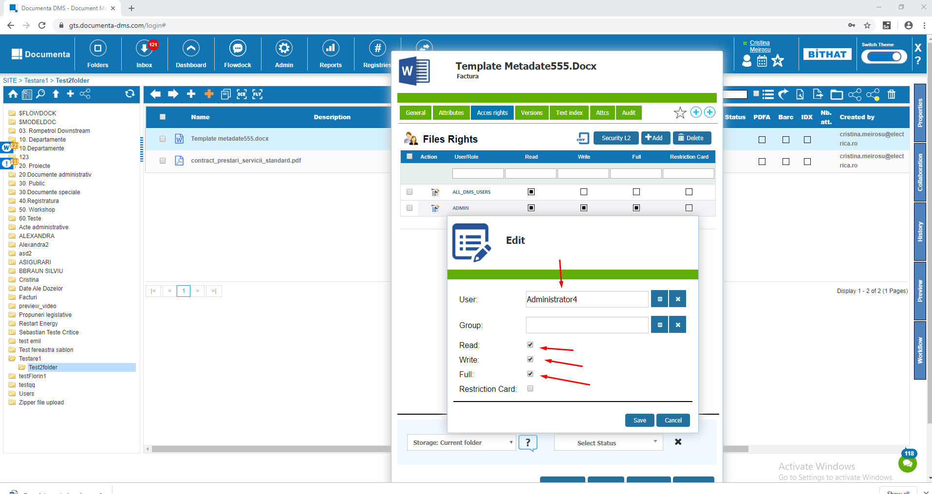

### Click on all the buttons in the Side Panel

#### Properties: General, Attributes.

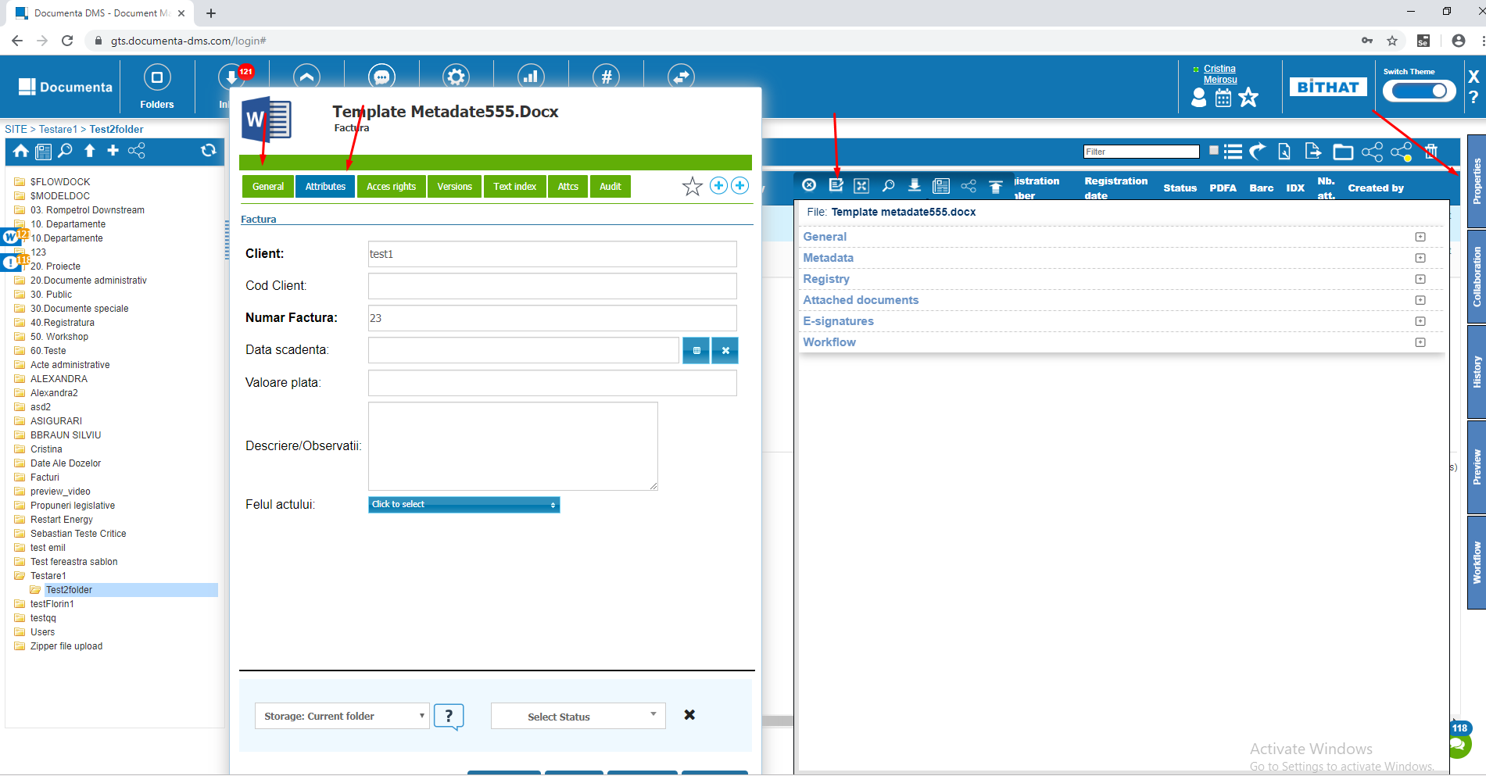

#### Attached documents, click on all the 4 options to attach documents.

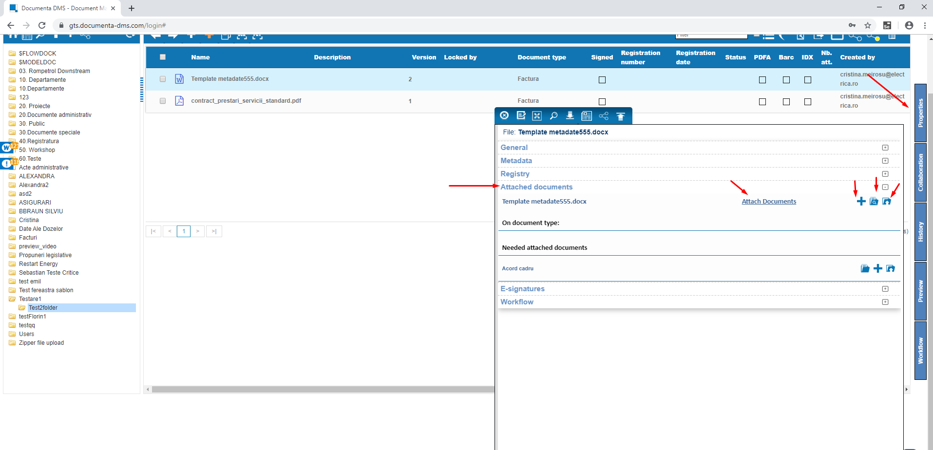

*E-signatures and Workflow - just click on them so something weird doesn't appear*

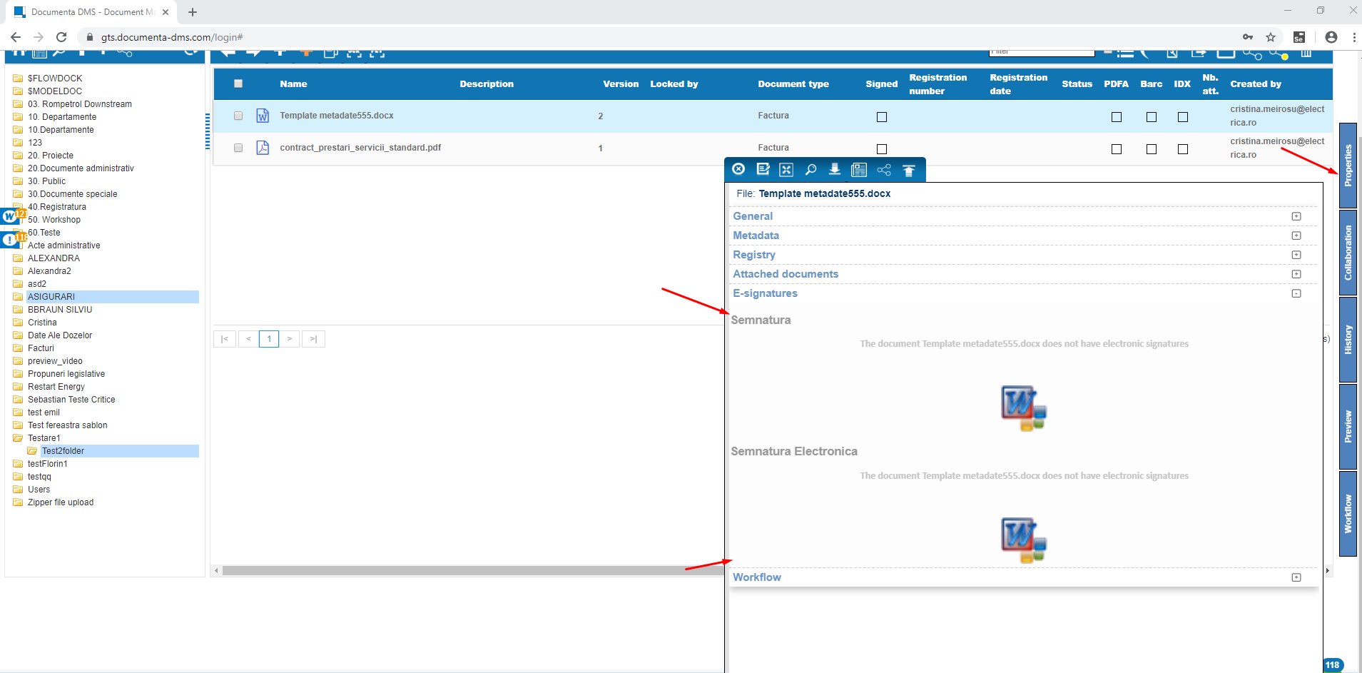

#### Collaboration Tab

* Write a message and put a picture / print screen

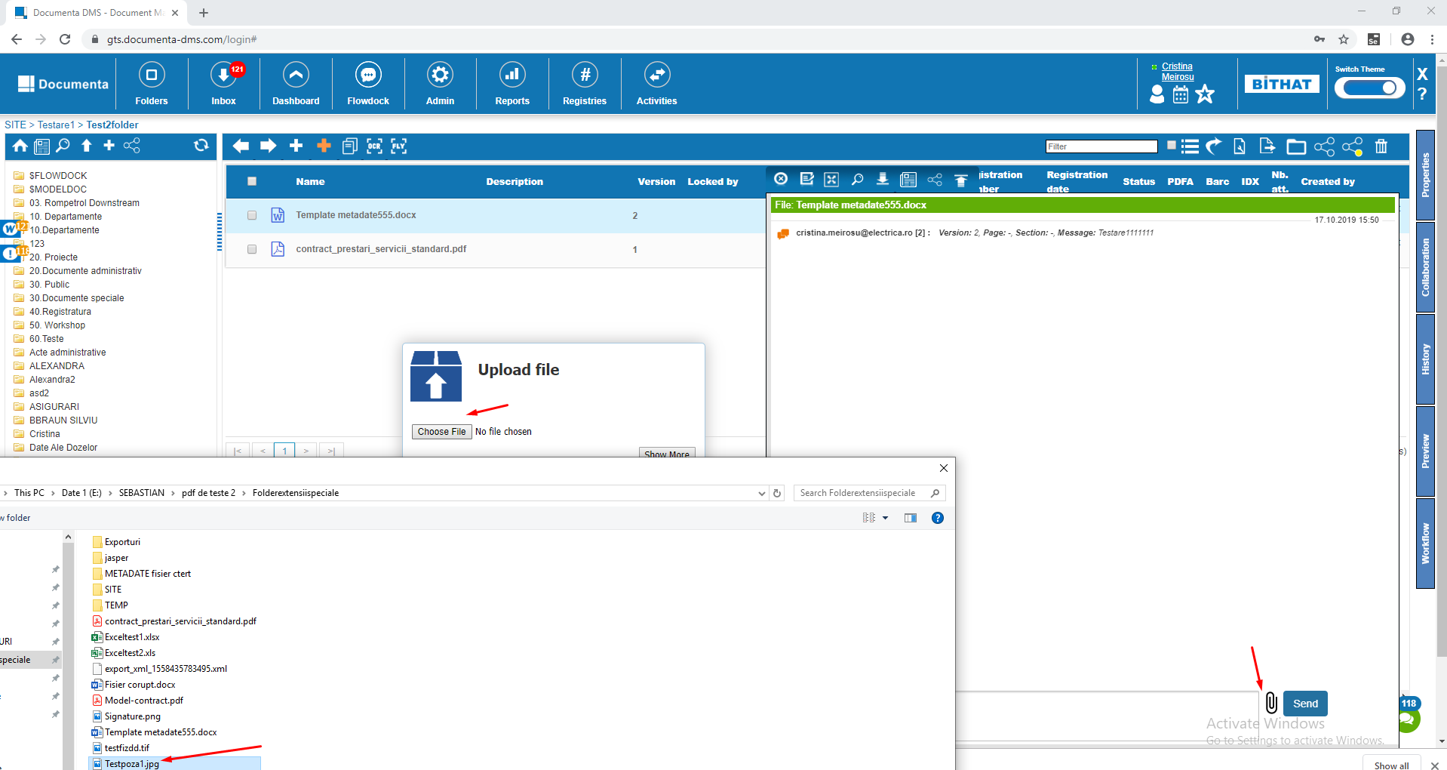

Click on the picture

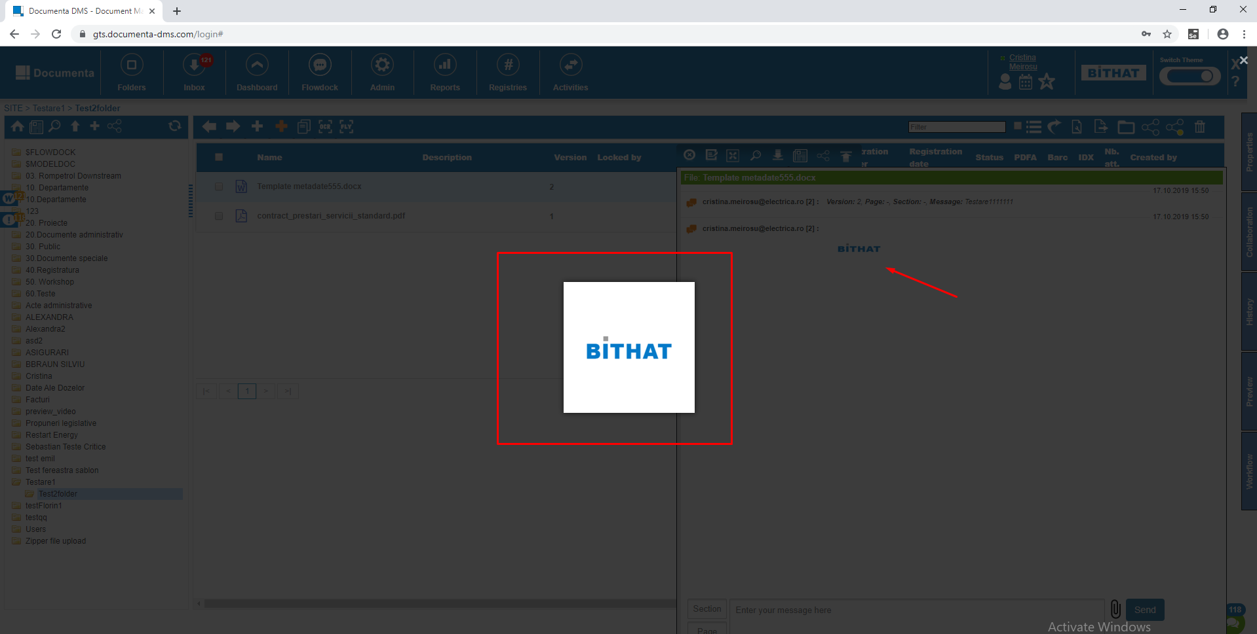

### Workflow creation/edit, process rights and workflow design

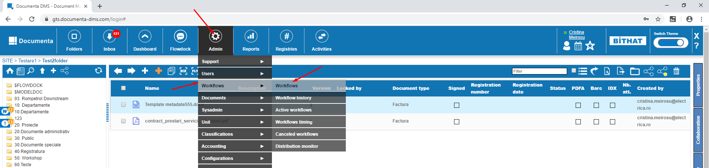

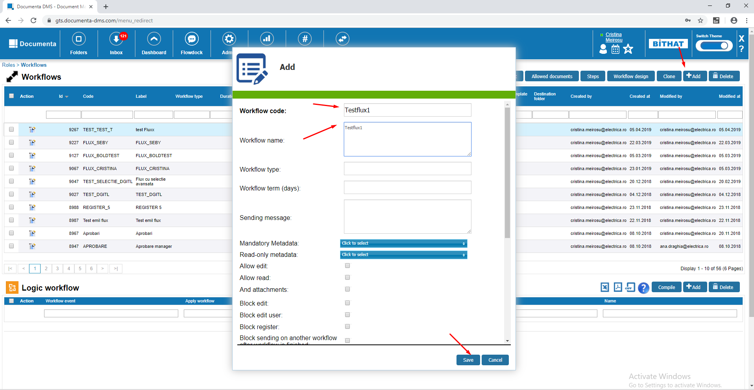

Edit the workflow

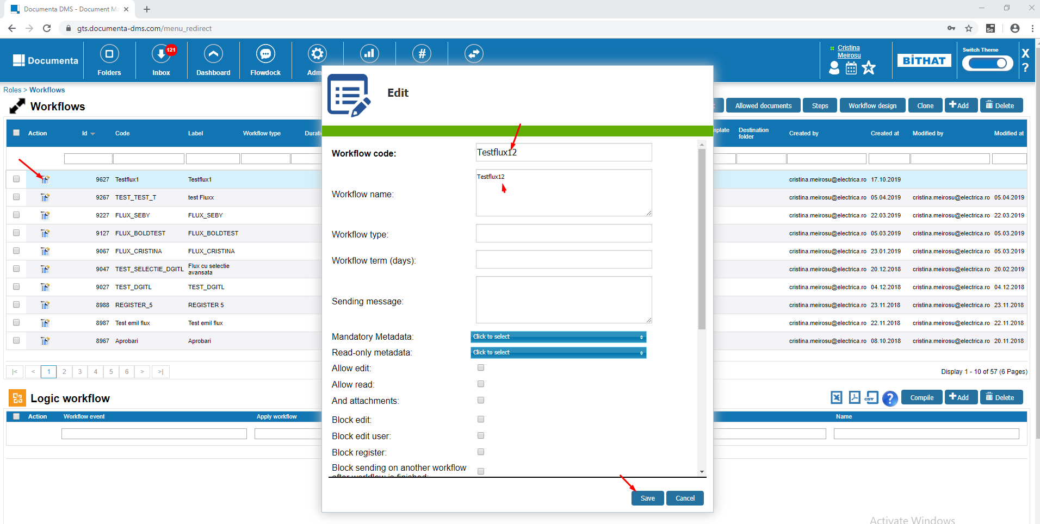

We give Process Rights to the workflow:

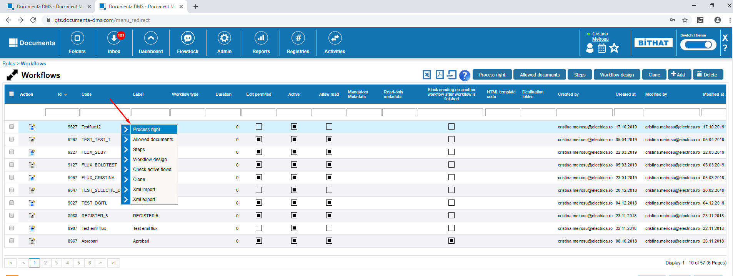

Select ALL_DMS_USERS group to give acces to all the users from the application

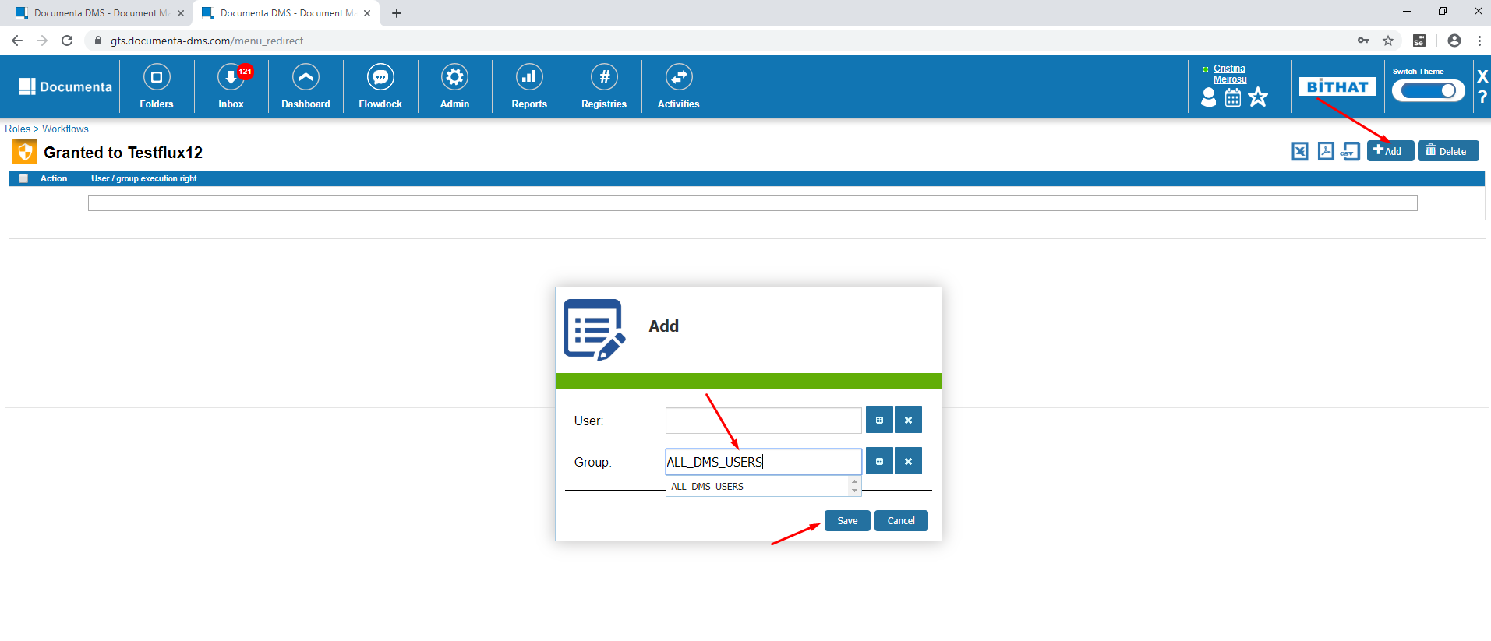

Create Workflow design:

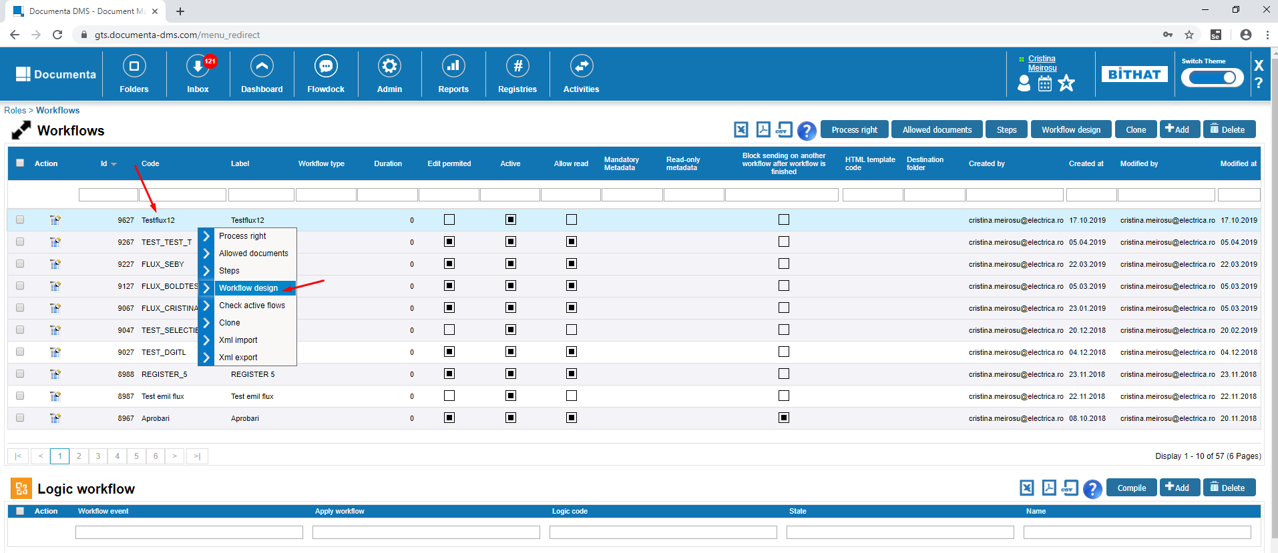

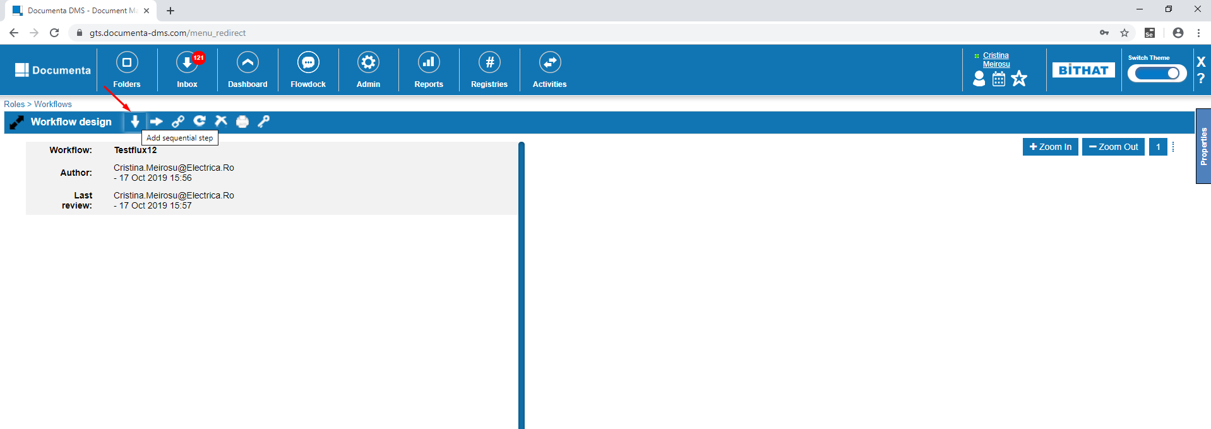

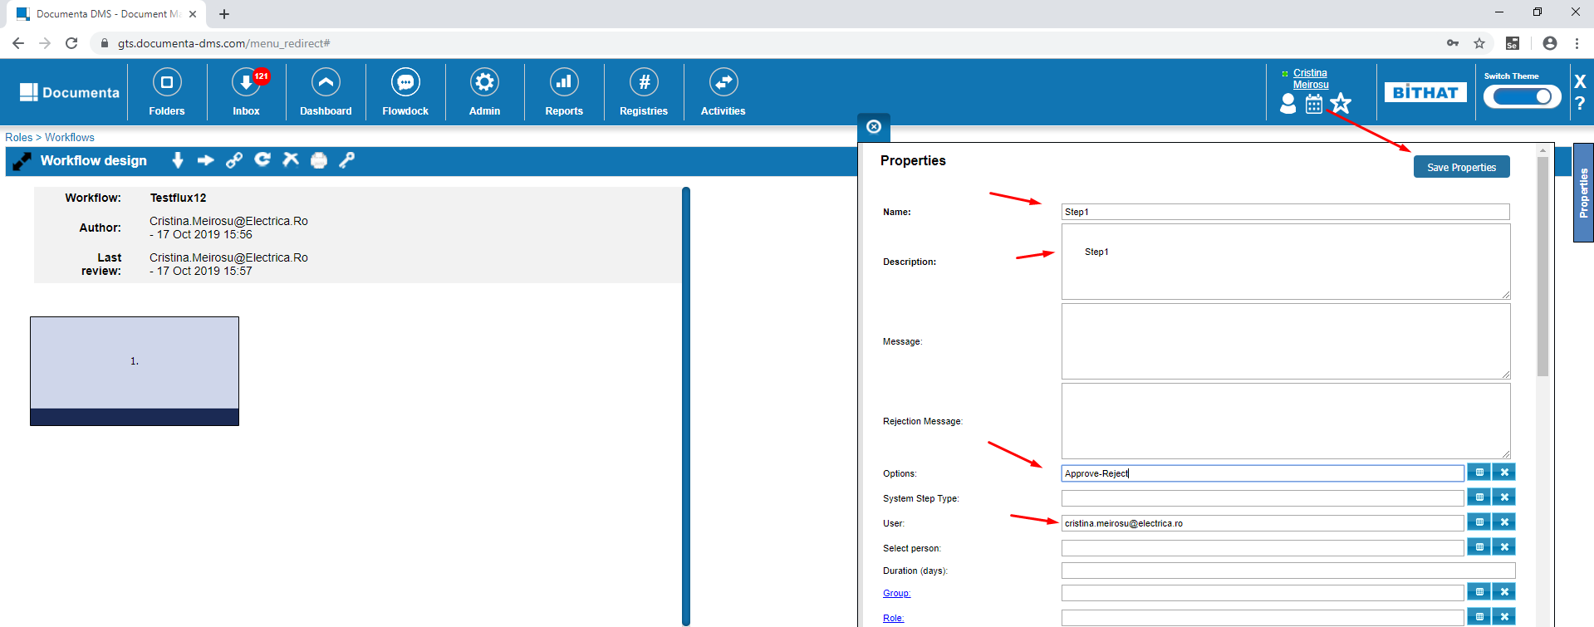

Click on the first sequential step and click on the button to add another step

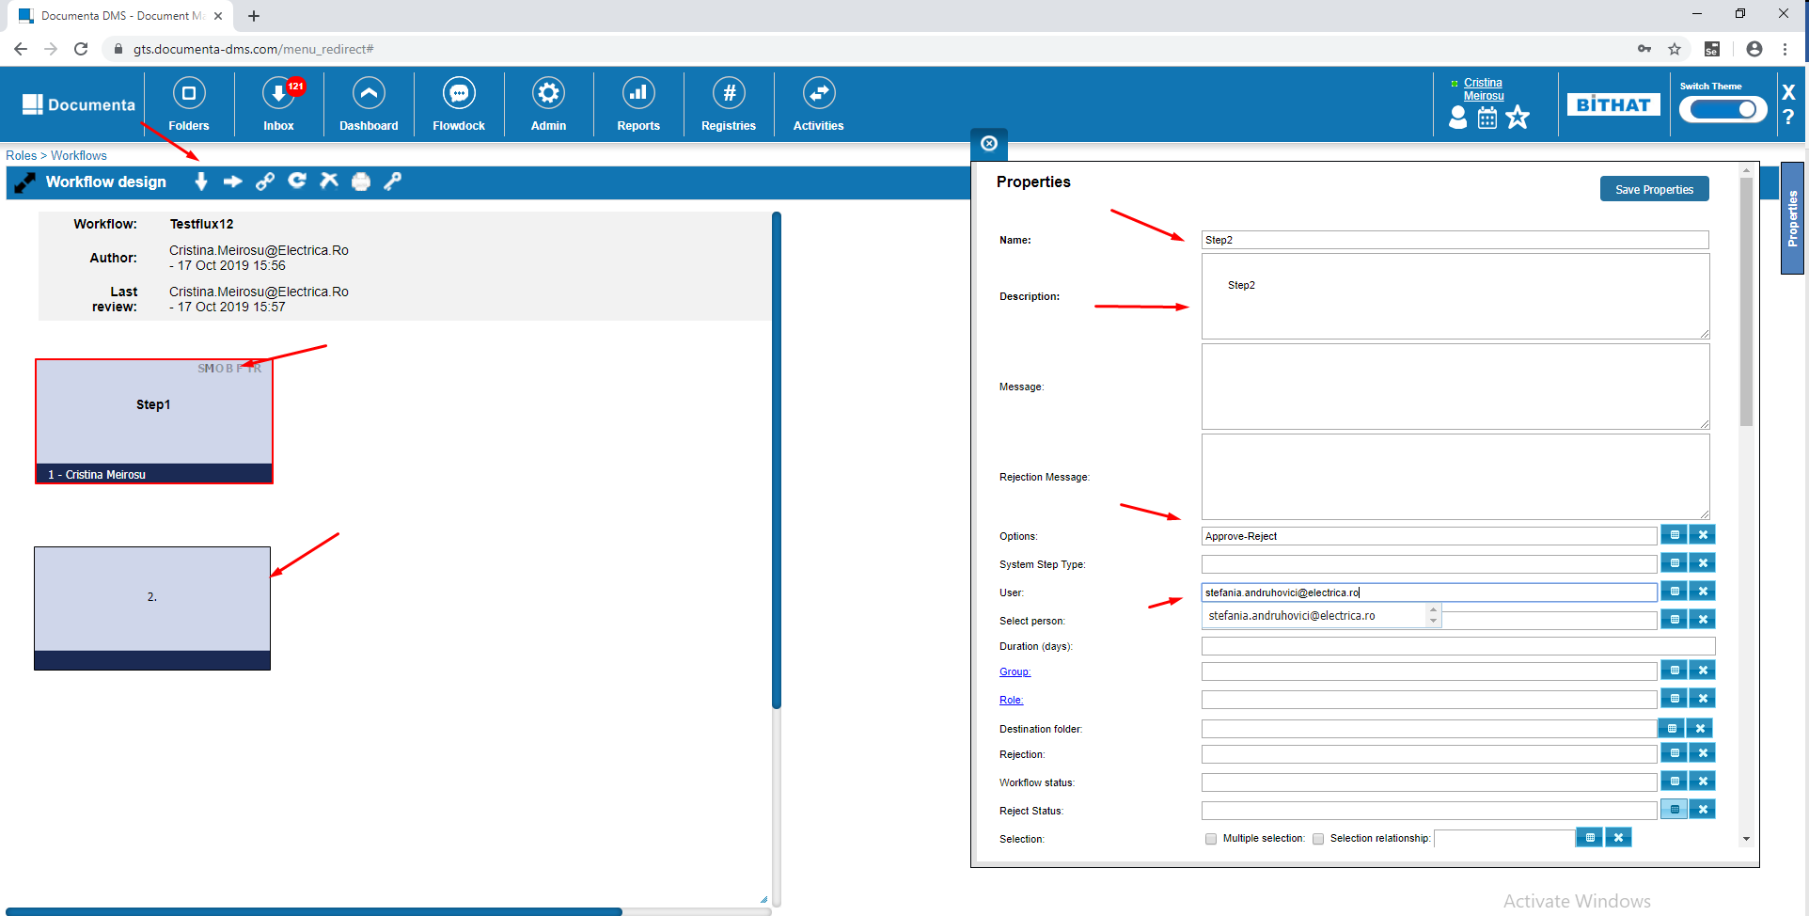

Select first stept and click on the button to create a link between the 2 steps.

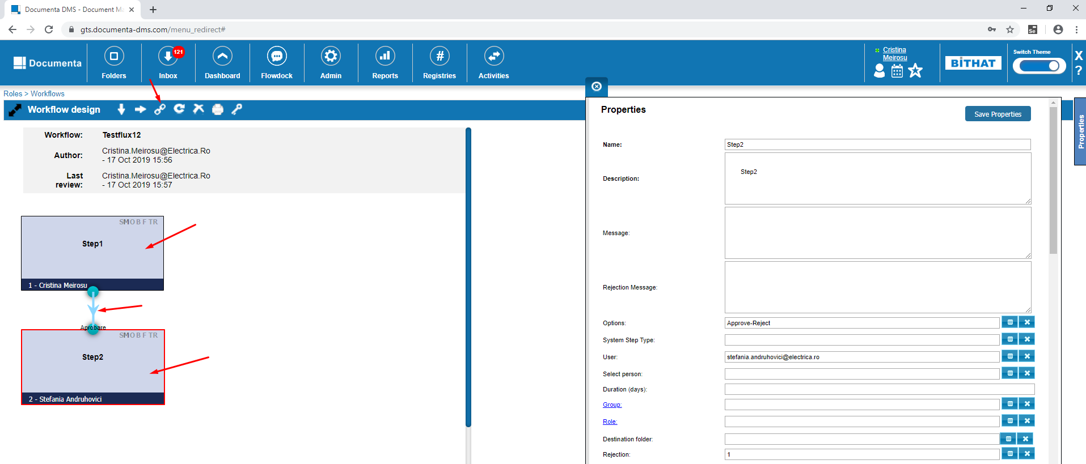

### Workflow initiation

Right click on a file and click on Send to workflow

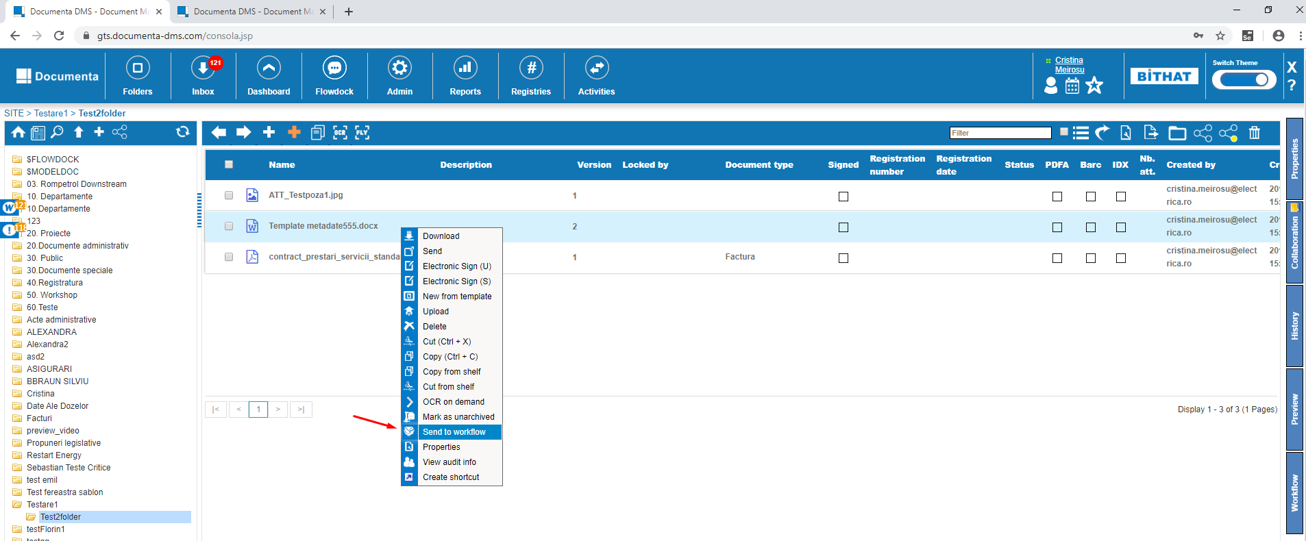

Search the workflow we just created

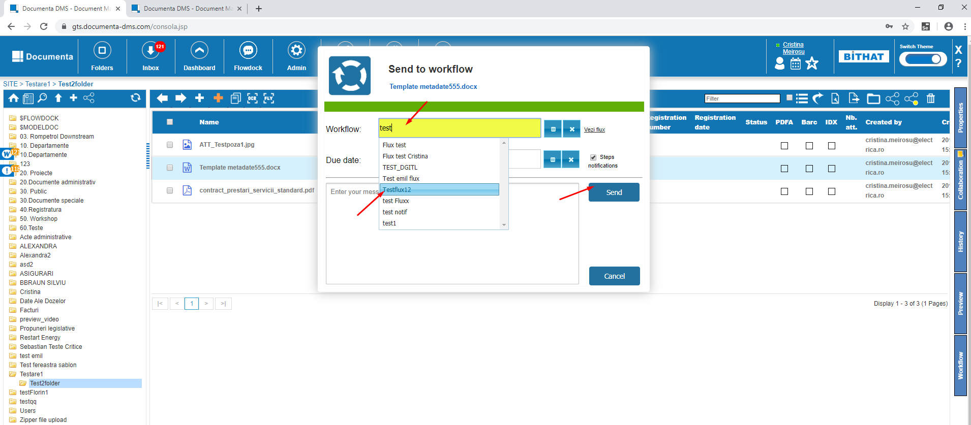

Click on Inbox and select the file that was sent. Open Workflow from Side Panel and click Approve

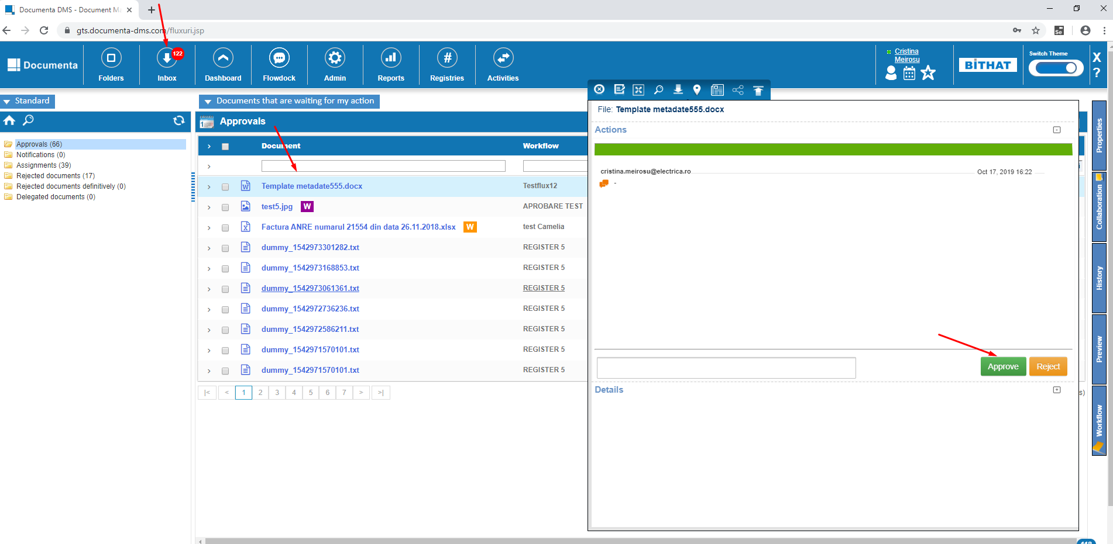

Open in Google Chrome incognito mode the application <https://gts.documenta-dms.com/login> with the user [stefania.andruhovici@electrica.ro](mailto:stefania.andruhovici@electrica.ro) and password imw1

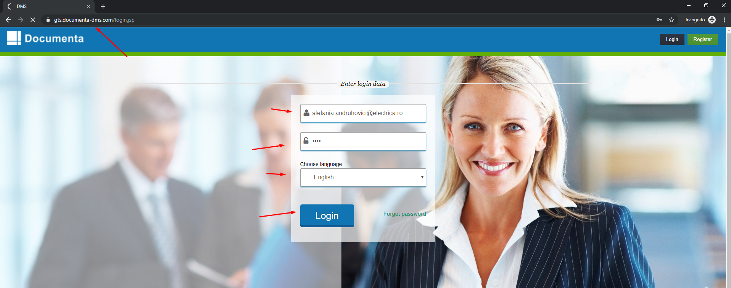

Click on Inbox and select the file that was sent. Open Workflow from Side Panel and click Approve

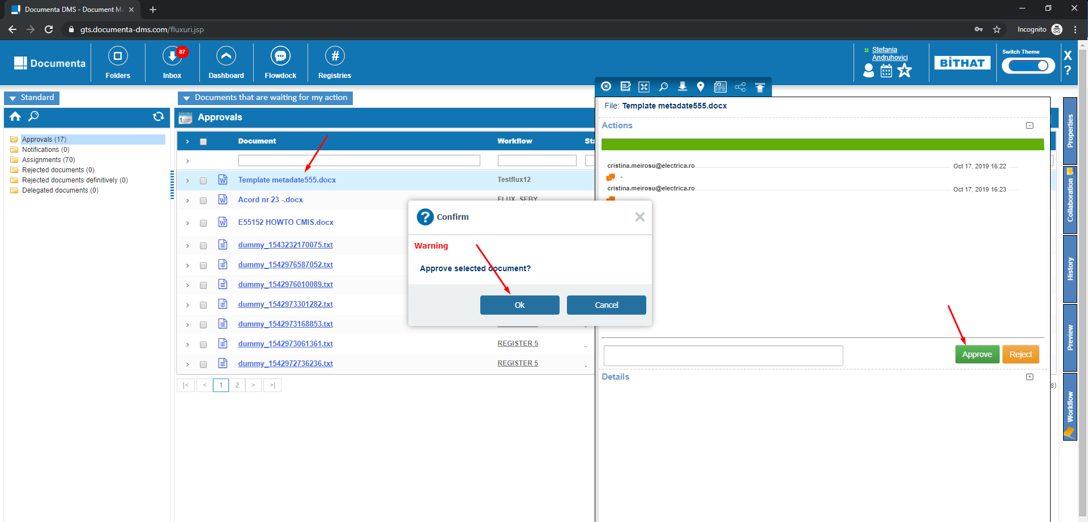

After this go back in the other session of Google Chrome where you are logged in with cristina.meirosu@electrica.ro

### New from template

1. Admin > Documents > Document type

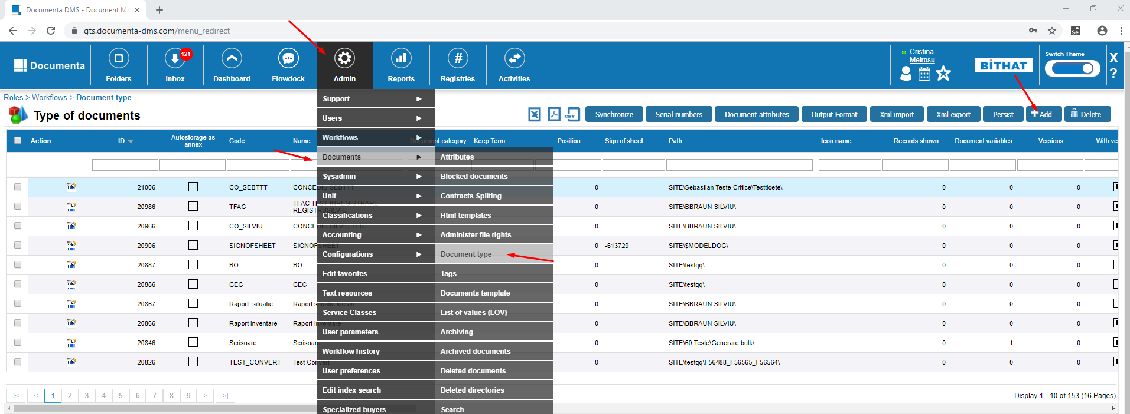

* Add / Save / Edit a document type. Complete the fields that are mandatory like in the screenshot bellow

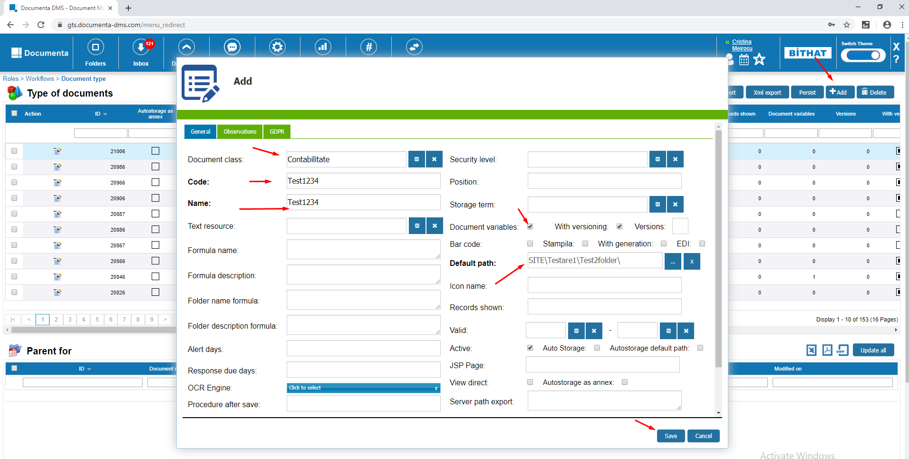

Edit

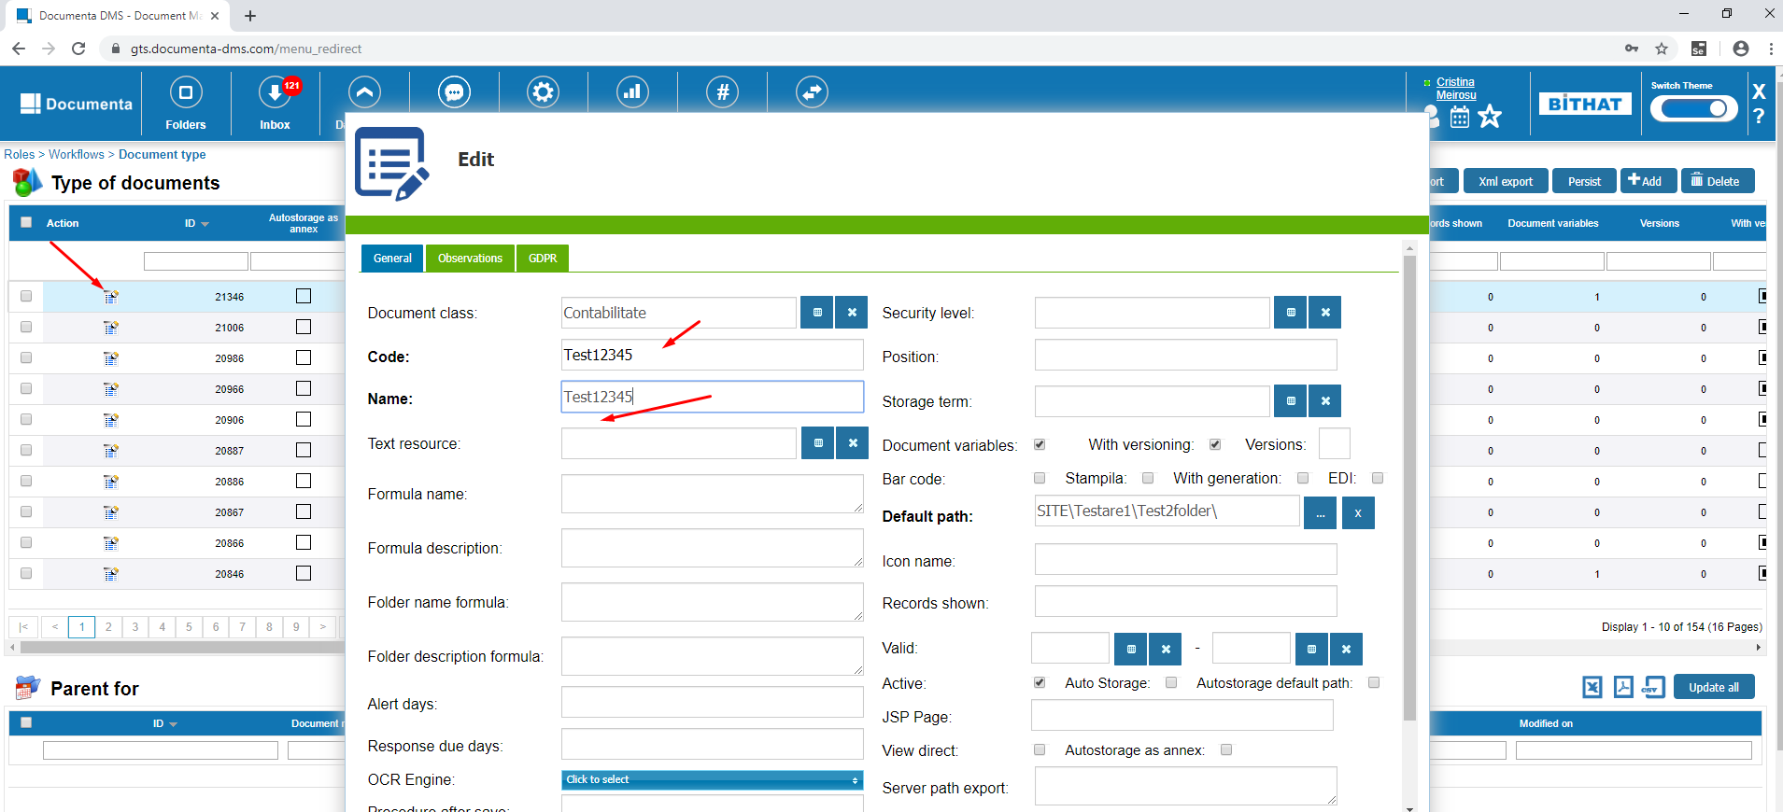

* Add attributes to the type of document we just created

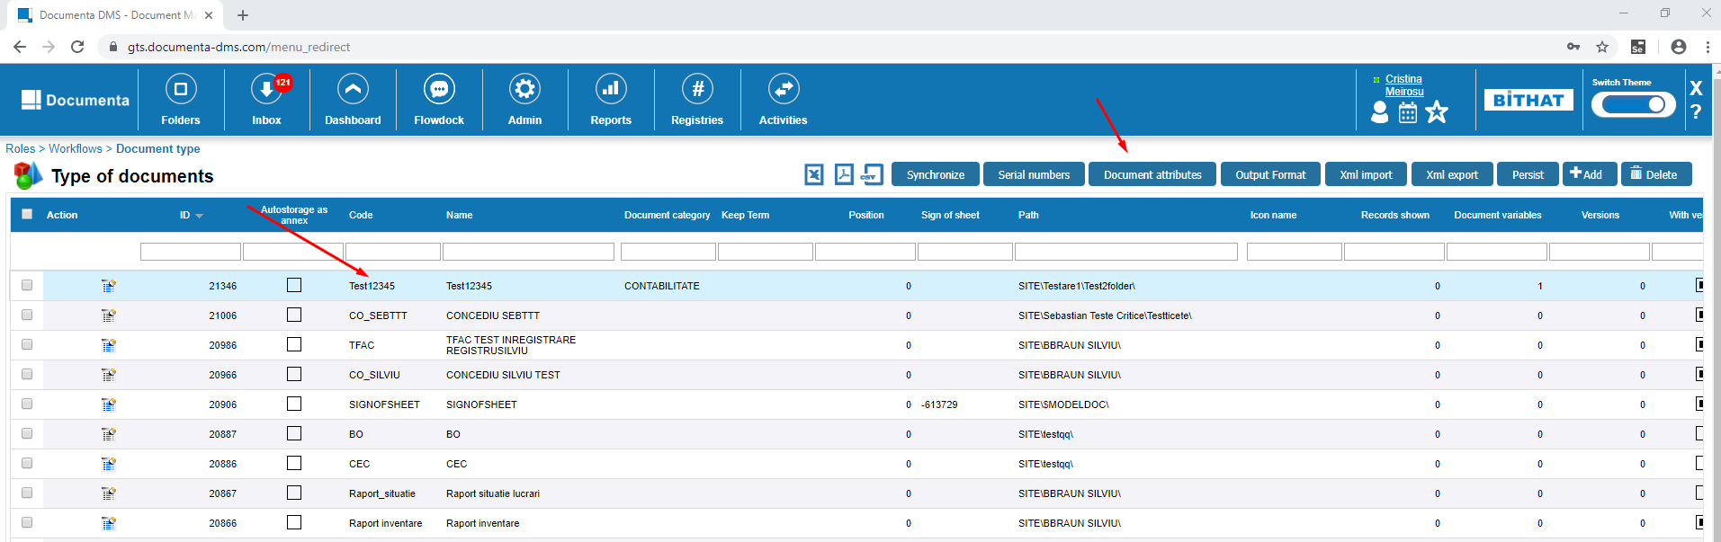

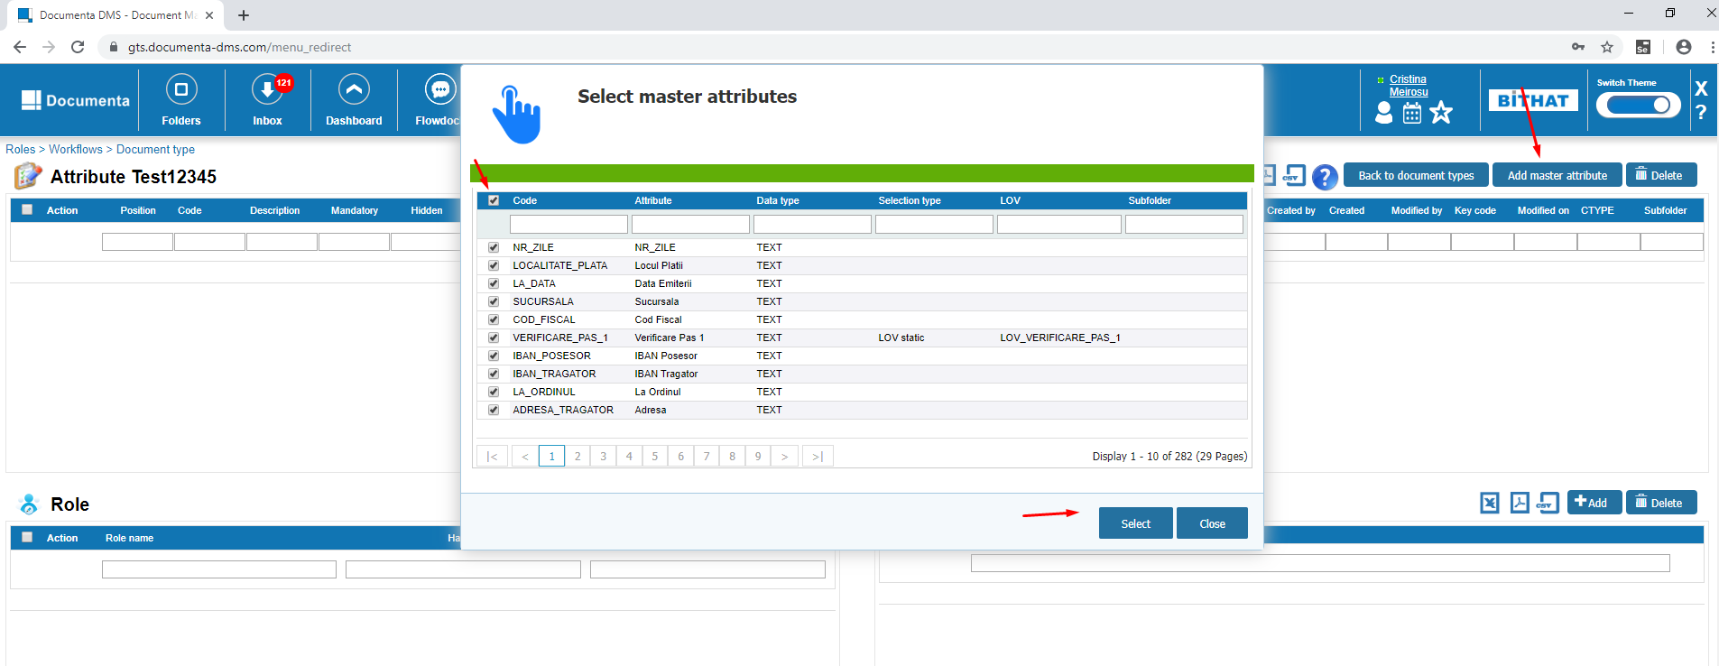

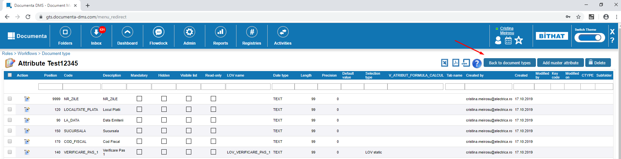

1. Click on Folders and Upload a new file in the $MODEL_DOC folder and setup the Document type we just created before ‘Test12345’

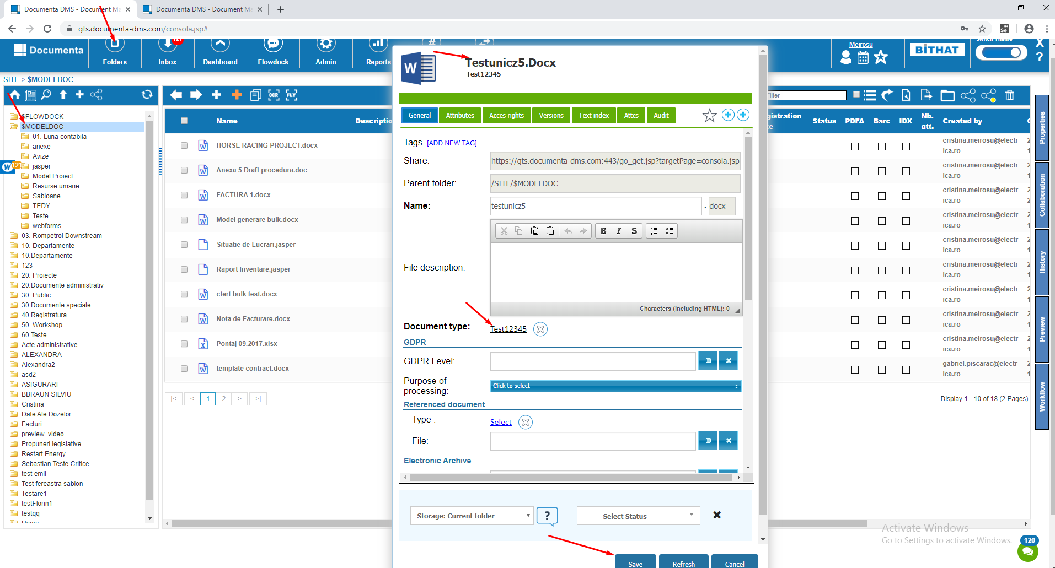

1. We go to the "Documents template" screen and make sure it has rights to all dms users

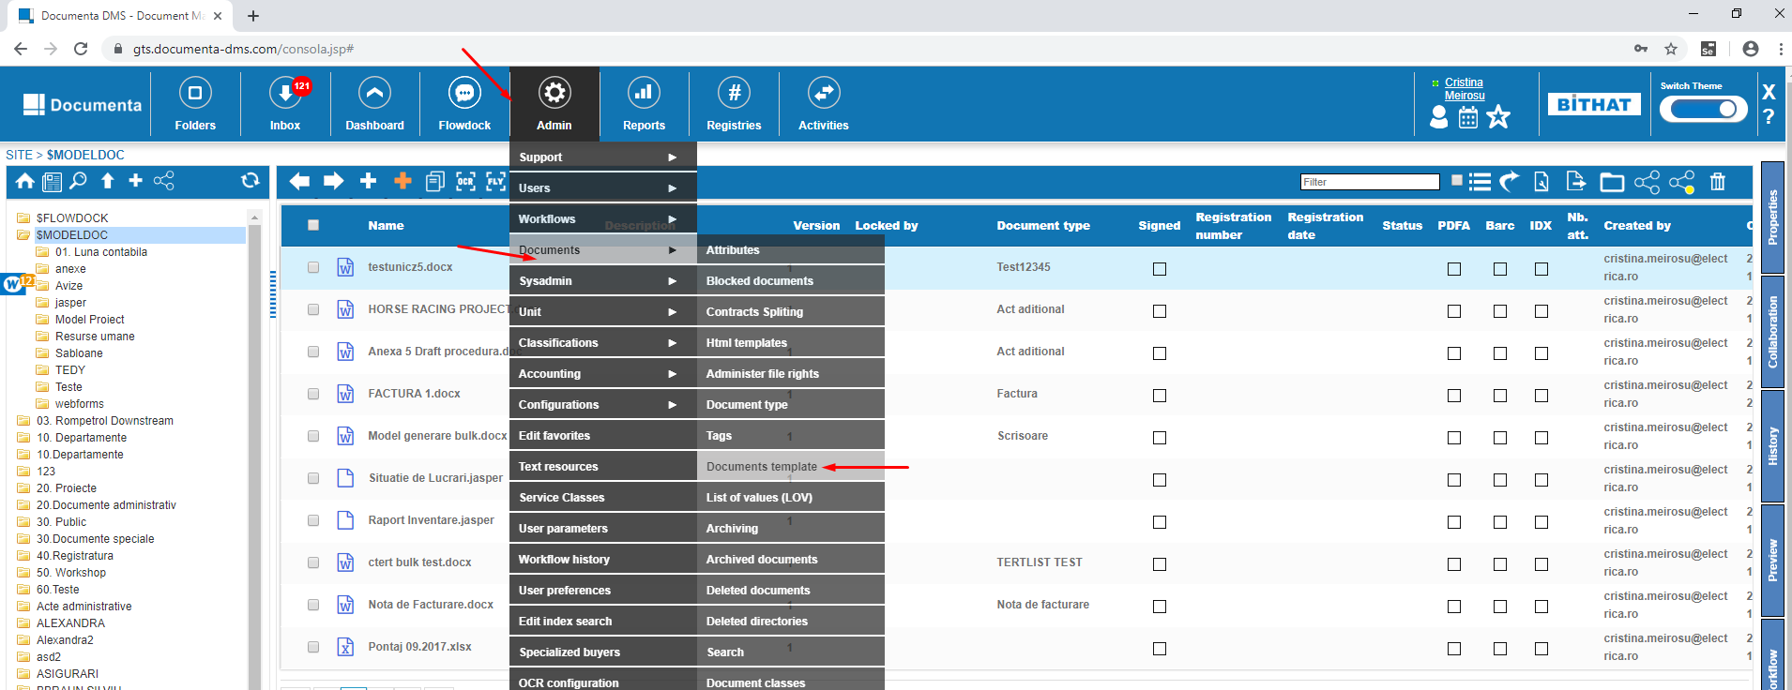

Search the file we just uploaded before

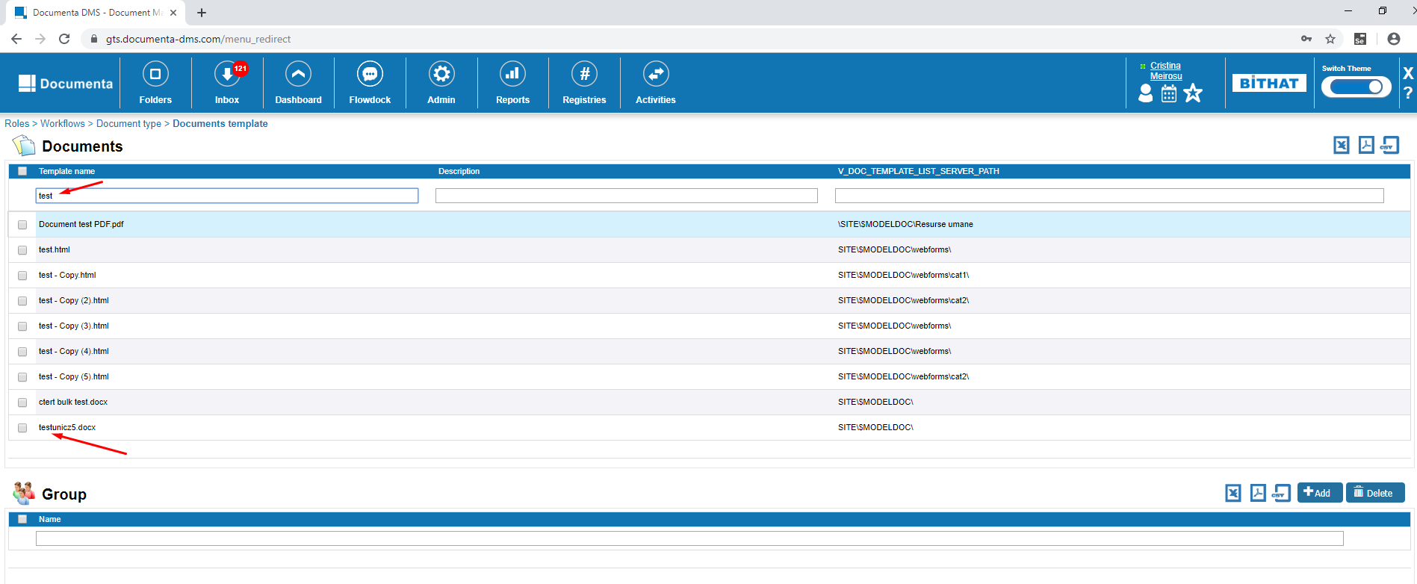

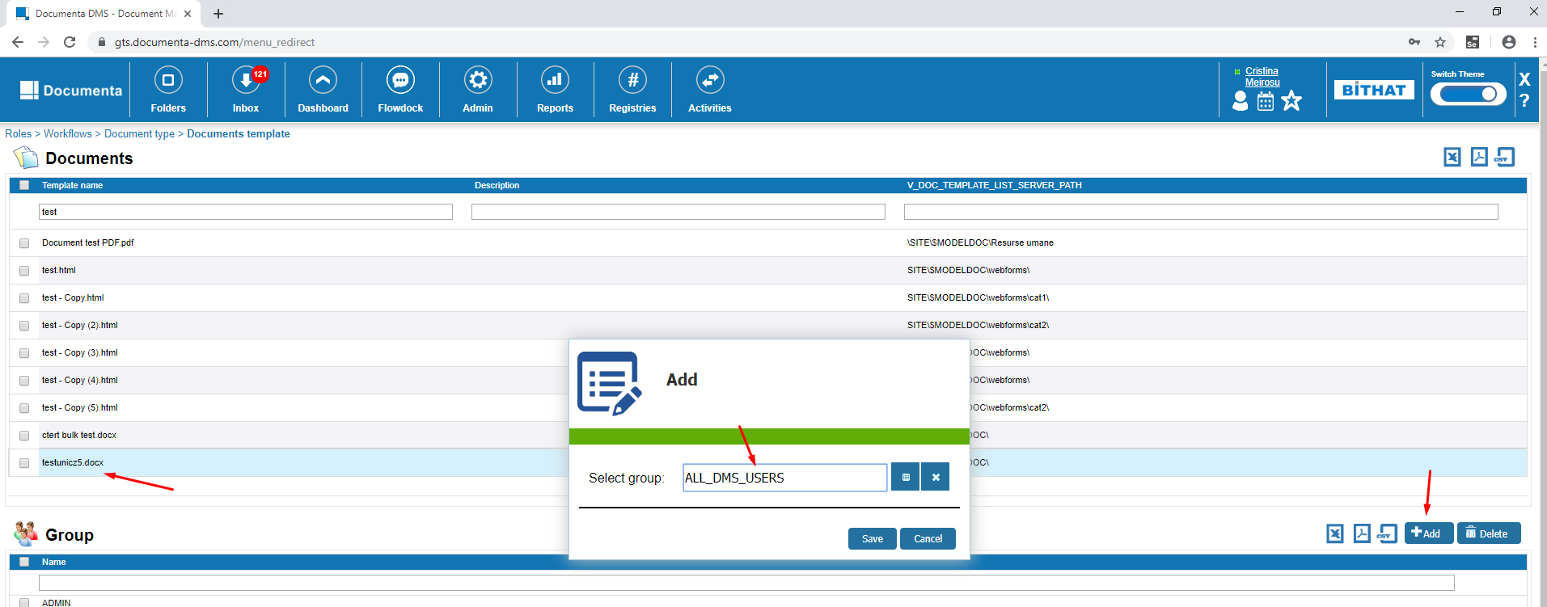

1. Click on folders, select any folder and click on New from template.

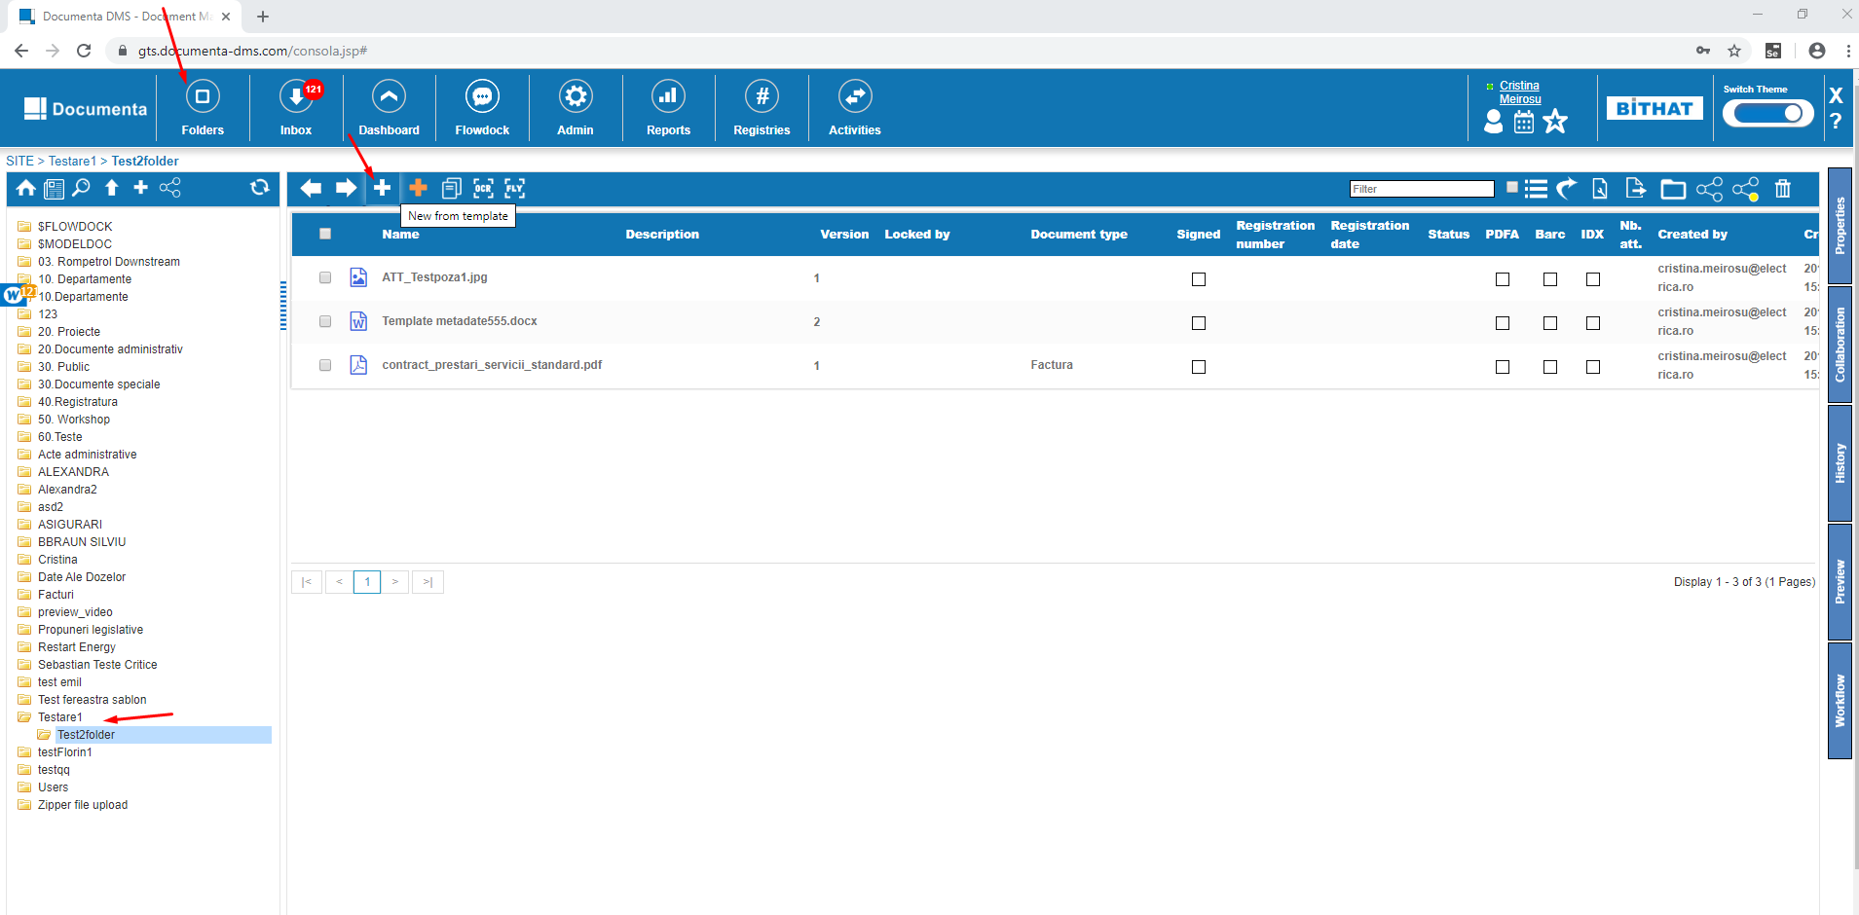

Search for the template we uploaded in the $MODELDOC folder, select it and click Next and Save.

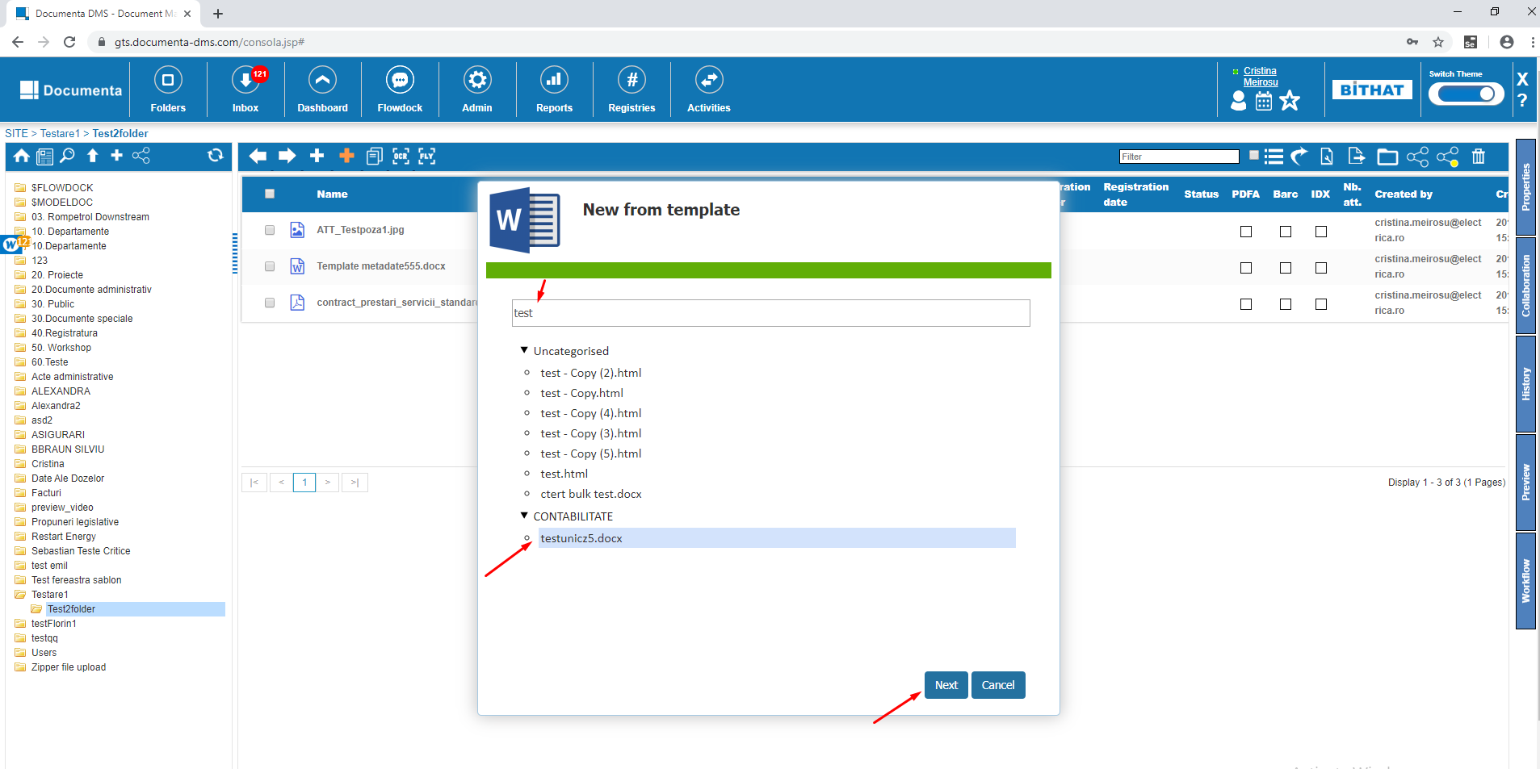

Open Preview from Side Panel

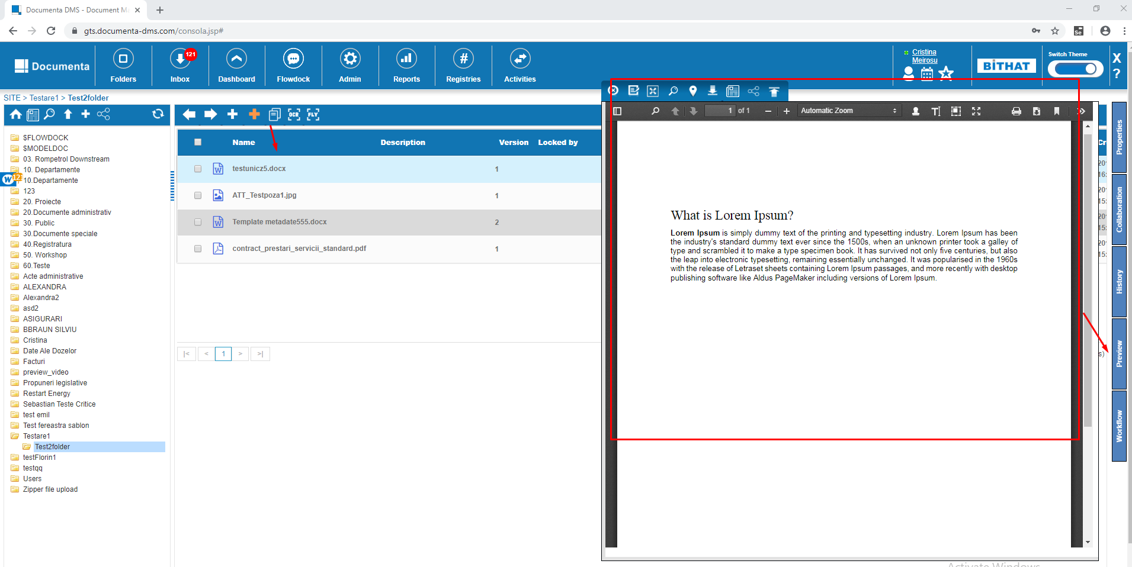

### 

### Advanced search

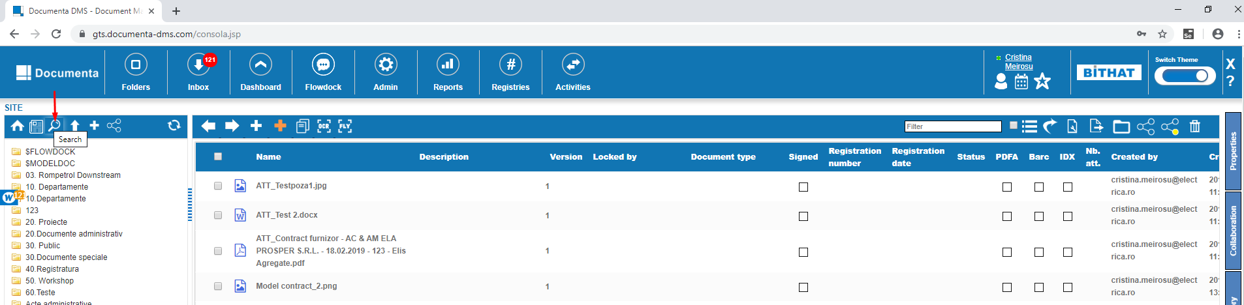

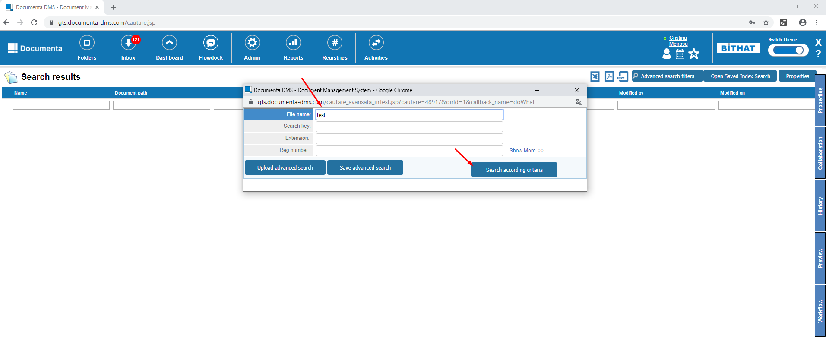

Select a file and click Properties

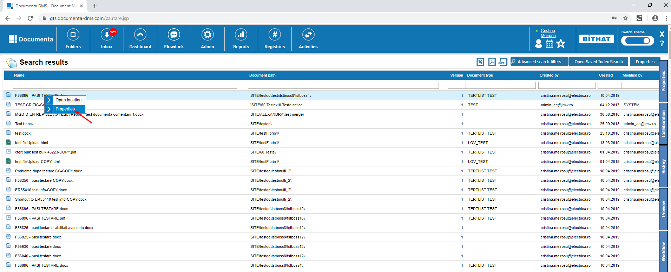

### File – properties – click on all the tabs from Consola, Inbox, Dashboard, Advanced Search like in the screenshot bellow:

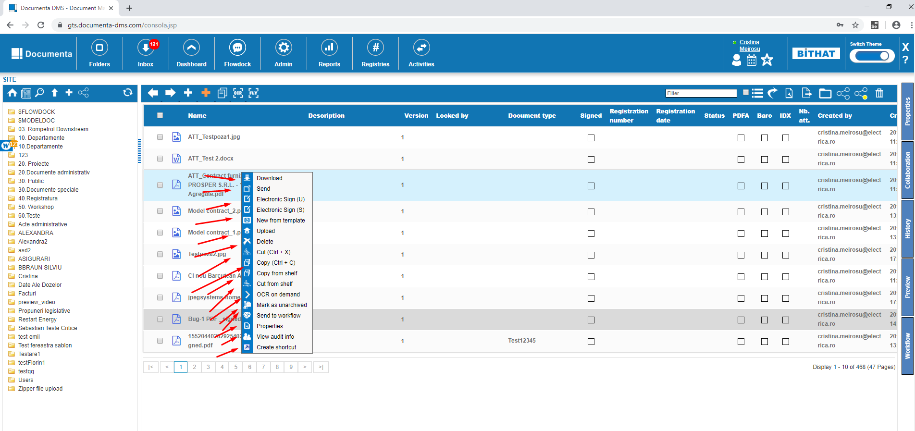

### Side panel - click on all tabs in Console, Inbox, Dashboard, Advanced Search, Reports

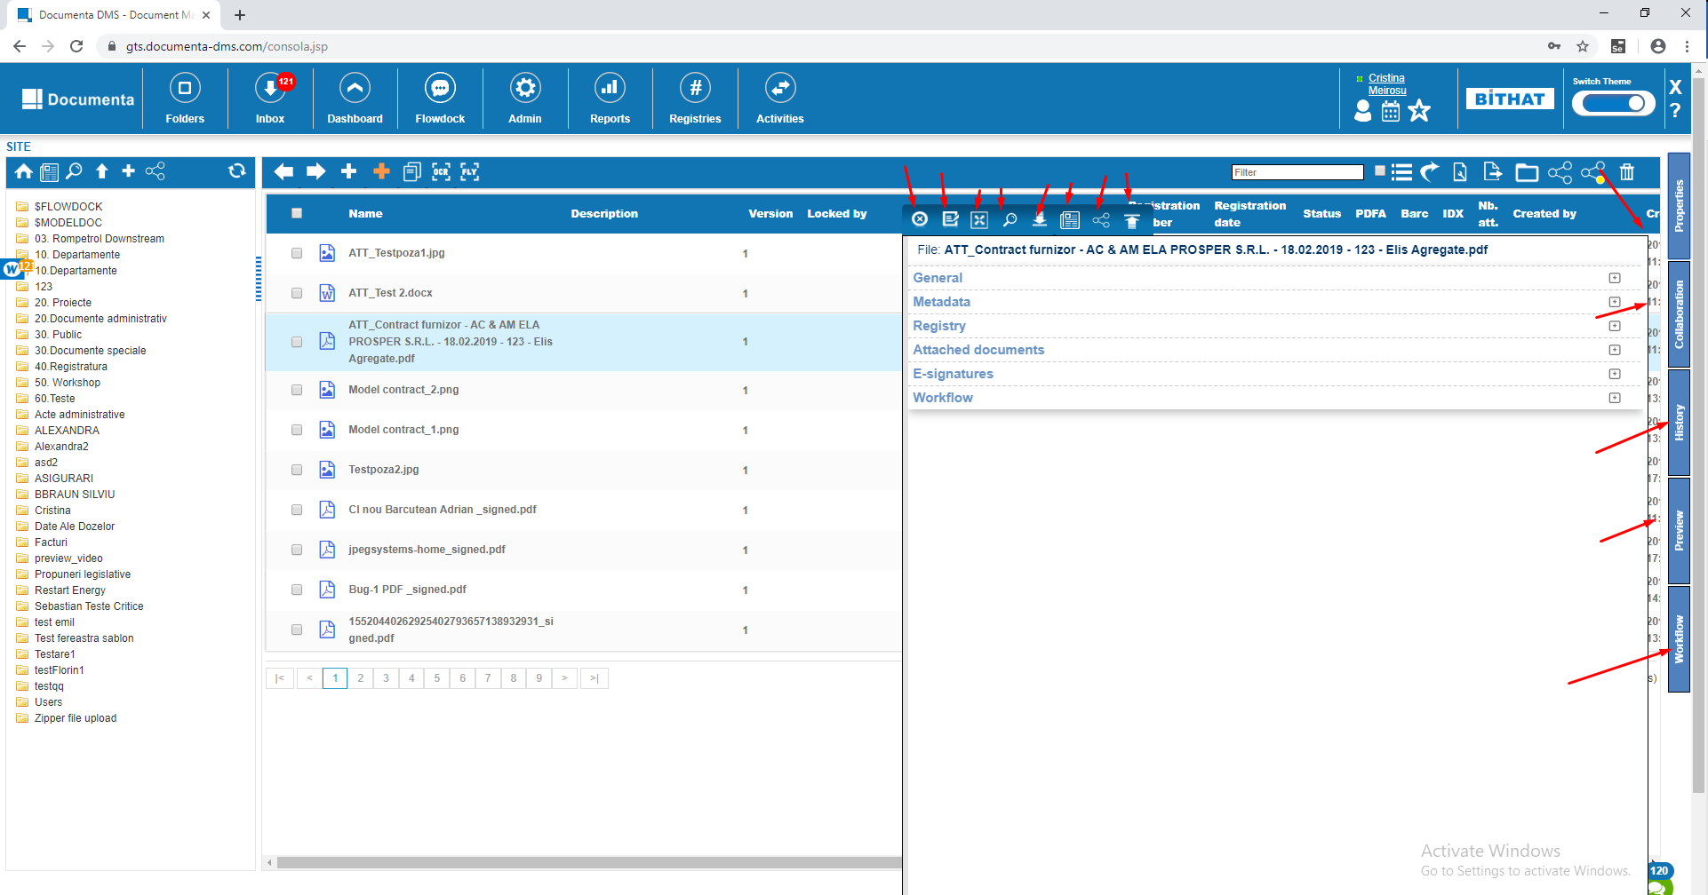

### 

## Administration

### 2.1 Users creation / Edit

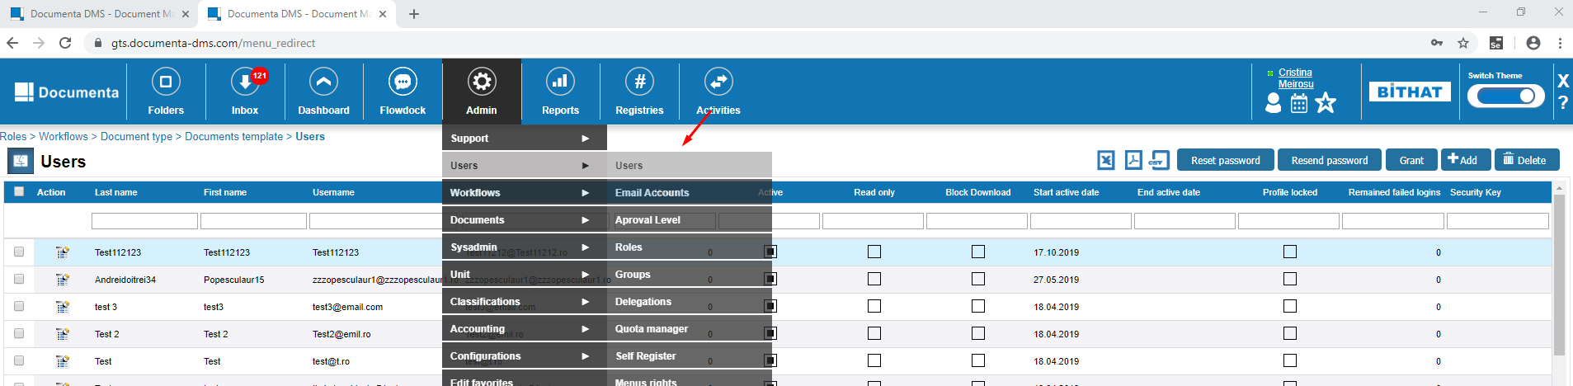

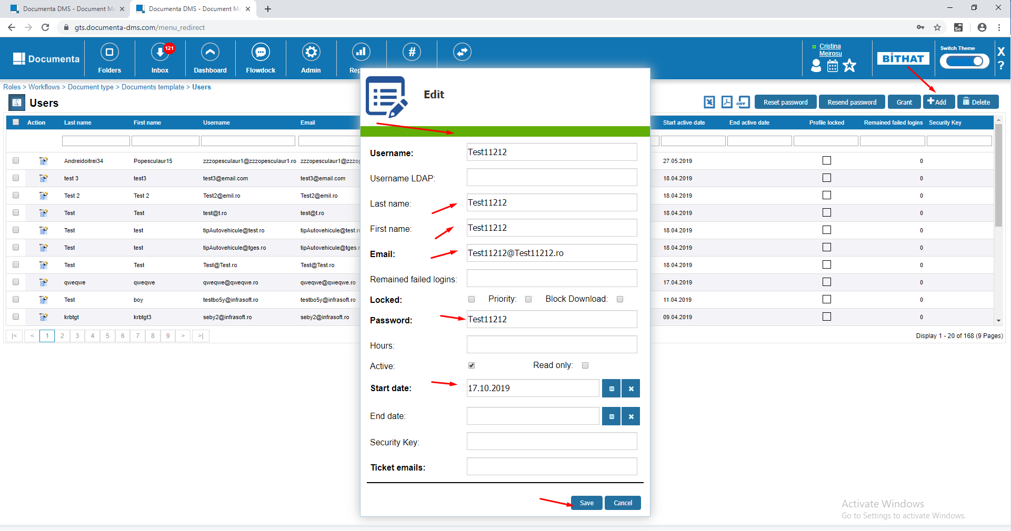

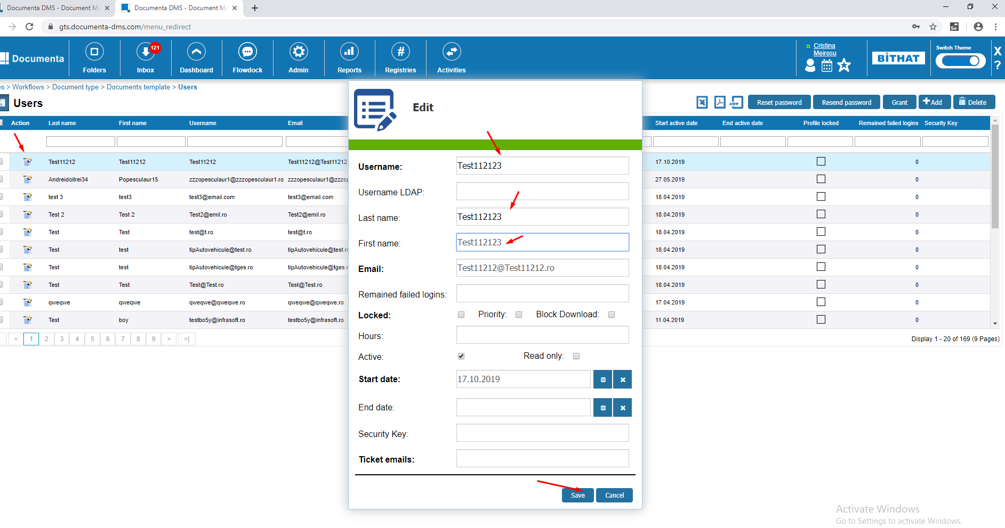

### 3.2 Users / Organization Chart / Create / Edit / save user & department

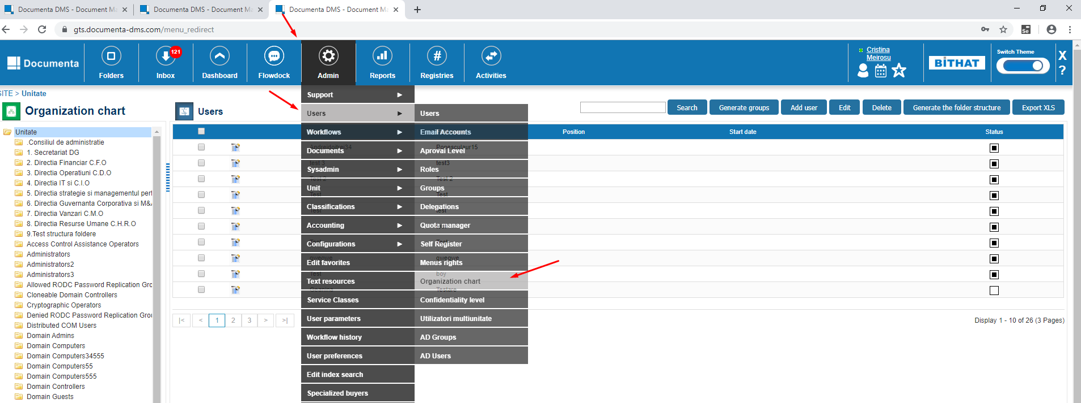

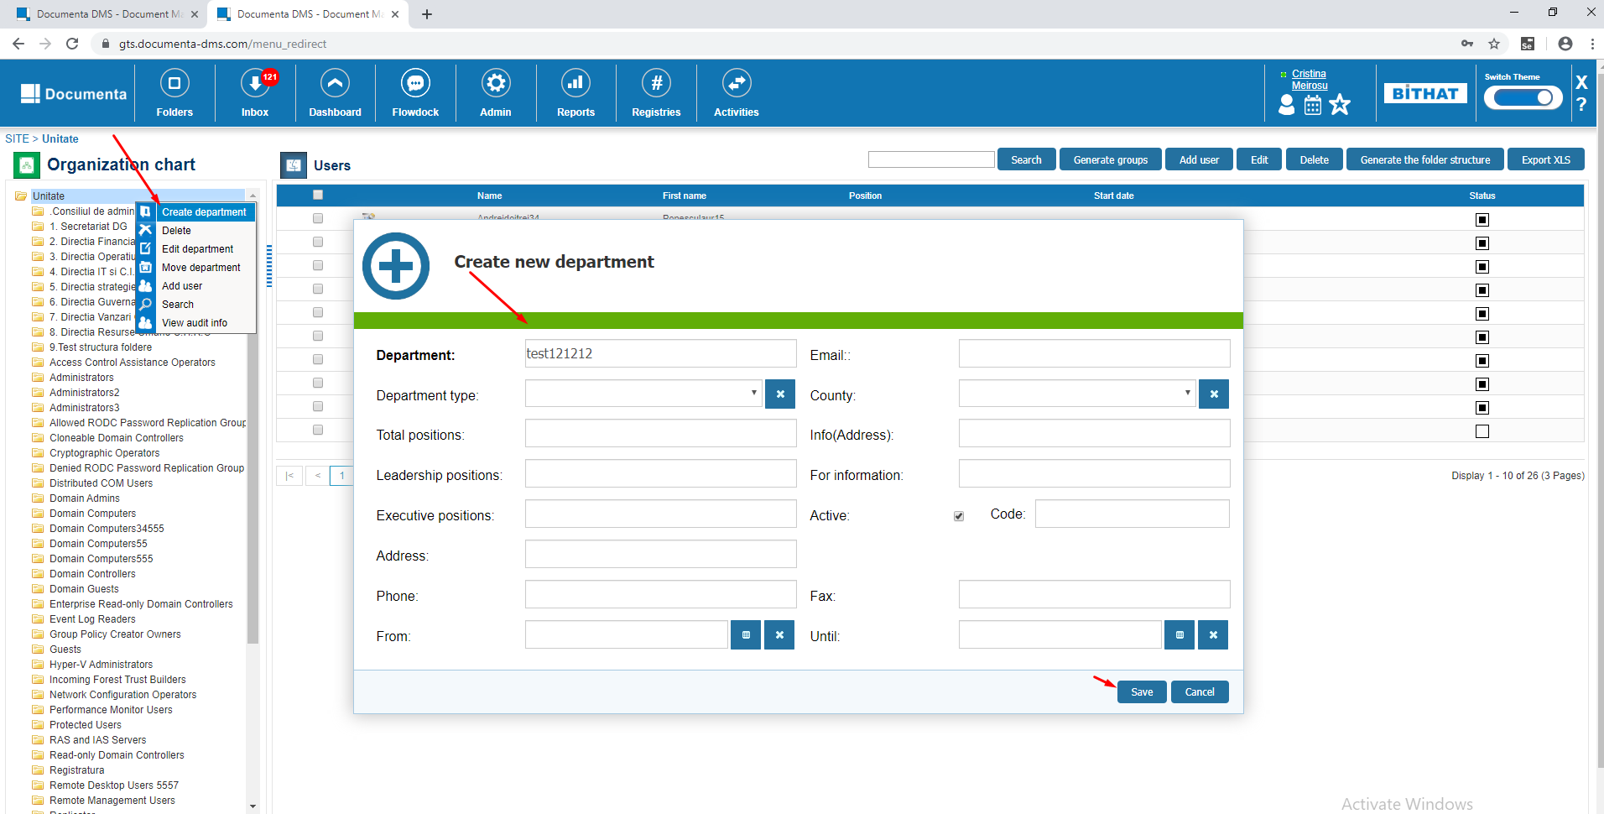

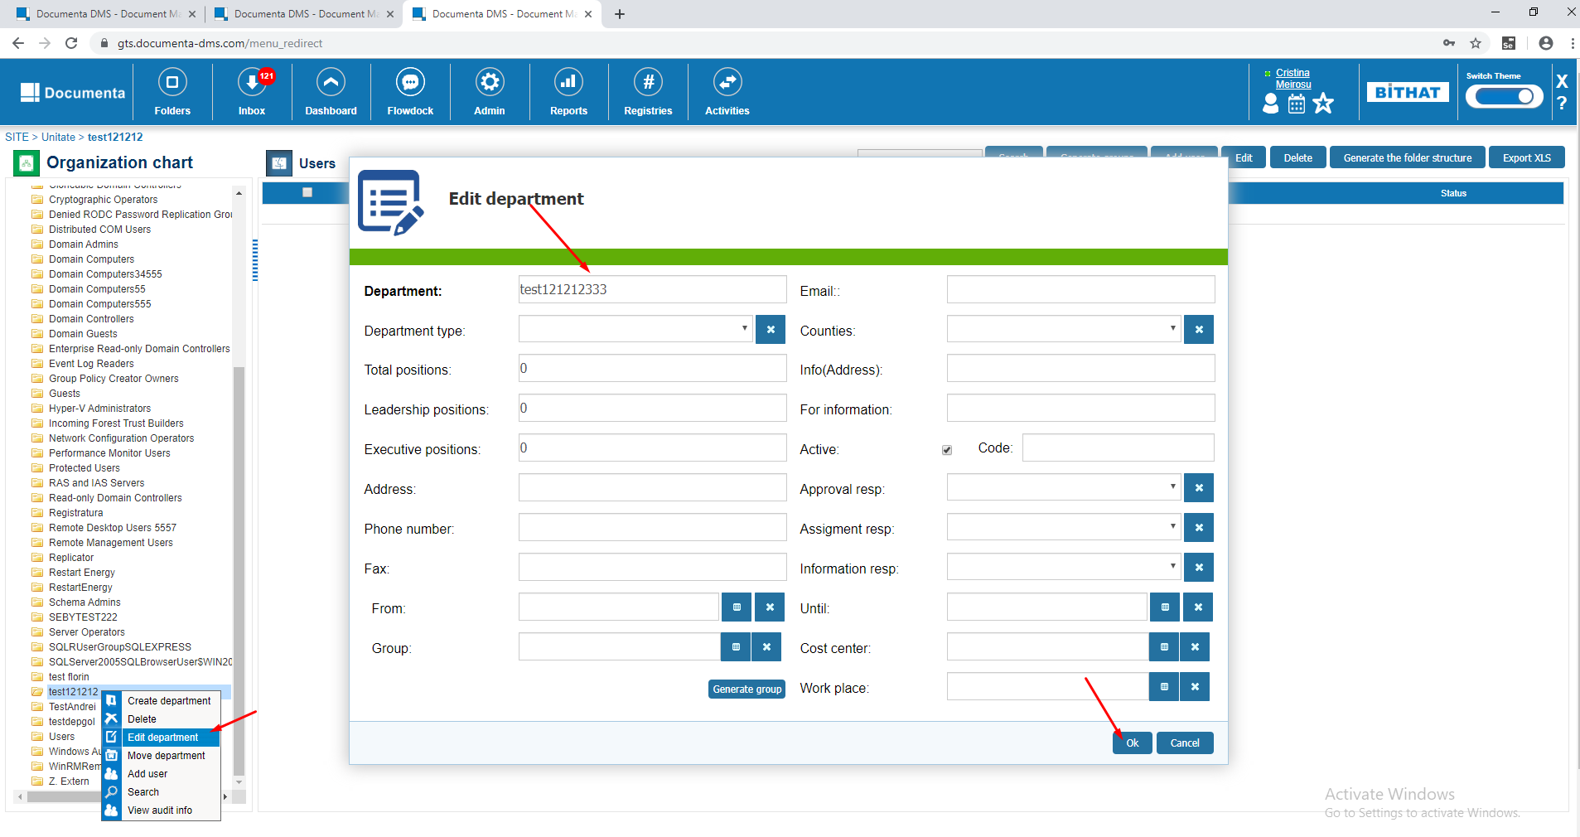

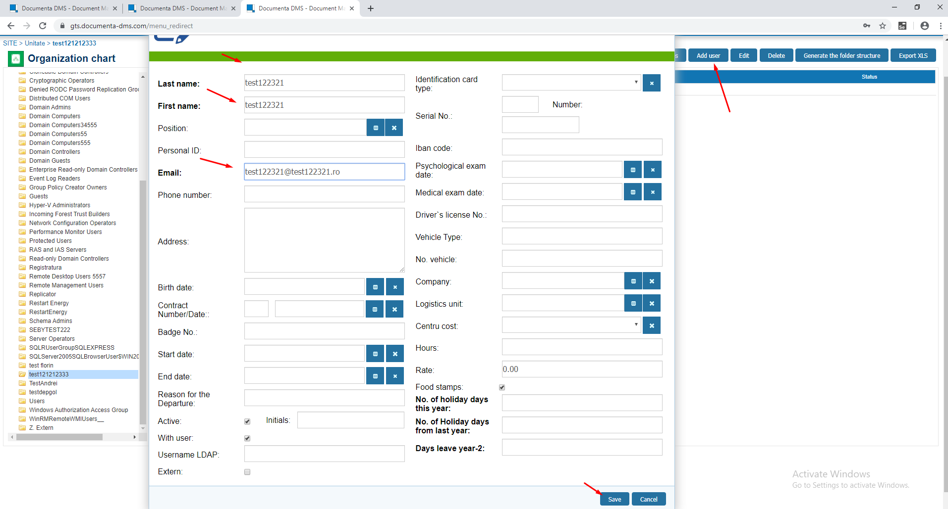

Edit on a person:

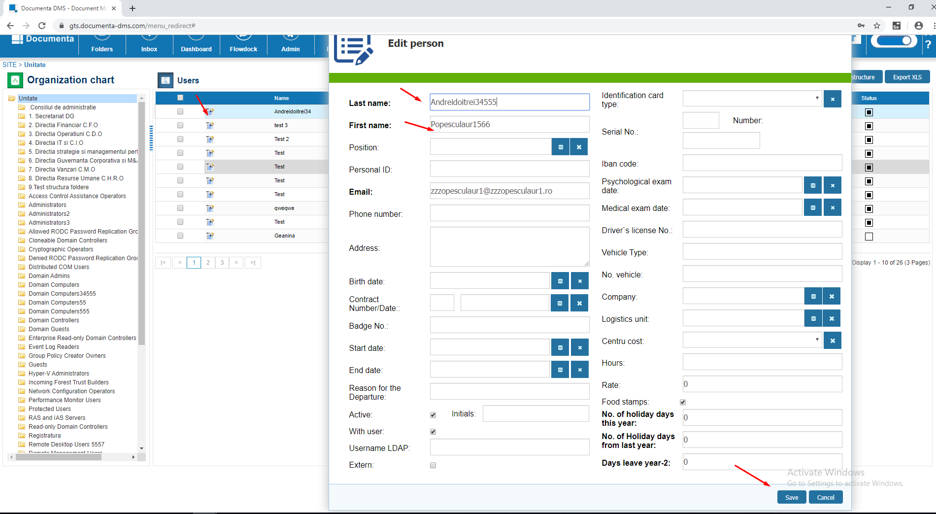

Delete a person. To delete a person you must make it inactive first.

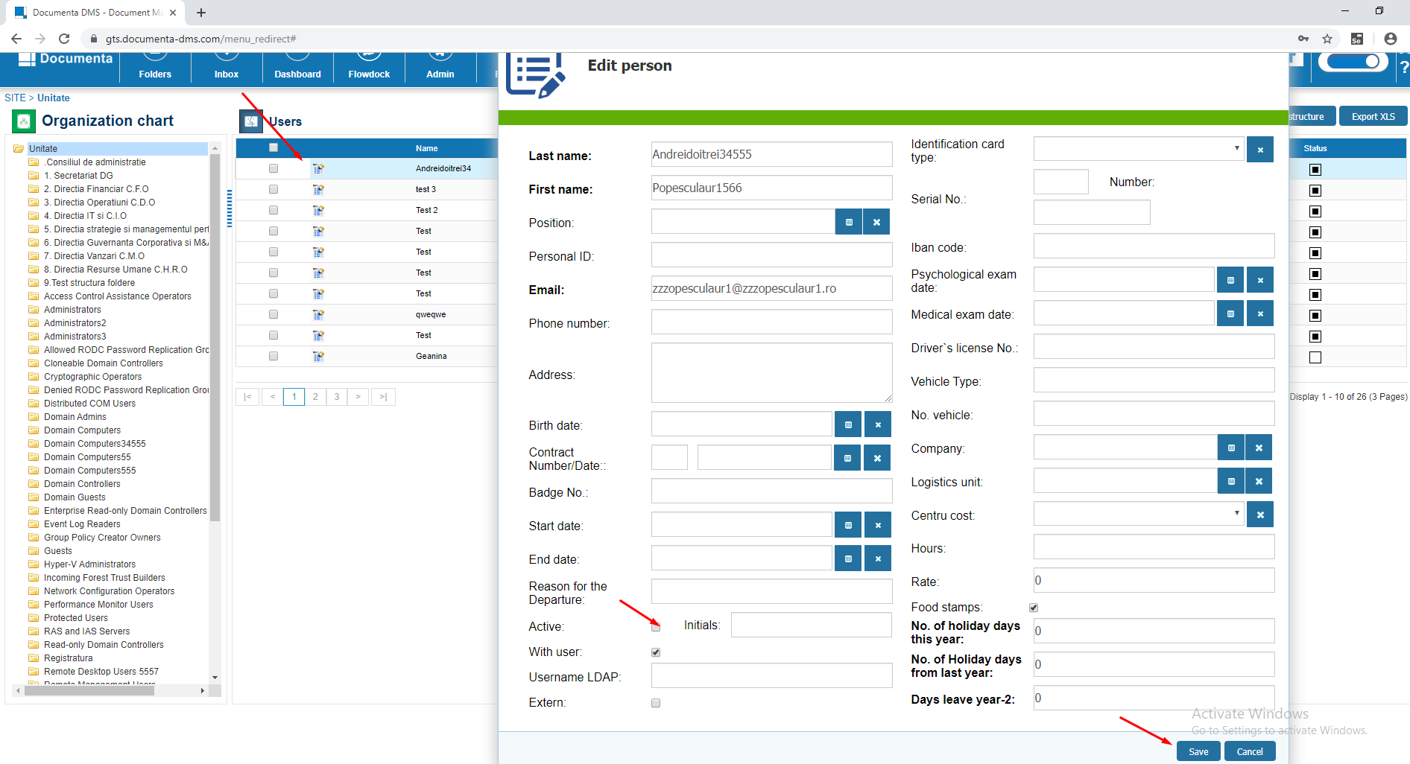

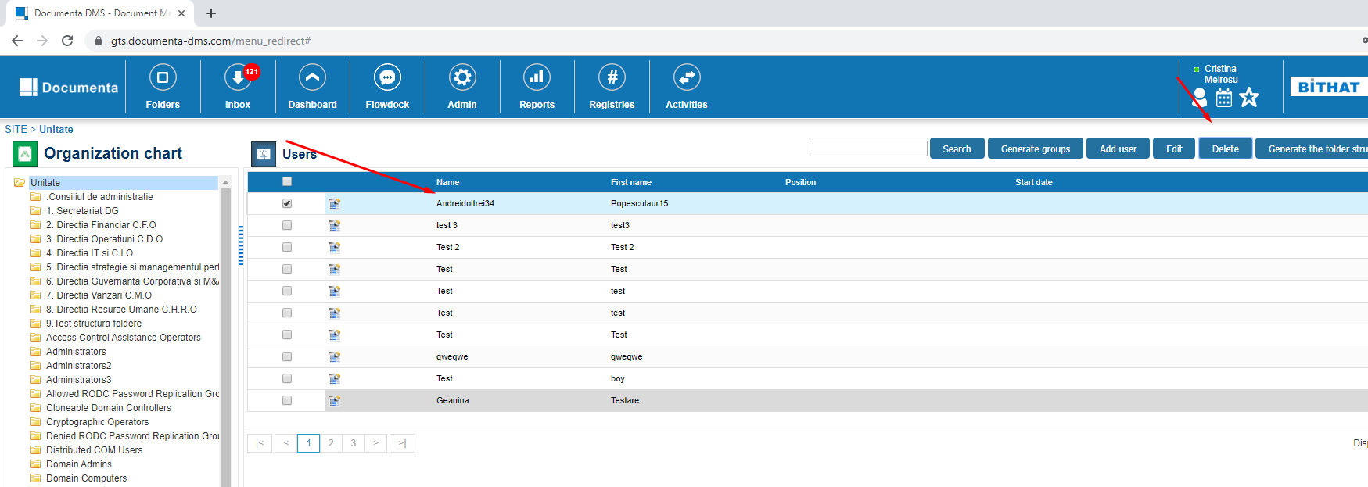

Delete a departament

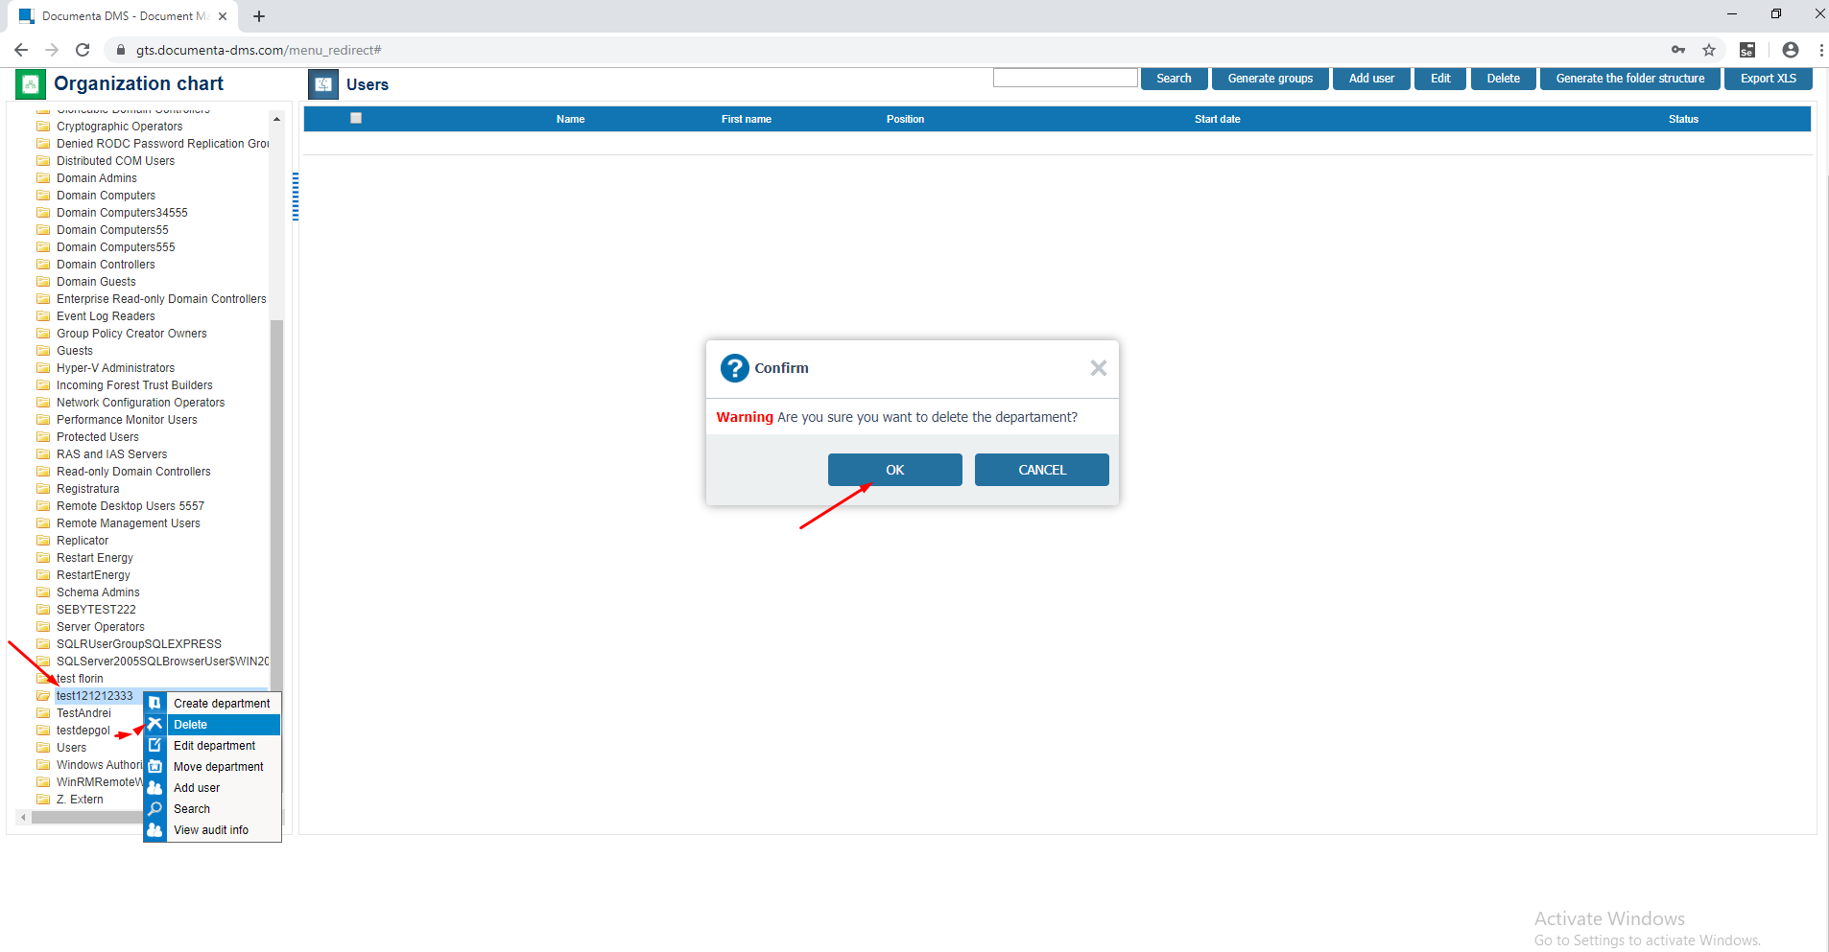

### 3.3 Documents > Attributes - Create / Edit / Save

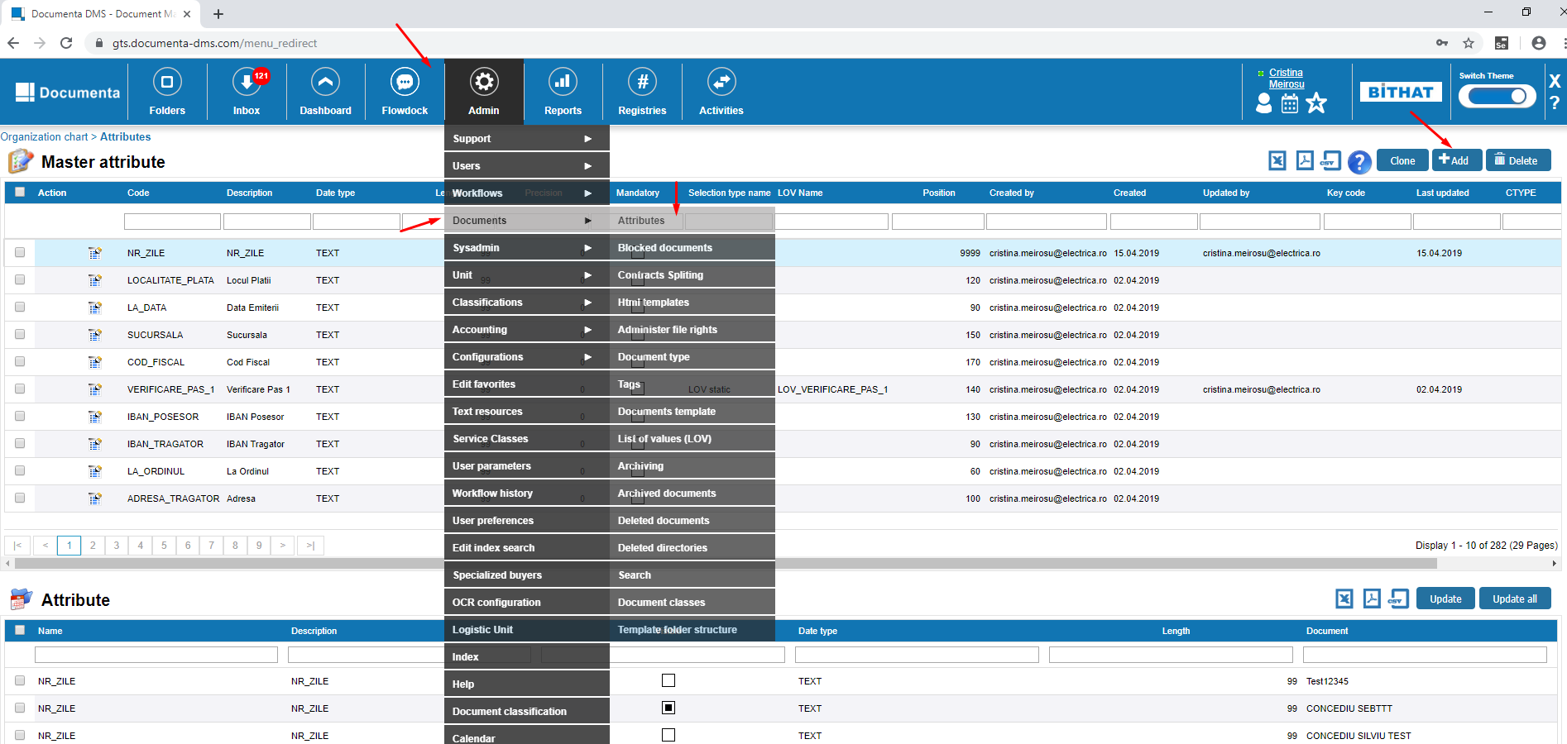

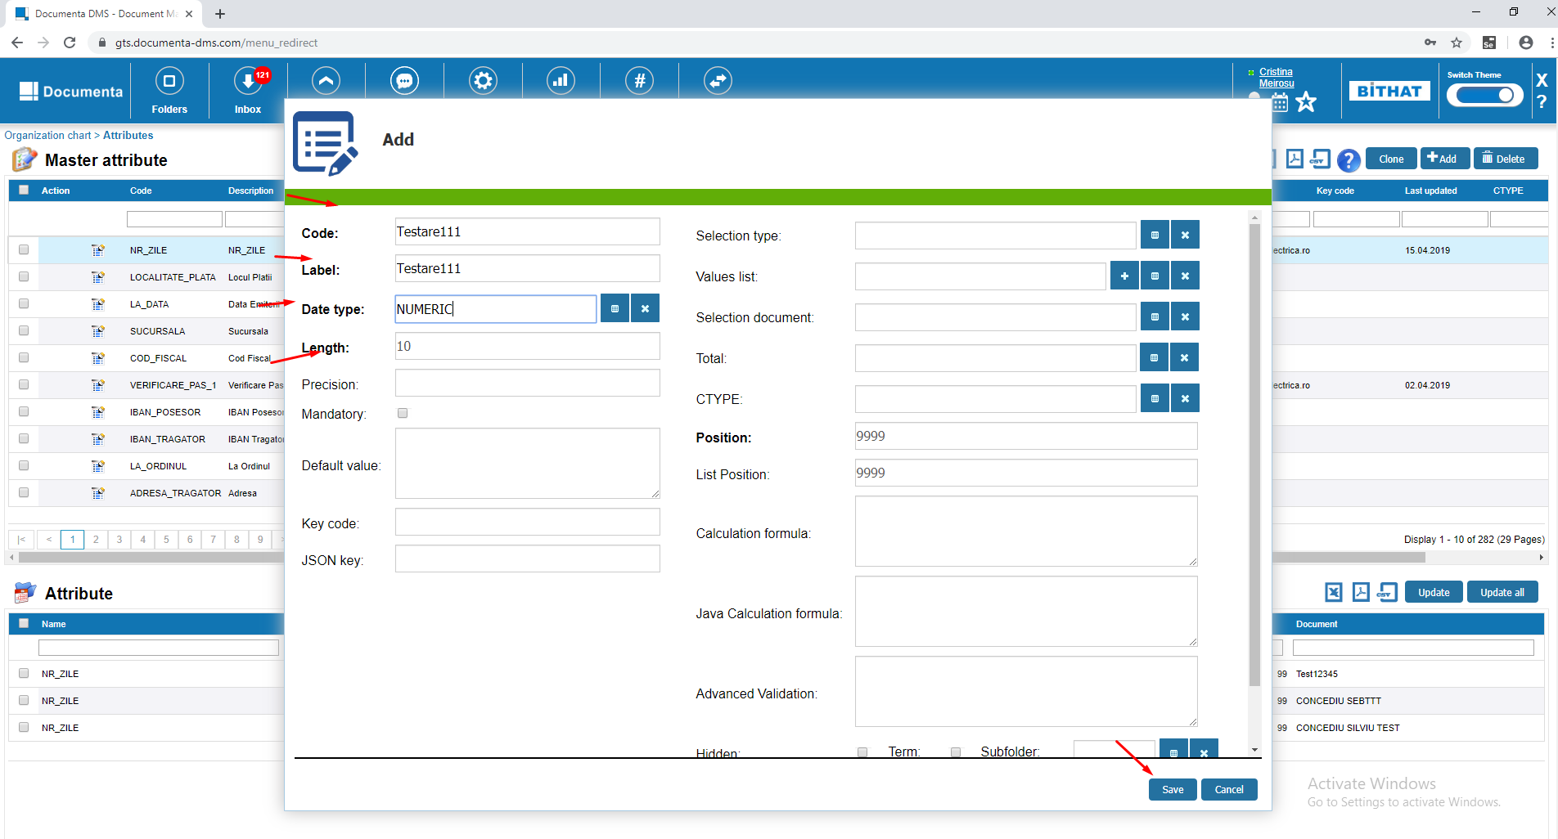

Edit:

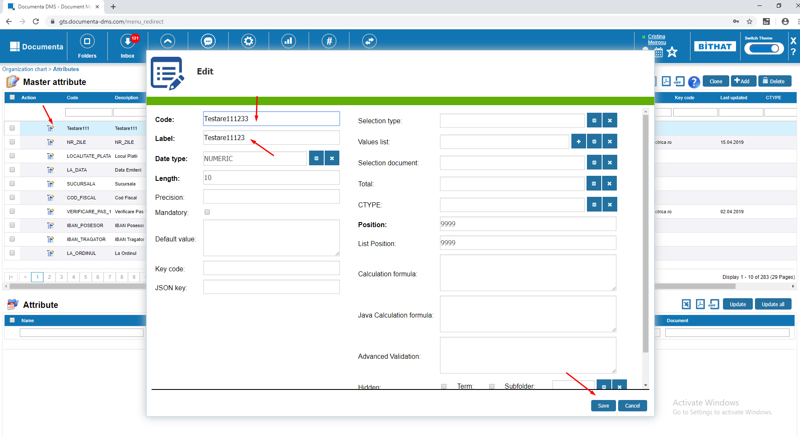

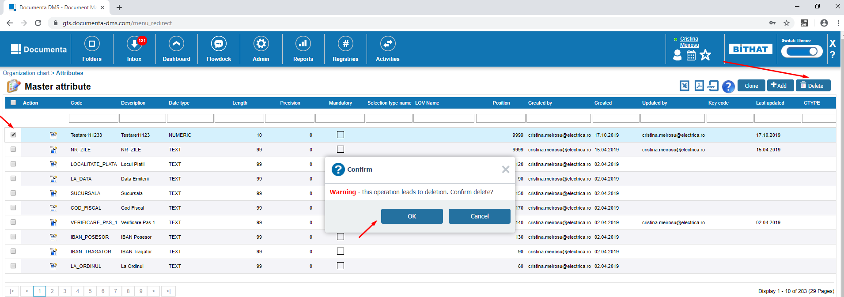

### 3.4 Admin > Unit > Partners Add/ Edit / Save

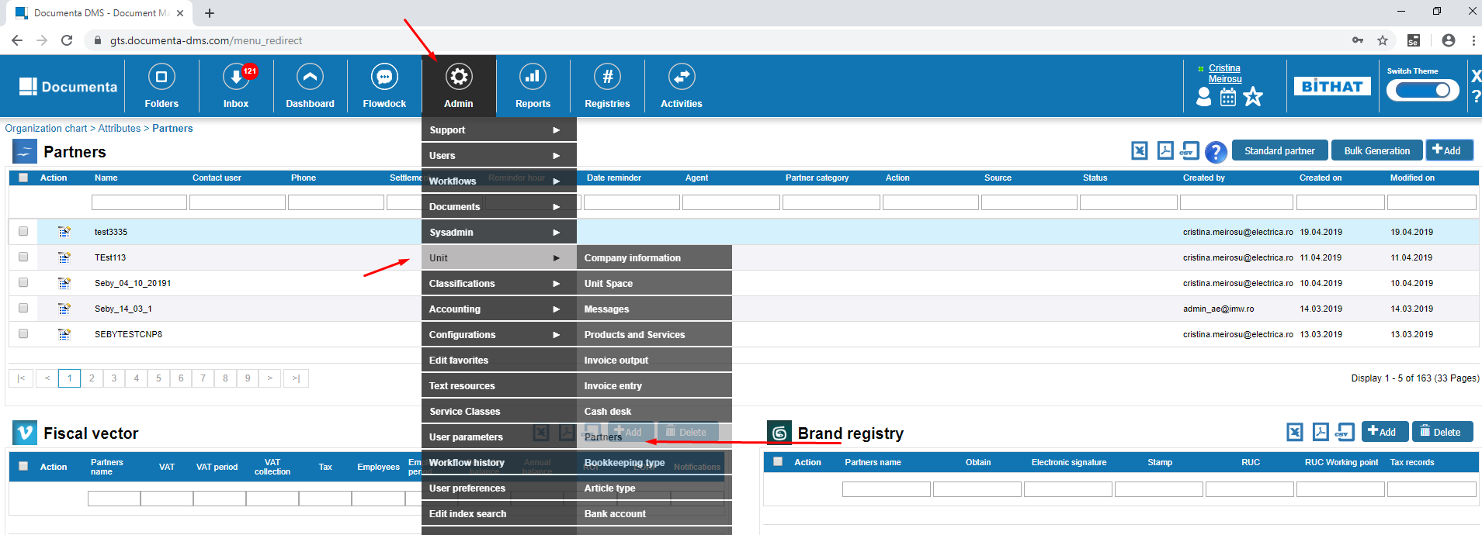

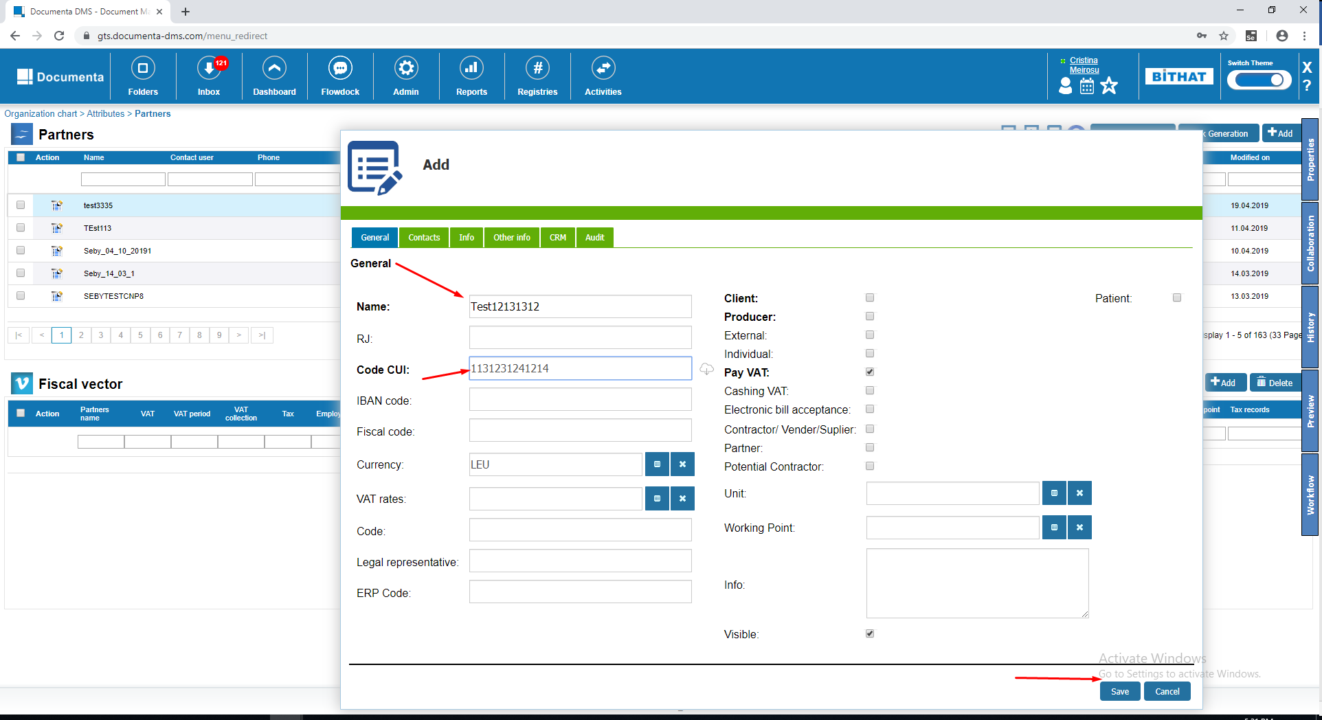

Edit:

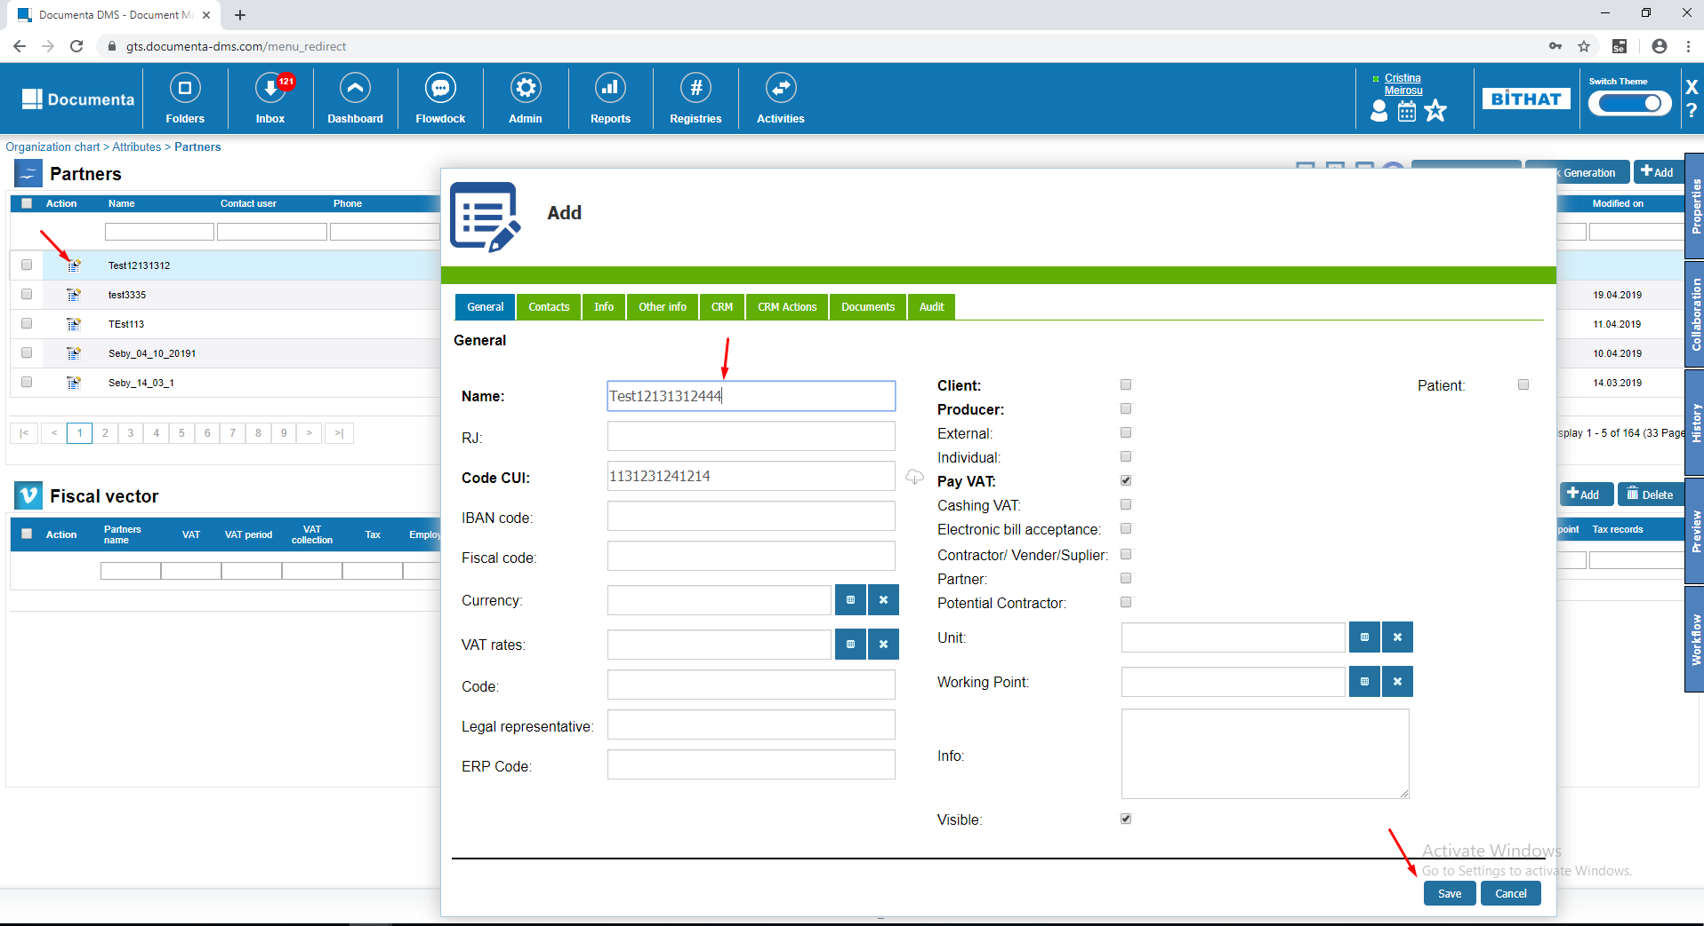

### 

## 4. Reports

### 4.1 Define a Report and Edit / Save columns

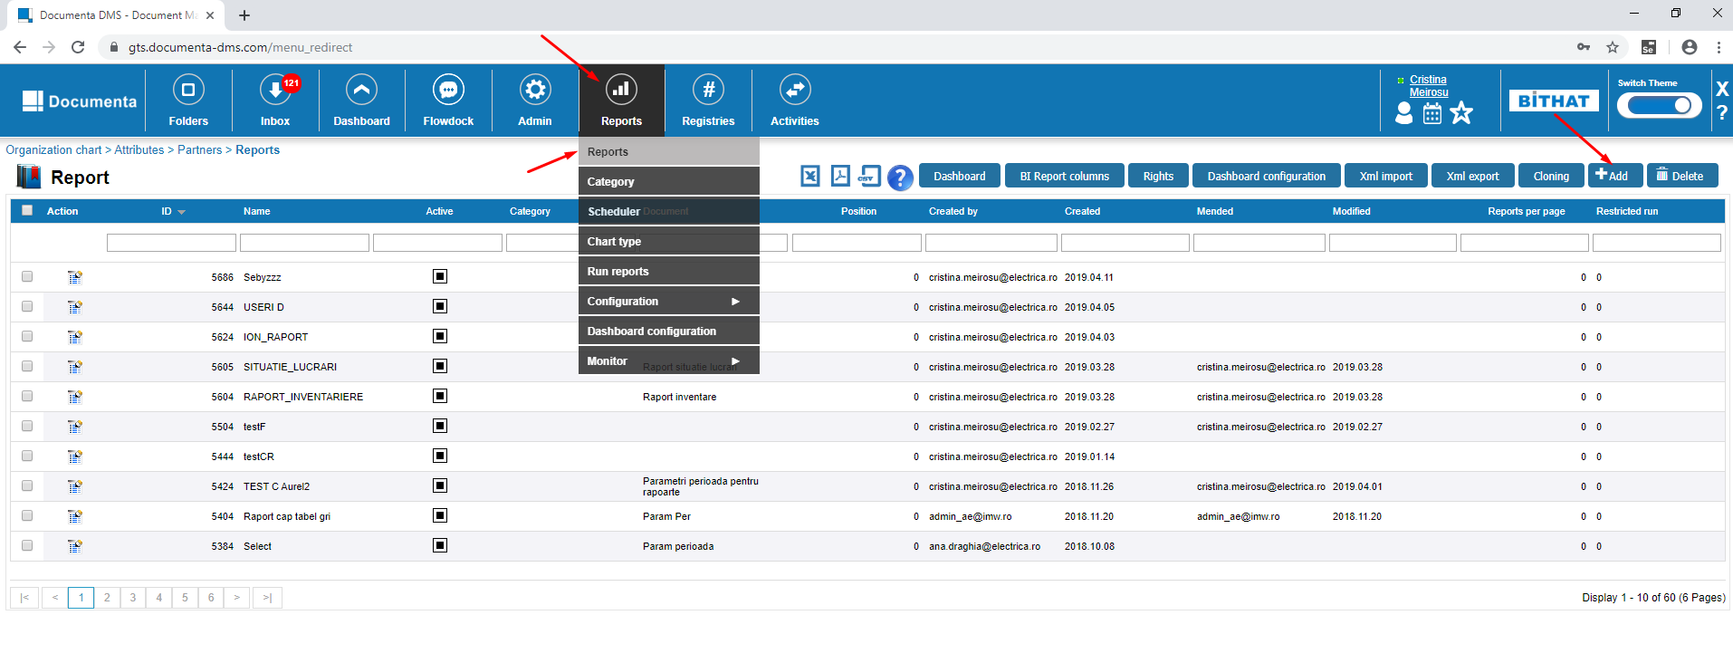

Complete the fields like in the screenshot bellow

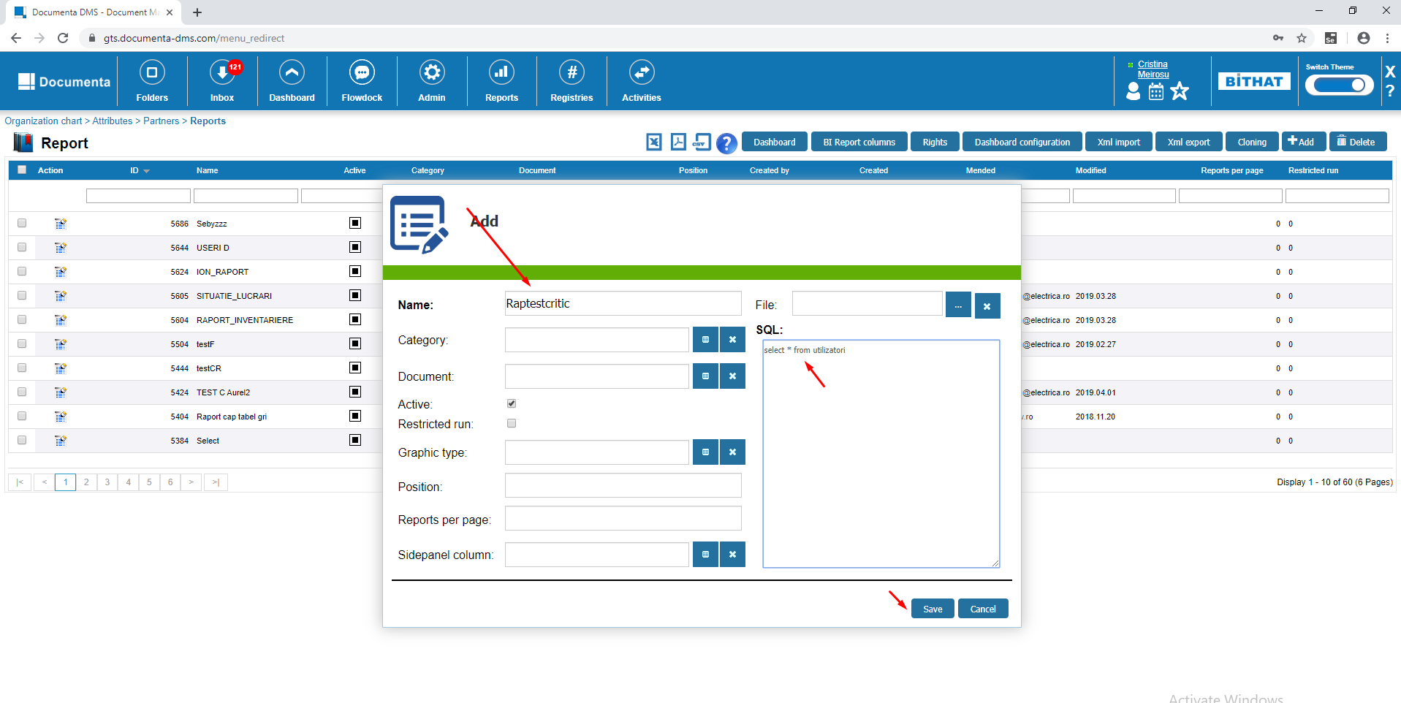

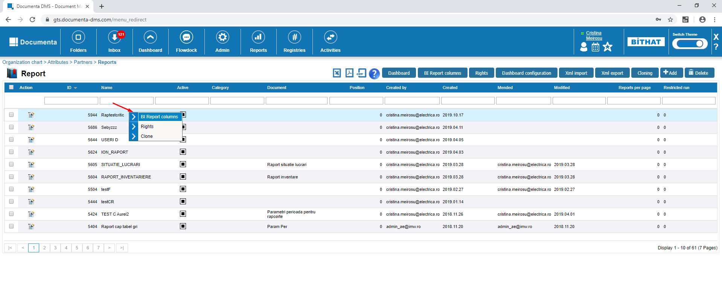

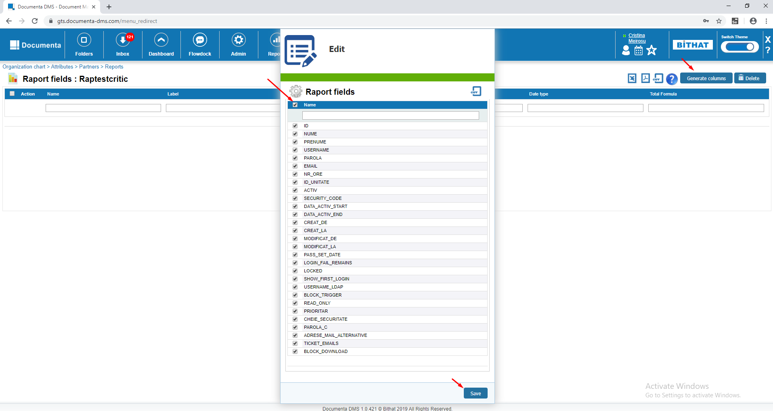

Go again in the Reports menu select the report that you just created and click on Rights.

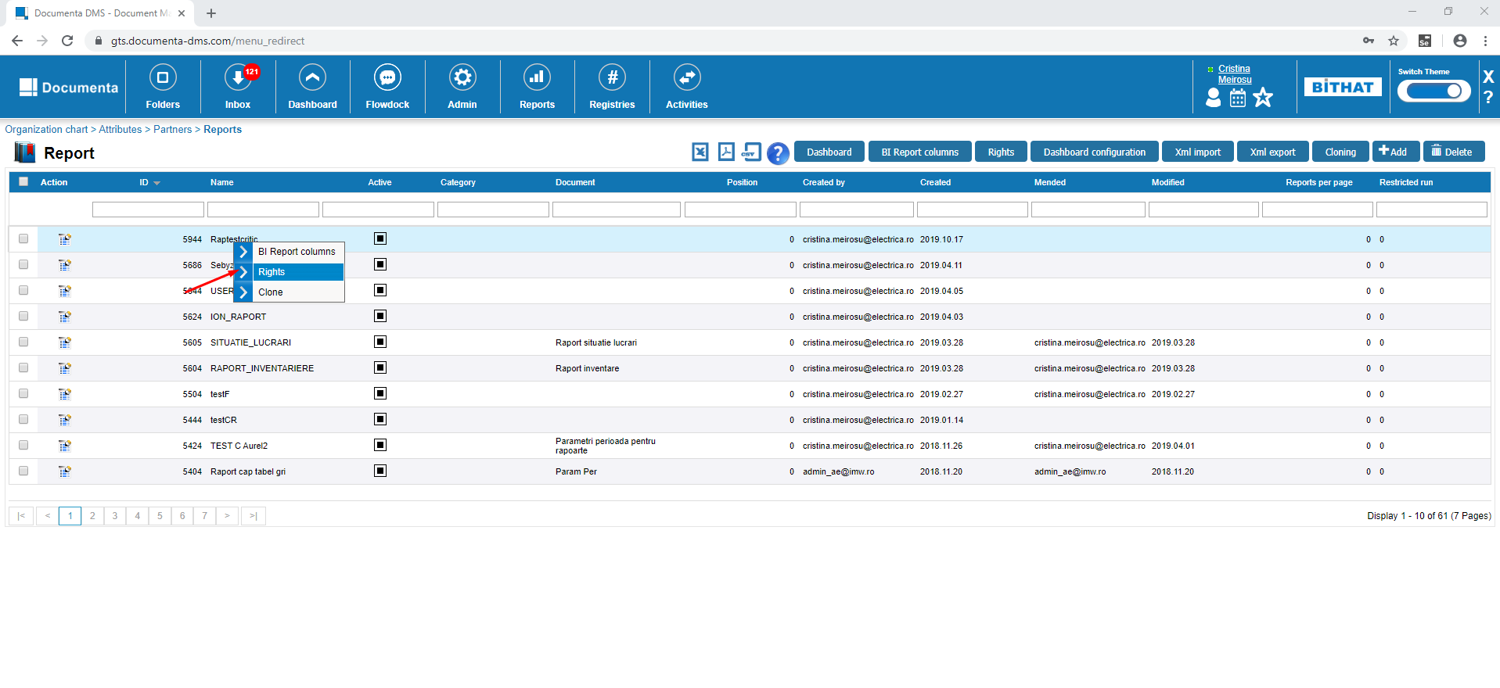

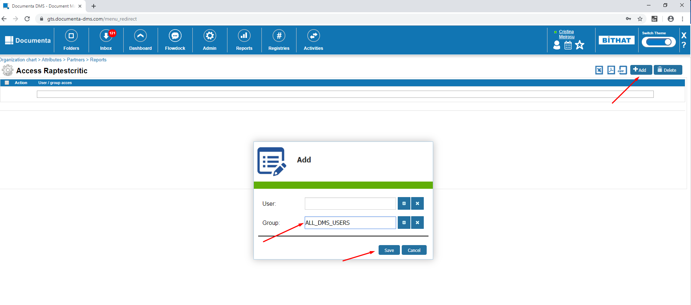

### 4.2. Run reports

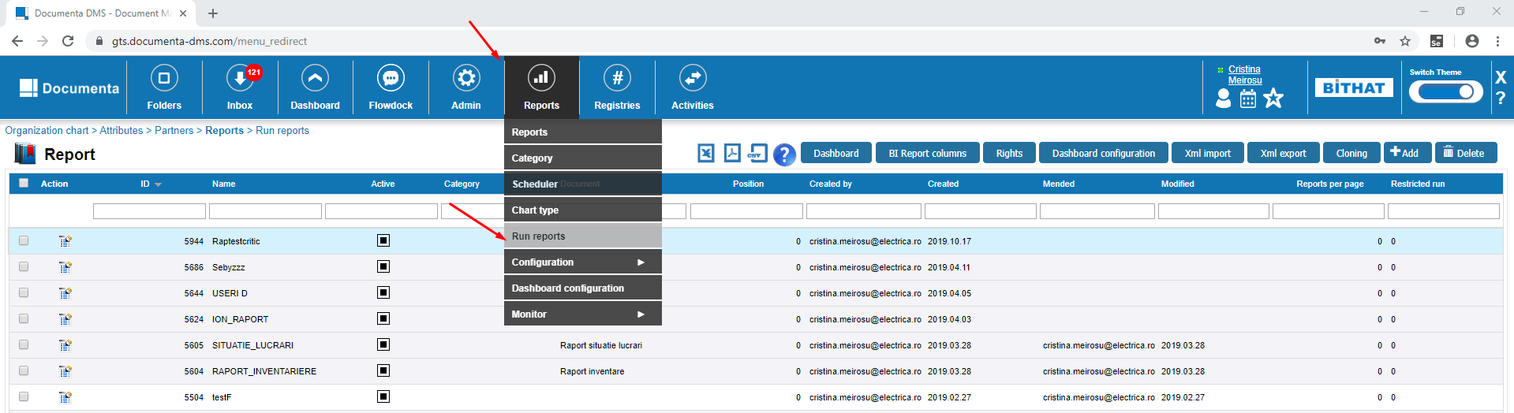

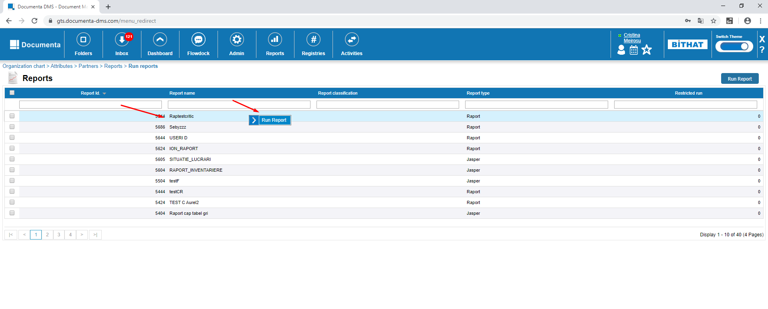

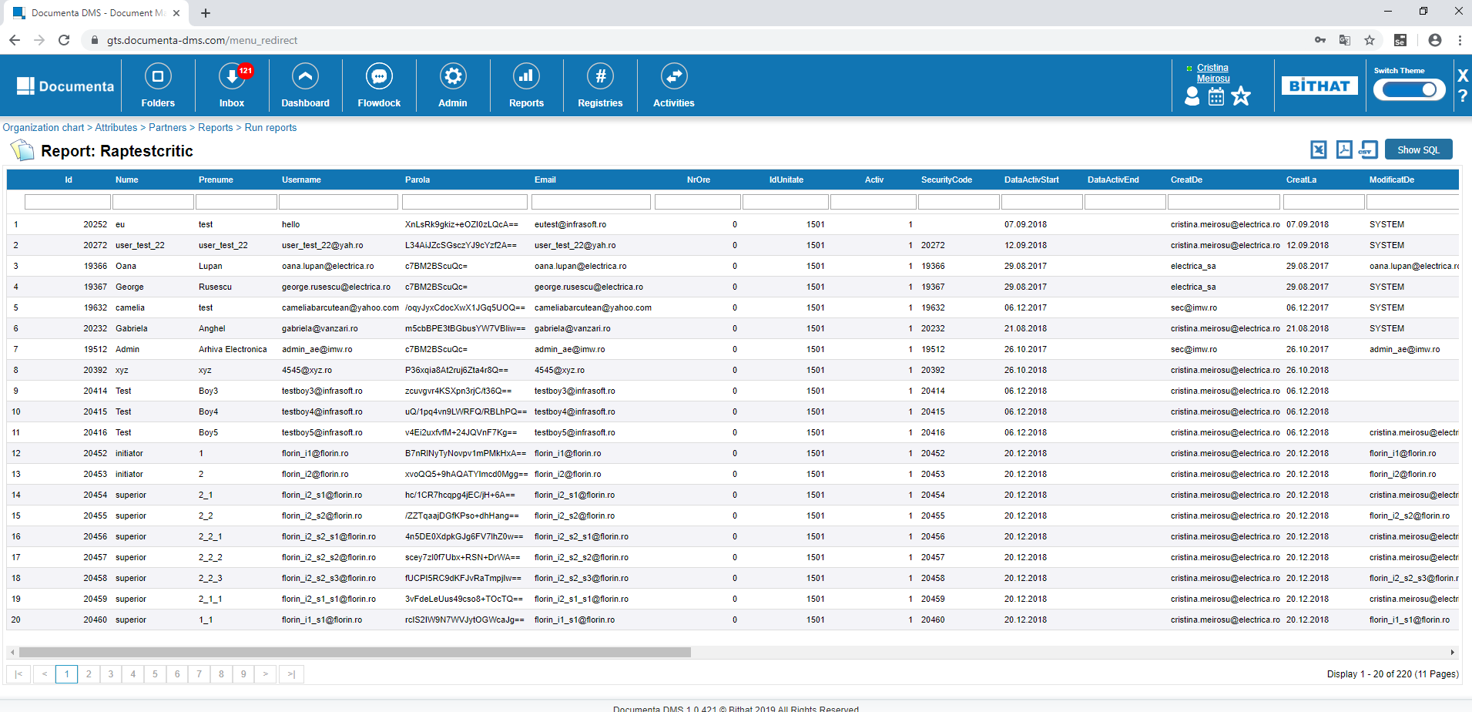

### 

## Activities

### Activities - Projects - Tickets – Add/Edit ticket

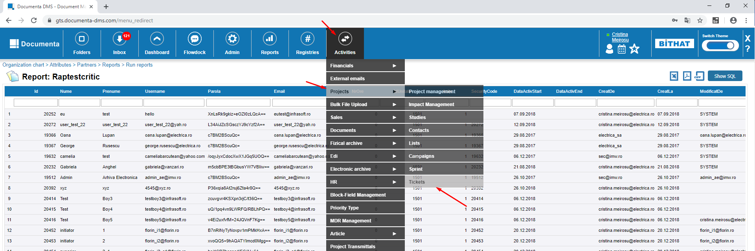

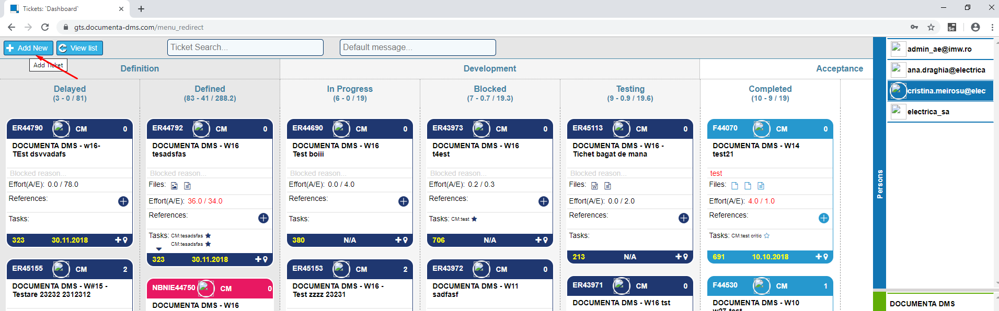

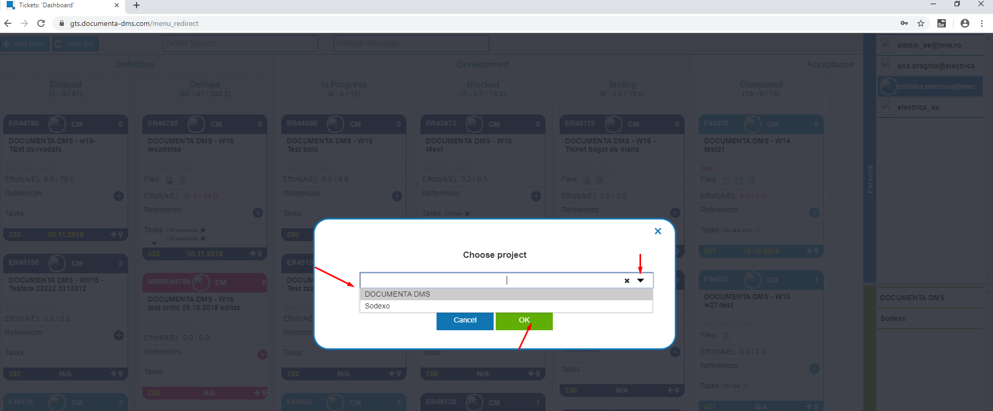

Complete all the fields:

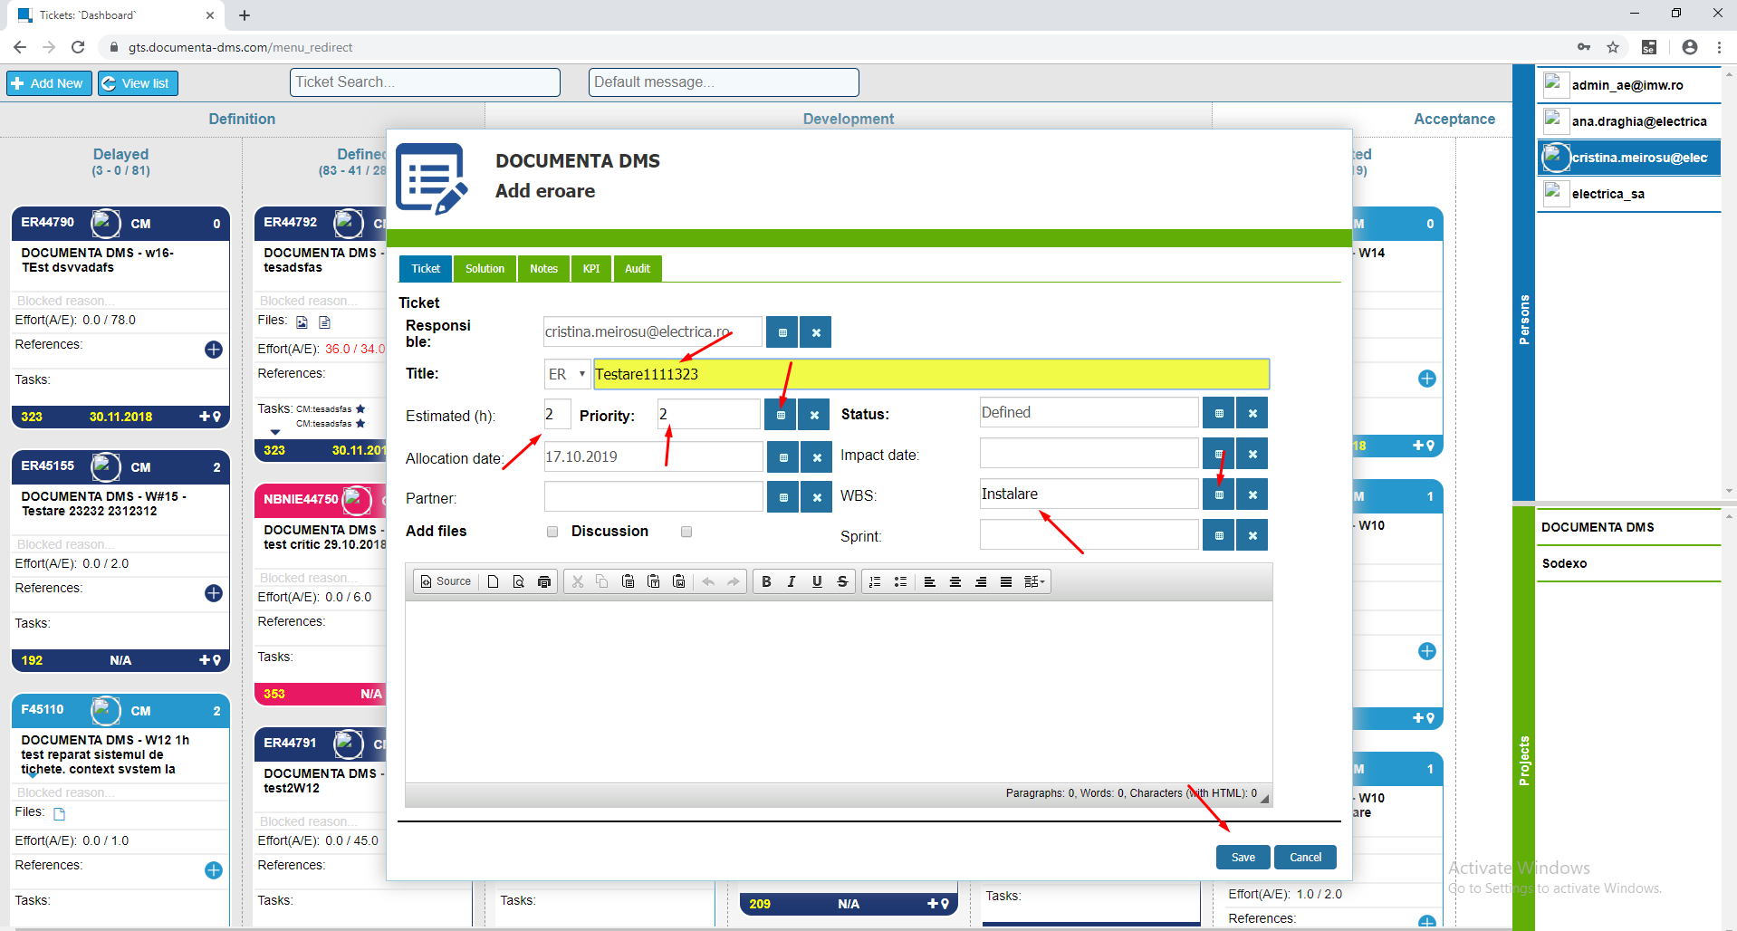

Click on the the ticket and edit something in the Title and Save.

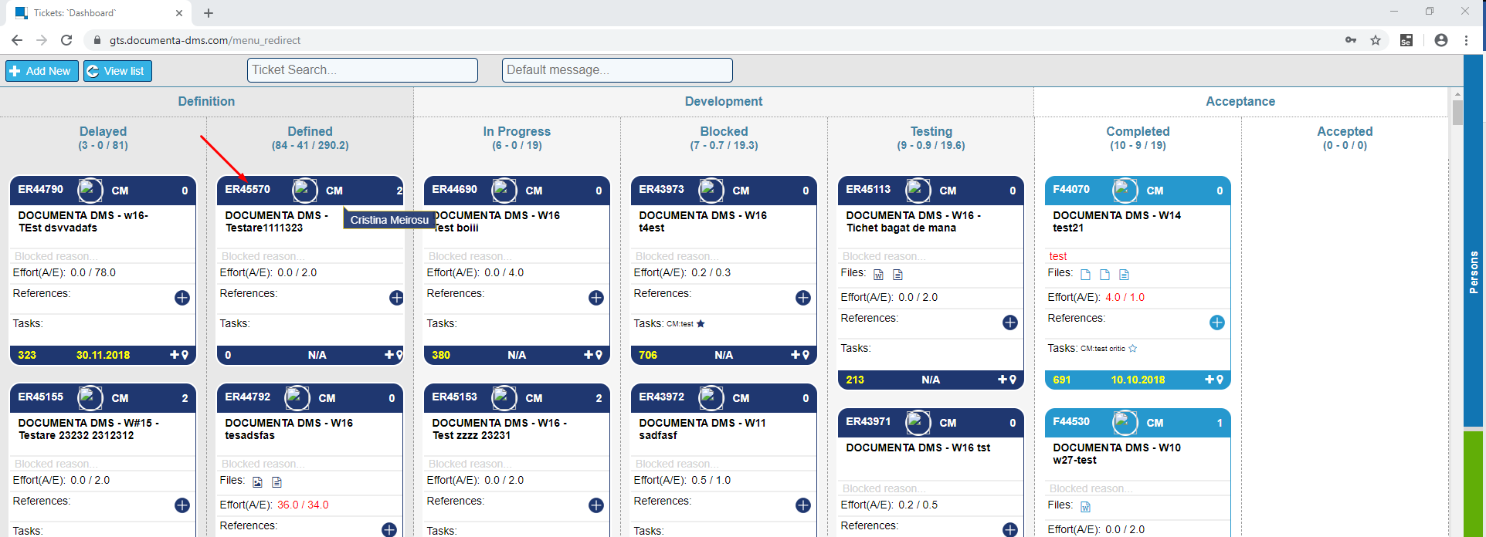

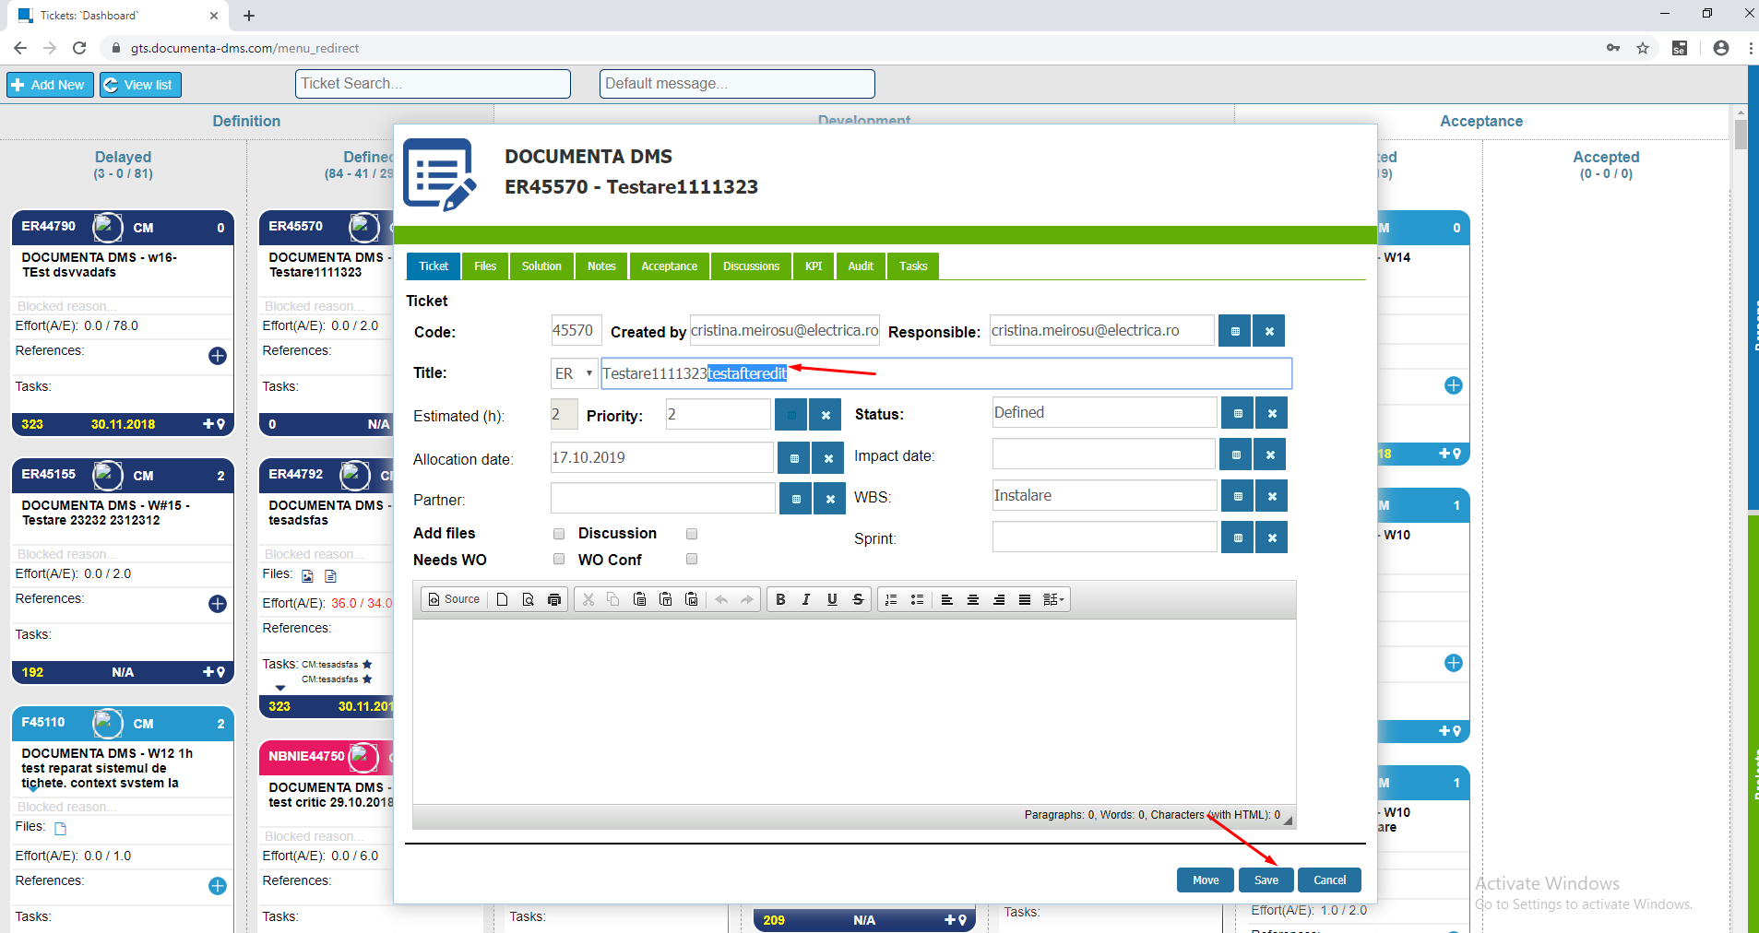

### 6.1. Register . Create / Edit

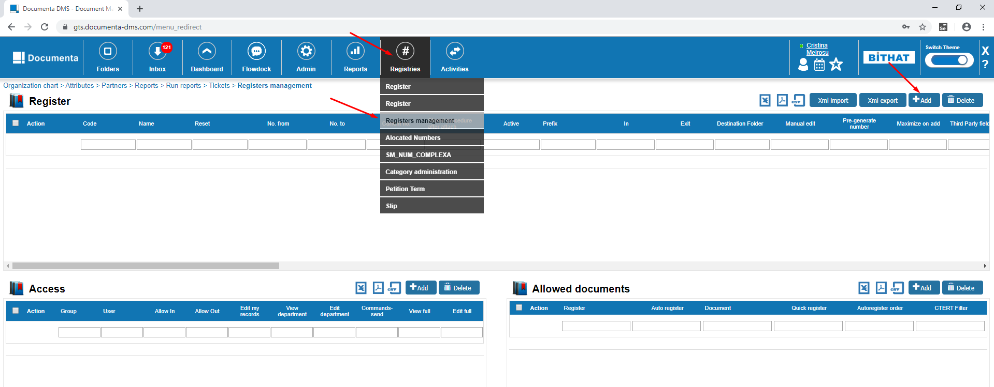

Complete the informations like in the screenshot bellow:

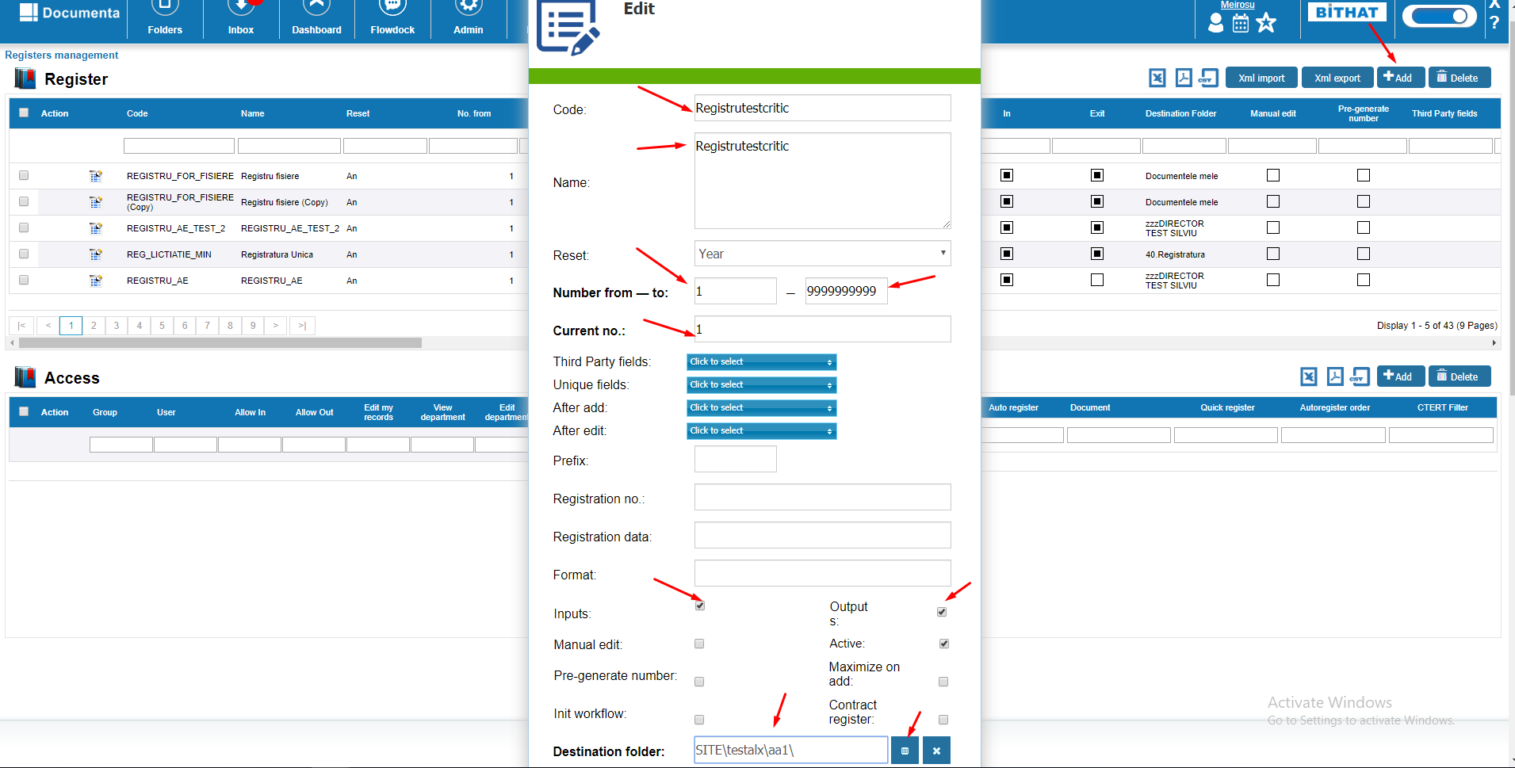

Edit:

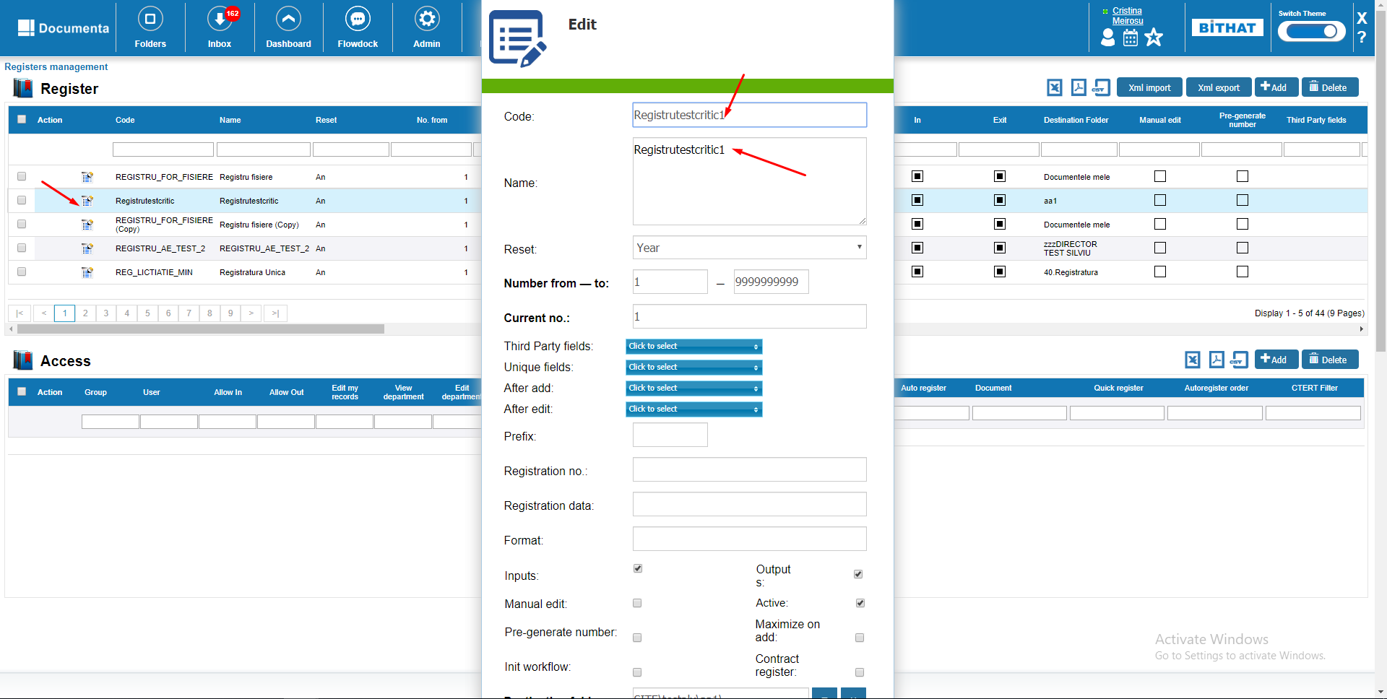

Configure the columns for a register.

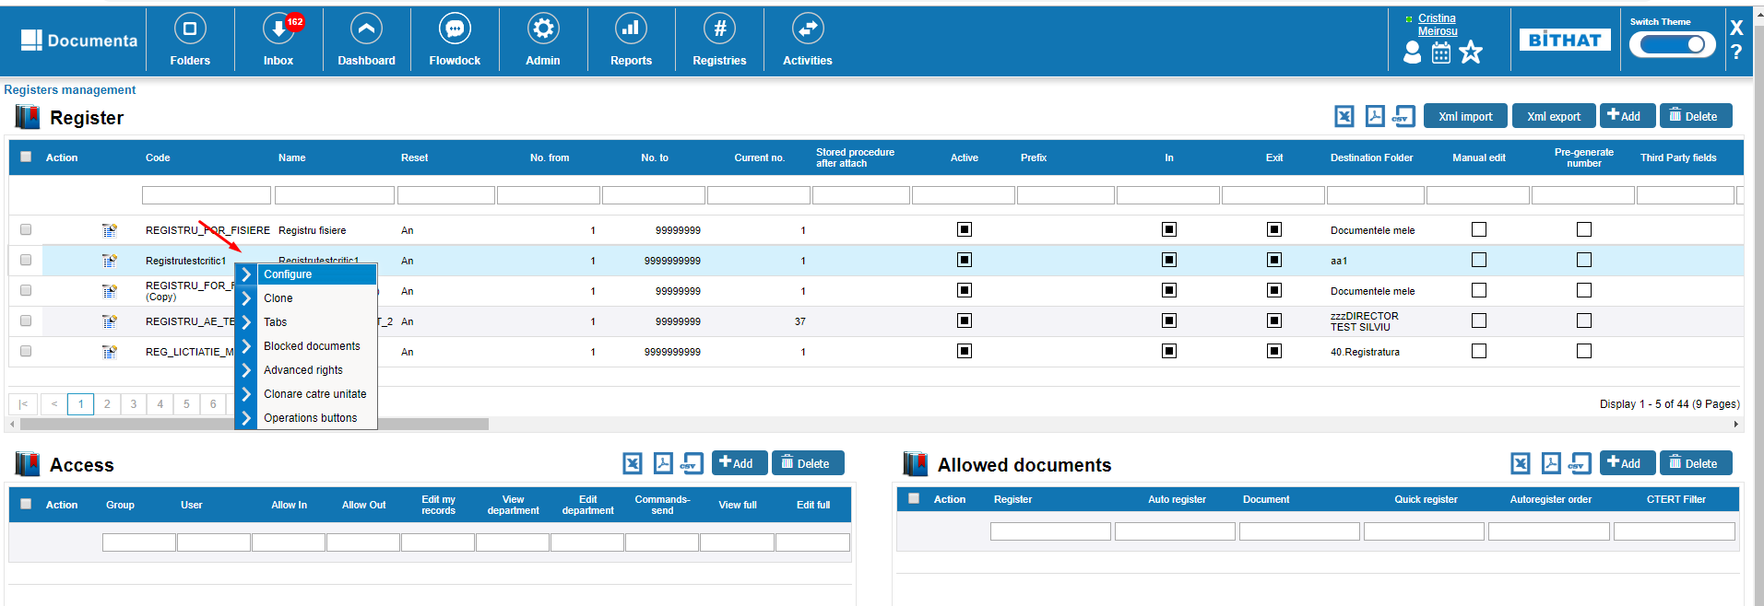

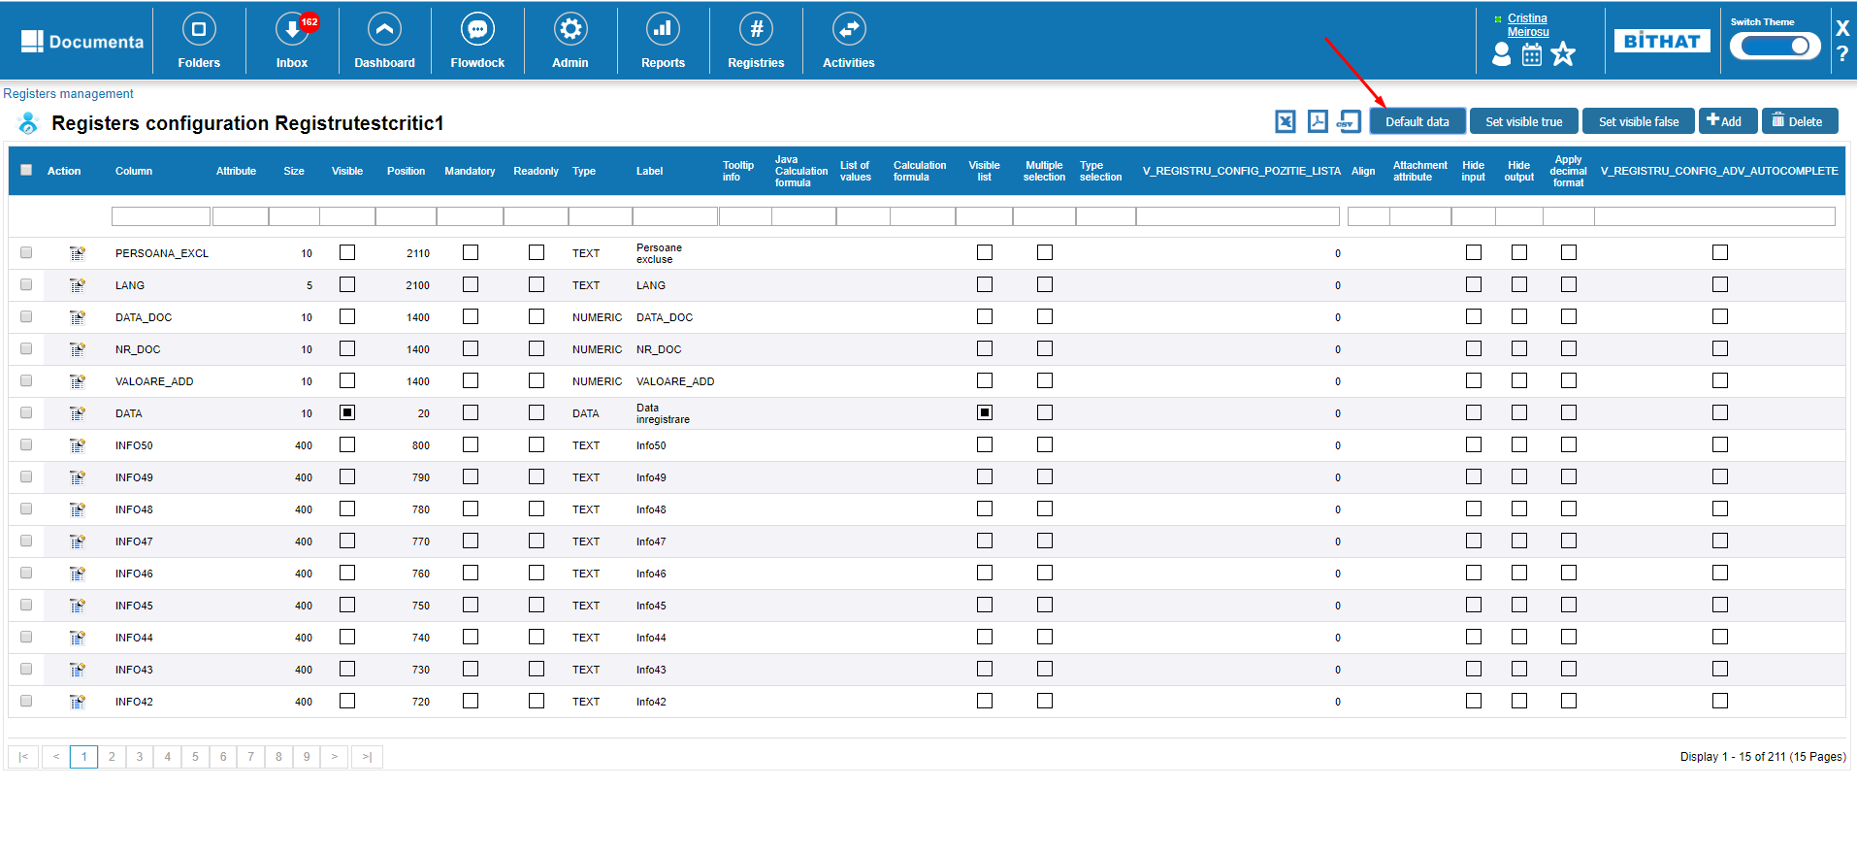

Search the ‘Secretariat’ name in the label field and click edit on it and uncheck the Mandatory field and save.

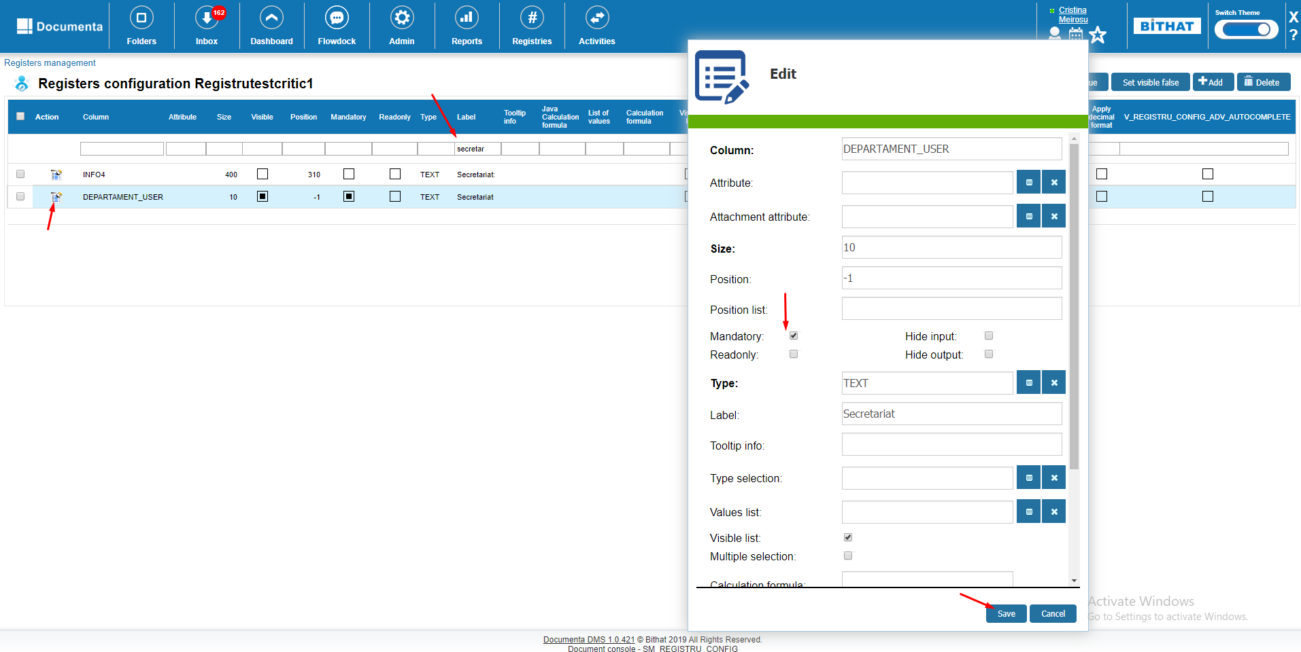

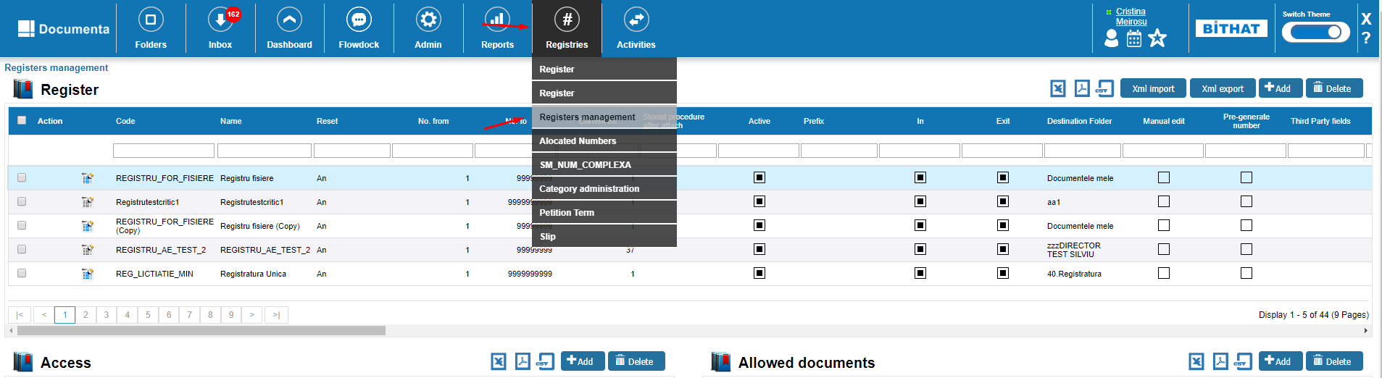

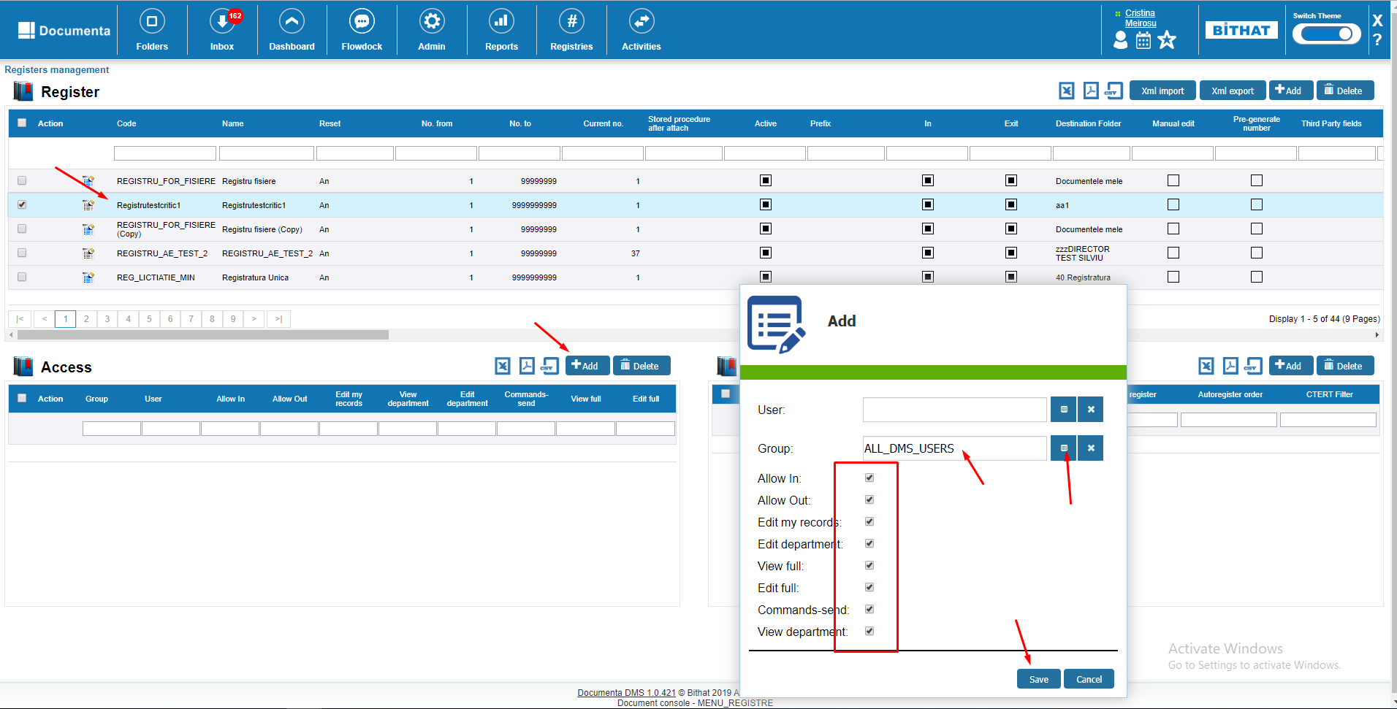

## 7. REGISTRATION LIGHT

### 7.1 Document registration and reference to a person, with PDF upload

Enter in Register

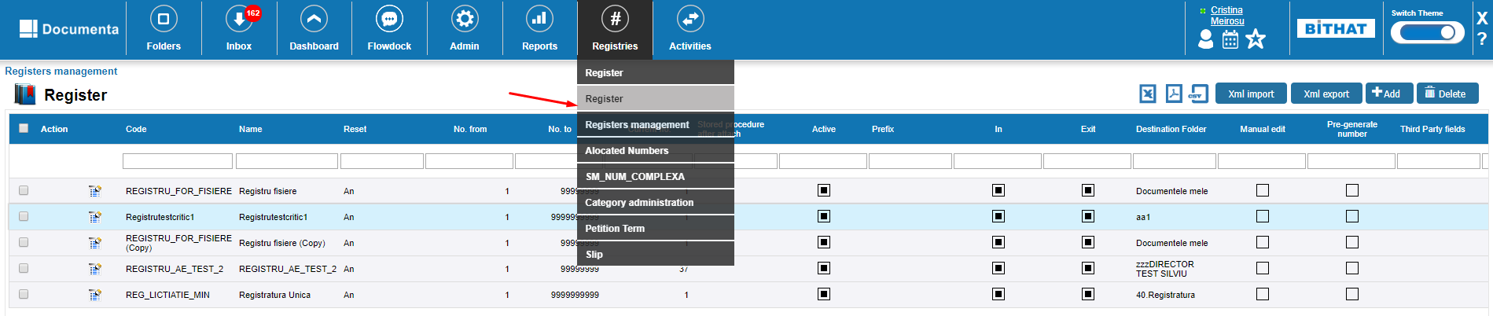

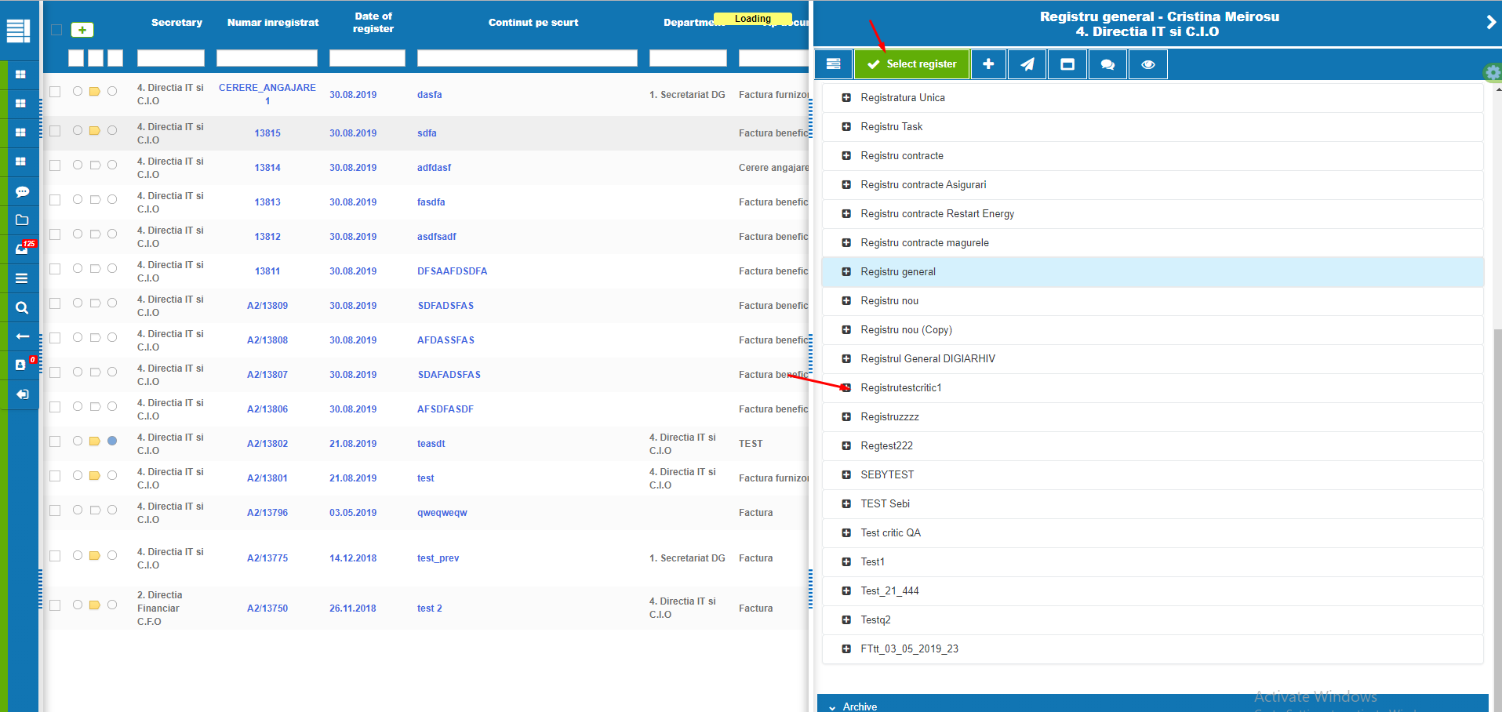

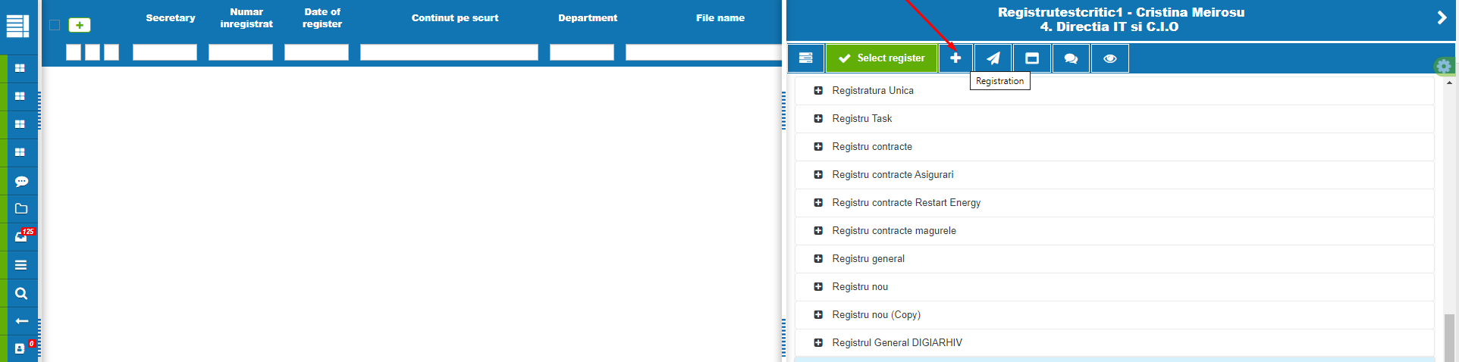

Complete the fields in the 2 screenshots bellow also add a PDF file to the registration:

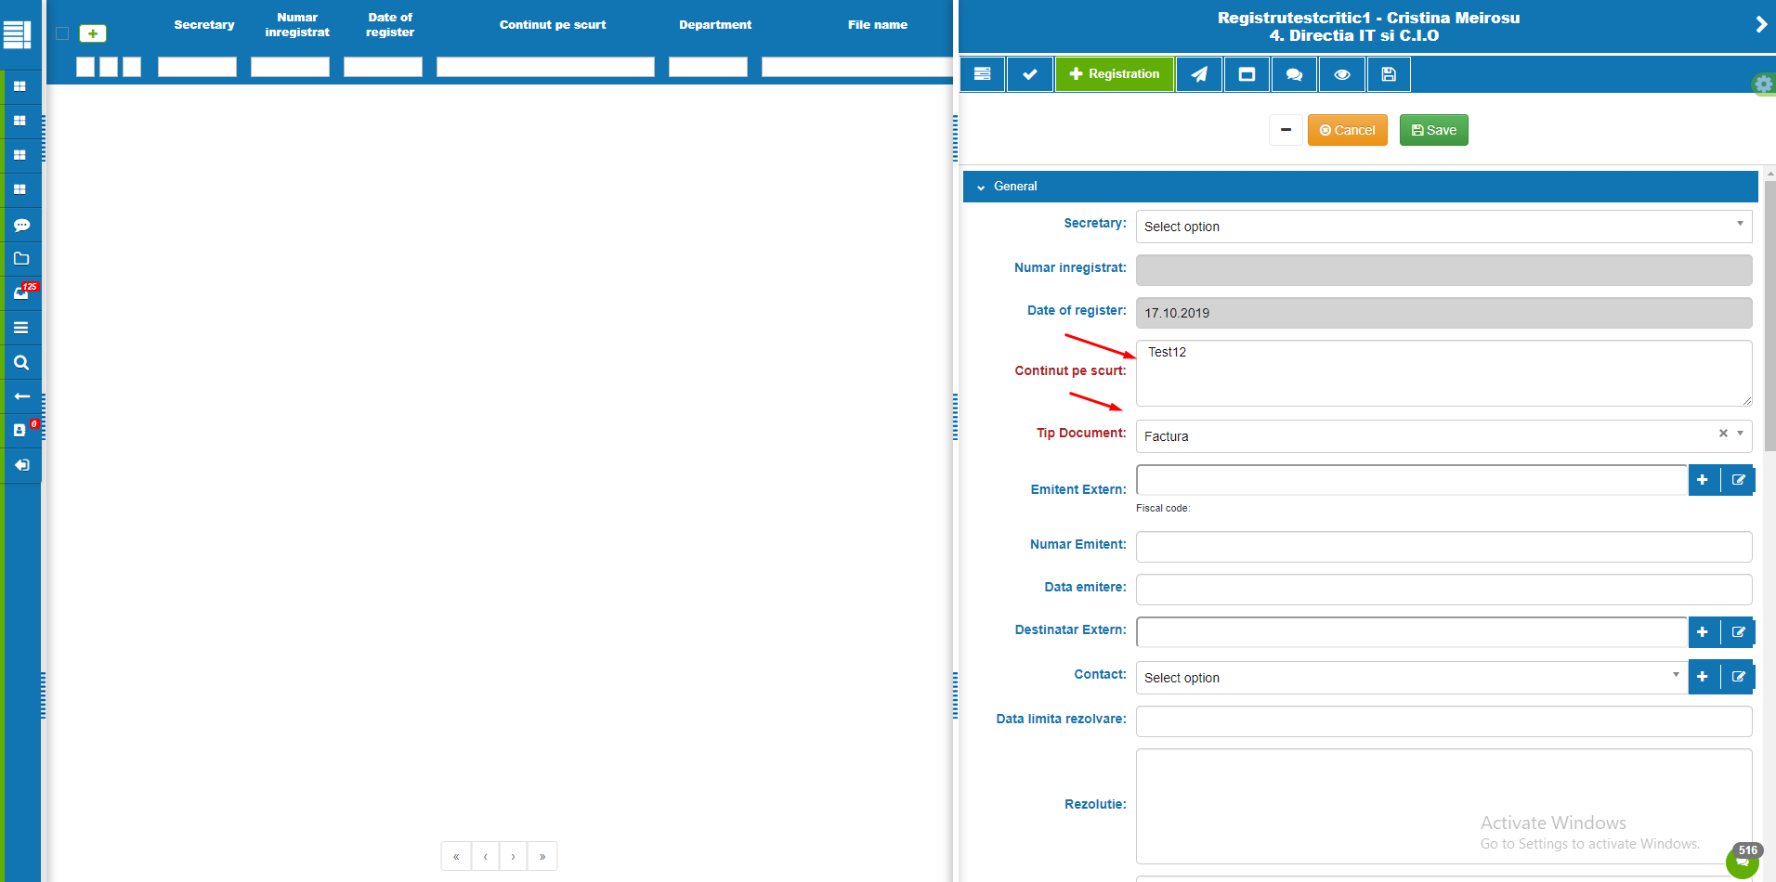

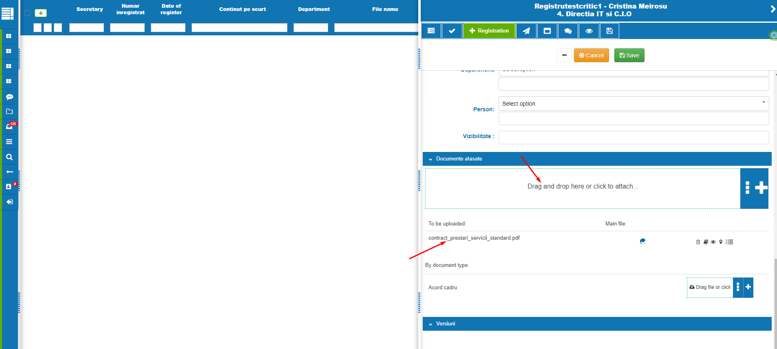

Click Save after.

Edit and Save.

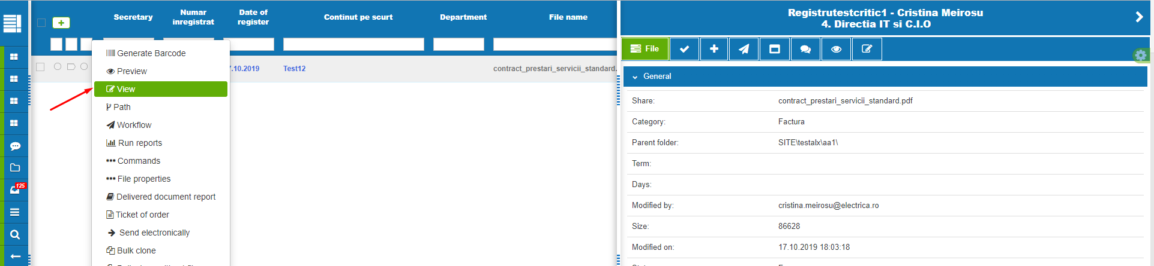

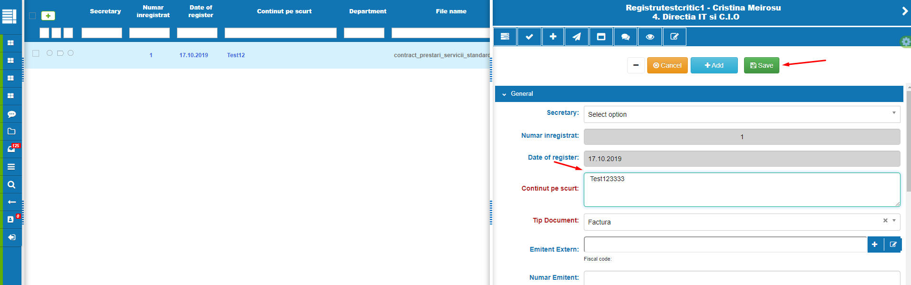

### 8.3 Preview

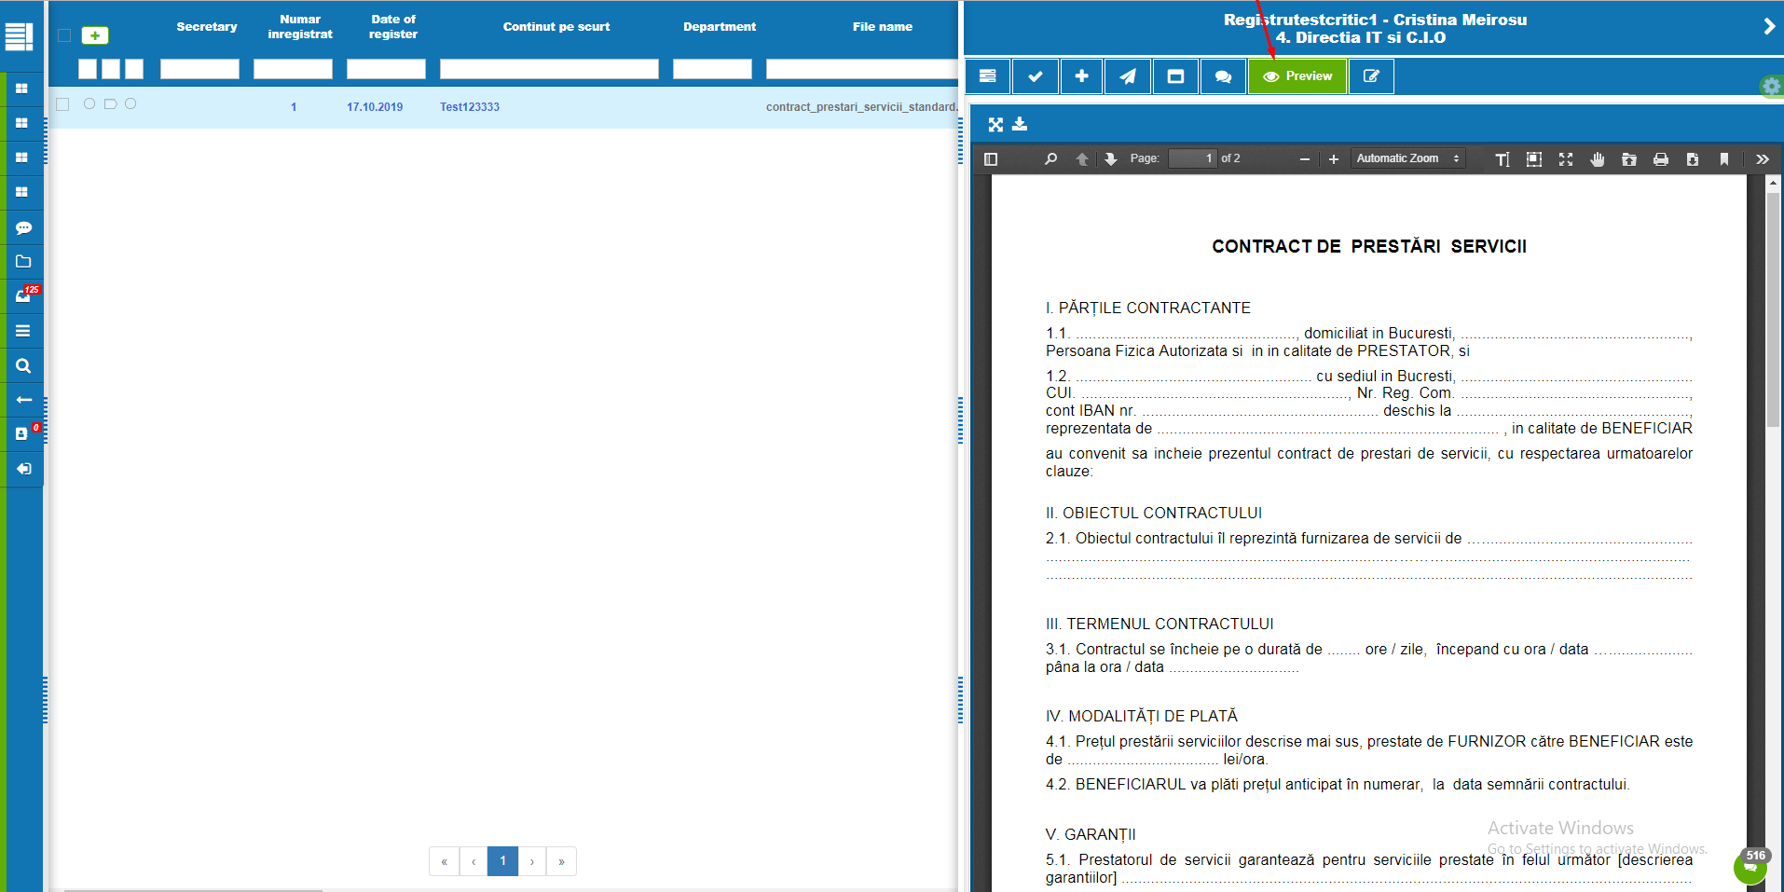

### 8.4. Send on workflow from Register

